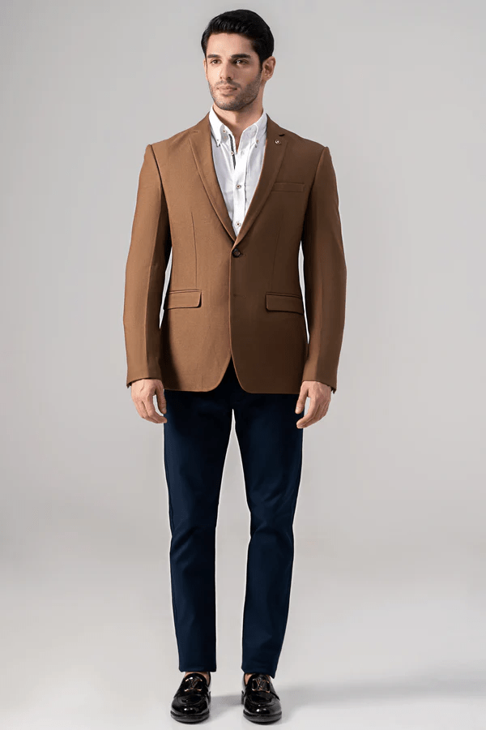**CASUAL COAT DARK KHAKI**

Sale priceRs.19,996.00

Notch lapel with two-button style coat is a true stunner! The chest welt pocket and front flap pockets add a touch of sophistication. And let's not forget about the special charcoal lapel pin, while the two side vents at the back ensure comfort and ease of movement. You're ready to make a statement with this ensemble