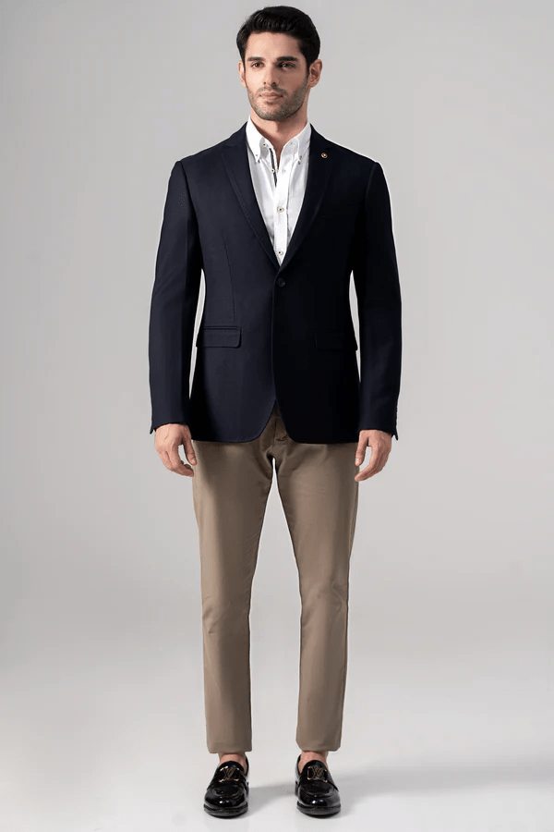**CASUAL COAT NAVY**

Sale priceRs.19,996.00Regular price

Tropical fabric notch lapel with special champa detailing, two-button style coat is a true stunner! The chest welt pocket and front flap pockets add a touch of sophistication. elbow patches add a unique and stylish flair. And let's not forget about the special charcoal lapel pin, while the two side vents at the back ensure comfort and ease of movement. You're ready to make a statement with this ensemble