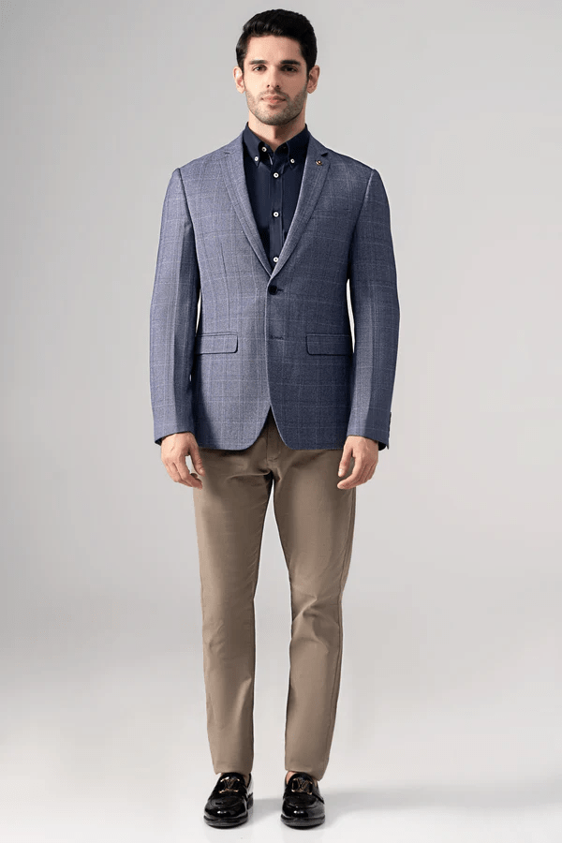**CASUAL COAT BLUE**

Sale priceRs.19,996.00

Self checked tropical fabric notch lapel two-button style coat is a true stunner! The chest welt pocket and front flap pockets add a touch of sophistication, while the two side vents at the back ensure comfort and ease of movement. And let's not forget about the special charcoal lapel pin, it adds a unique and stylish flair. You're ready to make a statement with this ensemble!