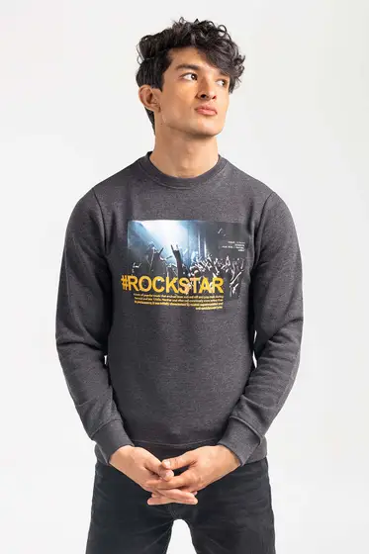Charcoal Fashion Sweatshirt JKT-MSS-D25-01

SKU

M-AP-21-272068 -P

IN STOCK

PKR 2,067

PRODUCT DETAILS

Banish the breeze with the latest drop of Sweatshirts by Ideas Man. This sweatshirt features a round neckline, long sleeves and ribbed trims.

70% Cotton 30% Polyester

Regular Fit

Model Specs: The model is 6ft 2in tall and is wearing size Medium.

More Information

NEW ARRIVALS: No

GENDER: Men

DISCOUNT PERCENTAGE: 31% to 40%

SHIRT FABRIC: Blended