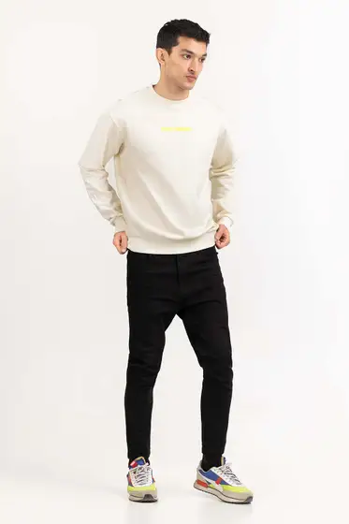Egret 224-112-045

SKU

M-AP-23-322821 -P

IN STOCK

PKR 2,009

PRODUCT DETAILS

Long sleeve sweatshirt with a round neck

Regular Fit

Model Specs: The model height is 6’2 and wearing size is Medium

More Information

NEW ARRIVALS: No

GENDER: Men

DISCOUNT PERCENTAGE: 51% to 60%