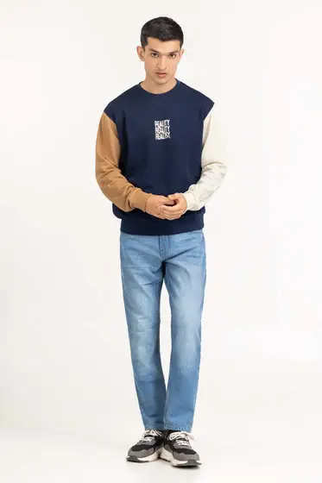Multi Knit Sweatshirt 224-112-058

SKU

M-AP-23-322841 -P

IN STOCK

PKR 3,075

PRODUCT DETAILS

Long sleeves sweatshirt with a round neck

Regular Fit

Model Specs: The model height is 6’2 and wearing size is Medium

More Information

NEW ARRIVALS: No

GENDER: Men

DISCOUNT PERCENTAGE: 31% to 40%