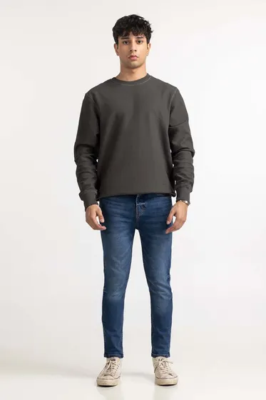Maddy Green Fashion Sweatshirt MN-SWS-WS23-003

SKU

M-AP-23-368816 -P

IN STOCK

PKR 2,574

PRODUCT DETAILS

T-Shirt With Round Neckline And Full sleeves raglan

Blended

Regular Fit

Model Specs: The model is 5'11 and wearing size is Medium

More Information

NEW ARRIVALS: No

GENDER: Men

DISCOUNT PERCENTAGE: 31% to 40%