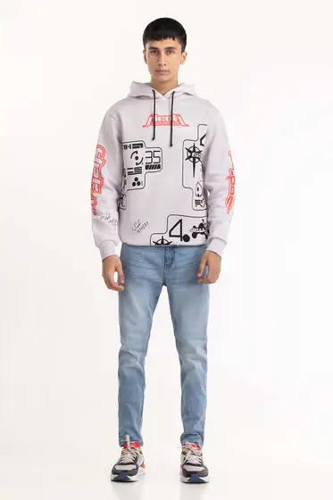White Printed Hoodie 224-112-032

SKU

M-AP-22-322813 -P

IN STOCK

PKR 3,444

PRODUCT DETAILS

Knit Hoodie With Long Sleeves And Ribbed Trims.

Regular Fit

Model Specs: The model height is 5’11 and wearing size is Medium

More Information

NEW ARRIVALS: No

GENDER: Men

DISCOUNT PERCENTAGE: 31% to 40%