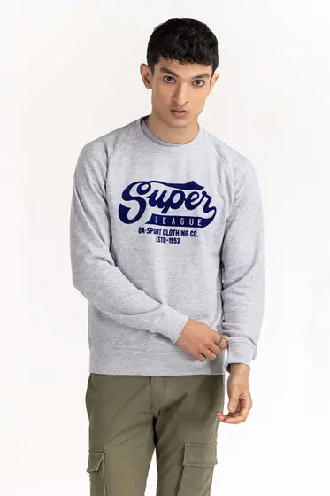Heather Grey SWS-F22-023

SKU

M-AP-22-313196 -P

IN STOCK

PKR 2,154

PRODUCT DETAILS

Banish the breeze with the latest drop of Sweatshirts by Ideas Man. This sweatshirt features a round neckline, long sleeves and ribbed trims.

70% Cotton 30% Poly

Regular Fit

Model Specs: The model is 6ft tall and is wearing size medium.

More Information

NEW ARRIVALS: No

GENDER: Men

DISCOUNT PERCENTAGE: 31% to 40%

SHIRT FABRIC: Blended

LEAVE A REVIEW