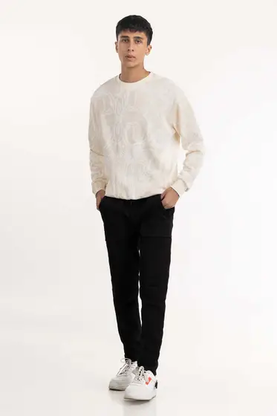224-112-060

SKU

M-AP-22-322845 -P

IN STOCK

PKR 1,804

PRODUCT DETAILS

Long Sleeve Sweatshirt With A Round Neck

Relaxed Fit

Model Specs: The model height is 5’11 and wearing size is Medium

More Information

NEW ARRIVALS: No

GENDER: Men

DISCOUNT PERCENTAGE: 51% to 60%