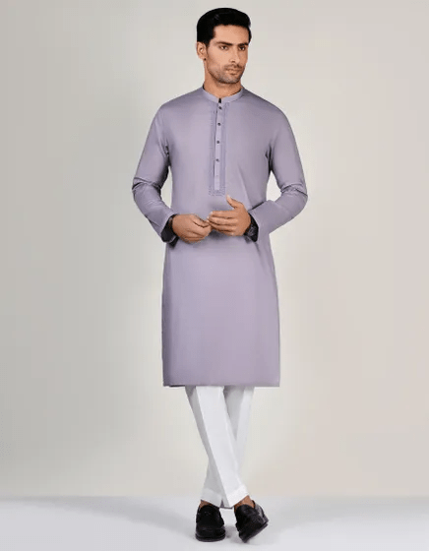BROWN COTTON KAMEEZ SHALWAR | JJKS-S-34530

**IN STOCK**

SKU

J-1207

[BE THE FIRST TO REVIEW THIS PRODUCT](https://www.junaidjamshed.com/brown-cotton-kameez-shalwar-jjks-s-34530.html#review-form)

**PKR 5,192.00**  
More Information

Color Brown

Fabric Cotton

Fit Type Regular Fit

Wear Type Casual

Product Category Casual Kameez Shalwar

Season Winter Collection

Disclaimer Due to the photographic lighting & different screen calibrations, the color