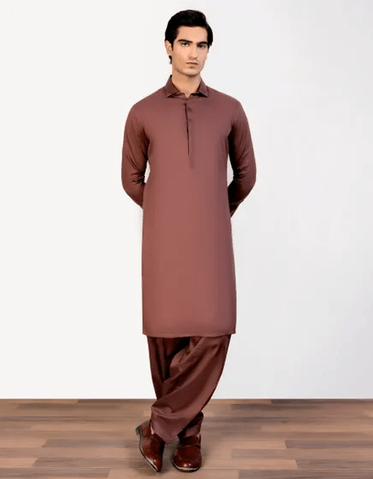RUSTIC BROWN COTTON KAMEEZ SHALWAR | JJKS-S-47048

**IN STOCK**

SKU

J-GM201517

[BE THE FIRST TO REVIEW THIS PRODUCT](https://www.junaidjamshed.com/rustic-brown-cotton-kameez-shalwar-jjks-s-47048.html#review-form)

**PKR 6,034.00**

More Information

More Information

Color Rustic Brown

Fabric Cotton

Fit Type Regular Fit

Wear Type Exclusive

Product Category Exclusive Kameez Shalwar

Season Festive Collection

Disclaimer Due to the photographic lighting & different screen calibrations, the colors of the original product may slightly vary from the picture