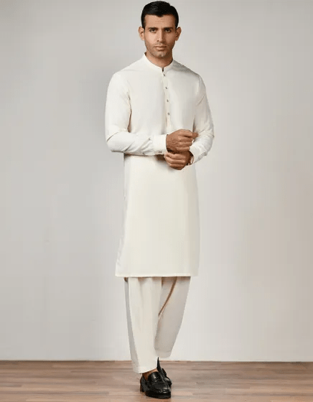WHITE KAMEEZ SHALWAR | JJKS-S-32801

**IN STOCK**

SKU

J-10000002536

[BE THE FIRST TO REVIEW THIS PRODUCT](https://www.junaidjamshed.com/white-kameez-shalwar-jjks-s-32801.html#review-form)

**PKR 3,983.00**

More Information

More Information

Color White

Fit Type Regular Fit

Wear Type Casual

Product Category Casual Kameez Shalwar

Season Festive Collection

Disclaimer Due to the photographic lighting & different screen calibrations, the colors of the original product may slightly vary from the picture