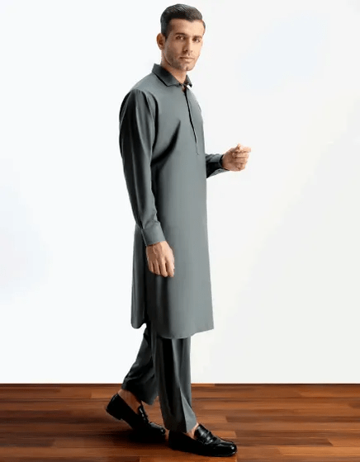GREY BLENDED KAMEEZ SHALWAR | JJKS-S-30820-R14

**IN STOCK**

SKU

J-GM159638

[BE THE FIRST TO REVIEW THIS PRODUCT](https://www.junaidjamshed.com/grey-blended-kameez-shalwar-jjks-s-30820-r14.html#review-form)

**PKR 5,030.00**

More Information

More Information

Color Grey

Fabric Blended

Fit Type Regular Fit

Wear Type Casual

Product Category Casual Kameez Shalwar

Disclaimer Due to the photographic lighting & different screen calibrations, the colors of the original product may slightly vary from the picture