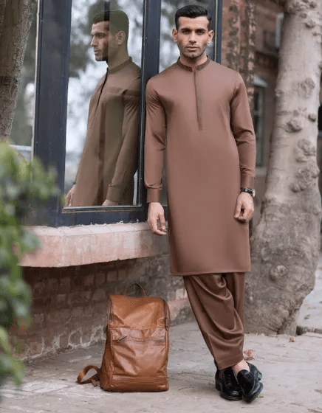BROWN COTTON KAMEEZ SHALWAR | JJKS-S-37726

**IN STOCK**

SKU

J-GM198990

[BE THE FIRST TO REVIEW THIS PRODUCT](https://www.junaidjamshed.com/brown-cotton-kameez-shalwar-jjks-s-37726.html#review-form)

**PKR 5,243.00**

More Information

More Information

Color Brown

Fabric Cotton

Product Category Semi-Formal Kameez Shalwar

Disclaimer Due to the photographic lighting & different screen calibrations, the colors of the original product may slightly vary from the picture