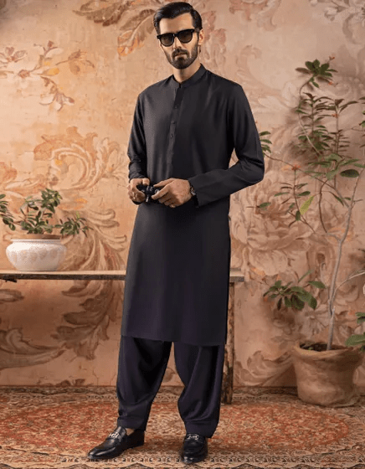BLACK BLENDED KAMEEZ SHALWAR | JJKS-A-30778-R28

**IN STOCK**

SKU

J-10000019536

[BE THE FIRST TO REVIEW THIS PRODUCT](https://www.junaidjamshed.com/black-blended-kameez-shalwar-jjks-a-30778-r28.html#review-form)

**PKR 4,990.00**

More Information

More Information

Color Black

Fabric Blended

Fit Type Regular Fit

Wear Type Plain

Product Category Casual Kameez Shalwar

Season Winter Collection

Disclaimer Due to the photographic lighting & different screen calibrations, the colors of the original product may slightly vary from the picture