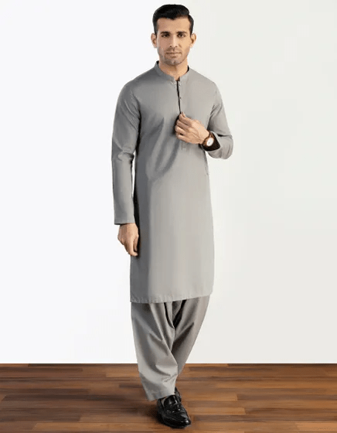GREY BLENDED KAMEEZ SHALWAR | JJKS-S-47020

**IN STOCK**

SKU

J-GM200085

[BE THE FIRST TO REVIEW THIS PRODUCT](https://www.junaidjamshed.com/grey-blended-kameez-shalwar-jjks-s-47020.html#review-form)

**PKR 4,669.00**

More Information

More Information

Color Grey

Fabric Blended

Fit Type Regular Fit

Wear Type Casual

Product Category Casual Kameez Shalwar

Season Festive Collection

Disclaimer Due to the photographic lighting & different screen calibrations, the colors of the original product may slightly vary from the picture