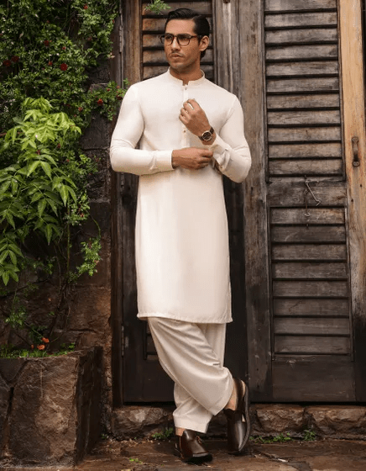WHITE BLENDED KAMEEZ SHALWAR | JJKS-S-47068

**IN STOCK**

SKU

J-GM207938

[BE THE FIRST TO REVIEW THIS PRODUCT](https://www.junaidjamshed.com/yellow-blended-kameez-shalwar-jjks-s-47068.html#review-form)

**PKR 4,592.00**

More Information

More Information

Color White

Fabric Blended

Fit Type Regular Fit

Wear Type Plain

Product Category Casual Kameez Shalwar

Season Winter Collection

Disclaimer Due to the photographic lighting & different screen calibrations, the colors of the original product may slightly vary from the picture