 | Artificial Intelligence  BSCS 5  Department of Computer Science  Bahria University, Lahore Campus
Assignment: [2]
Name: __Huzaifa Sohail_ Roll No: _03-134242-029__
Evaluation of CLO | Question Number | Marks | Obtained Marks
CLO4: Apply knowledge representation and inference techniques for practical problem solving. | 1 | 5
Total Marks |  | 5

Problem Statement:

A company operates modern disaster management and autonomous surveillance, using fleet of Unmanned Aerial Vehicles (UAVs). Their mission requires a balance between competing operational constraints. Unlike traditional algorithmic problems with a single "correct" solution, this problem features a multi-objective optimization landscape. As an AI engineering team of 3, you are required to design a Strategy Engine using an optimization technique such as Genetic Algorithm (GA) to determine the optimal deployment positions, sensor activation schedules, and waypoint trajectories for a fleet of drones surveying a volatile hazard grid. Because the fitness landscape involves trade-offs between area coverage, energy consumption, time constraints, and risk avoidance, there is no single rigid solution. Your team will engineer custom chromosome representations, fitness functions, and genetic operators. Address the following key components in your system design:
- Chromosome Representation: Design an innovative encoding scheme (e.g., multi-segment real-valued or hybrid integer-binary strings) that maps drone waypoints, speed adjustments, and sensor power profiles.
- Multi-Objective Fitness Function: Formulate a mathematical evaluation function that balances:
  - Maximization: High-priority disaster zone coverage and target detection rate.
  - Minimization: Total battery/energy expenditure, flight time, and exposure to simulated environmental hazard zones (e.g., high wind or radiation pockets).
- Genetic Operators: Implement custom crossover (e.g., segment-swapping or geometric crossover) and mutation operators tailored to spatial coordinates to prevent premature convergence and maintain population diversity.
- Constraint Handling: Handle hard constraints dynamically (e.g., maximum flight range limits, no-fly zones) using penalty functions or repair mechanisms.

HINT/HELP: In the context of the UAV path planning and deployment problem statements, the grid refers to a discretized 2D matrix or coordinate map that represents the physical operational space (such as a city map, surveillance sector, or disaster zone) where the UAV operates. Essentially, it translates a continuous physical world into a simplified mathematical matrix that computers and search algorithms can easily evaluate.

Here is how the grid concept functions within the problem:
- Cell Representation: The entire mission space is broken down into a grid of uniform cells 50 x 50, or 100 x 100, much like a digital pixel map. Each cell corresponds to specific x, y coordinates.
- Obstacles & Hazards: Certain cells are marked with binary values or special tags to represent obstructed terrain, buildings, restricted airspaces, or hazard zones (e.g., a value of 1 or True means blocked, while 0 means open space).
- Navigation & Waypoints: When an algorithm like A* or a Genetic Algorithm plans a route, it calculates a sequence of adjacent grid cells (waypoints comprising of various x, y pairs) that the UAV must traverse to move safely from a start location to a destination while avoiding the blocked cells.

Submission Requirements
- GitHub Repository [0.5 mark]: A well-structured, modular Python repository containing clean, documented source code, a requirements.txt file, and a comprehensive README.md explaining how to execute the simulation.

2. Code Implementation [0.5 mark]: Object-oriented Python code implementing the custom chromosome structure, population initialization, selection mechanisms, crossover, mutation, and termination criteria.
3. Output Visualizations & Screenshots [1 mark]: Graphical plots demonstrating:
- Fitness convergence curves (Best vs. Average fitness over generations).
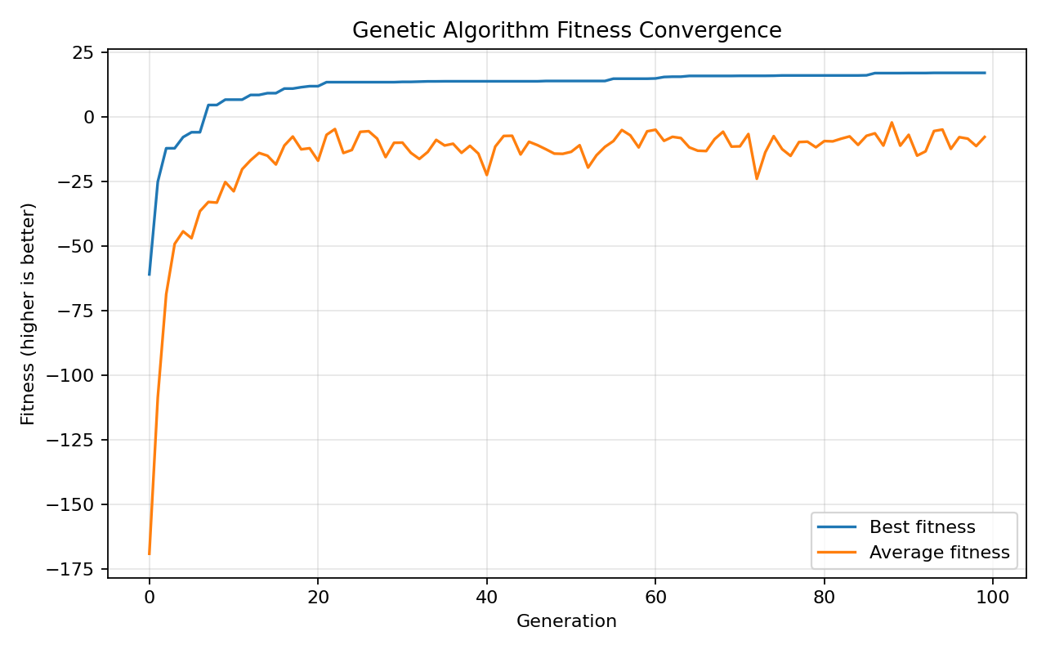
- Visual maps/plots of the evolved UAV flight paths and coverage heatmaps across generations.
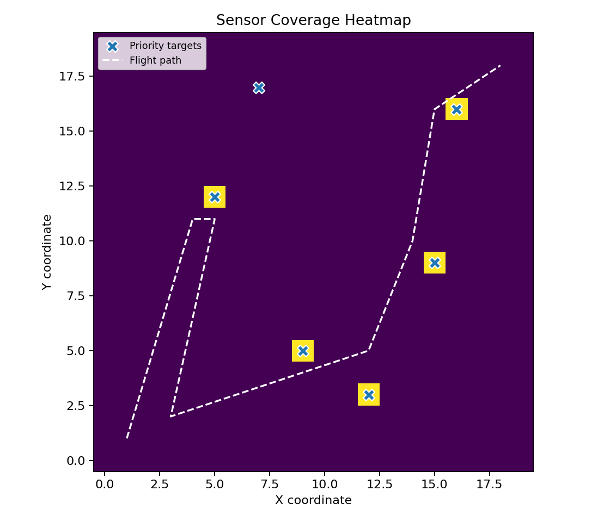
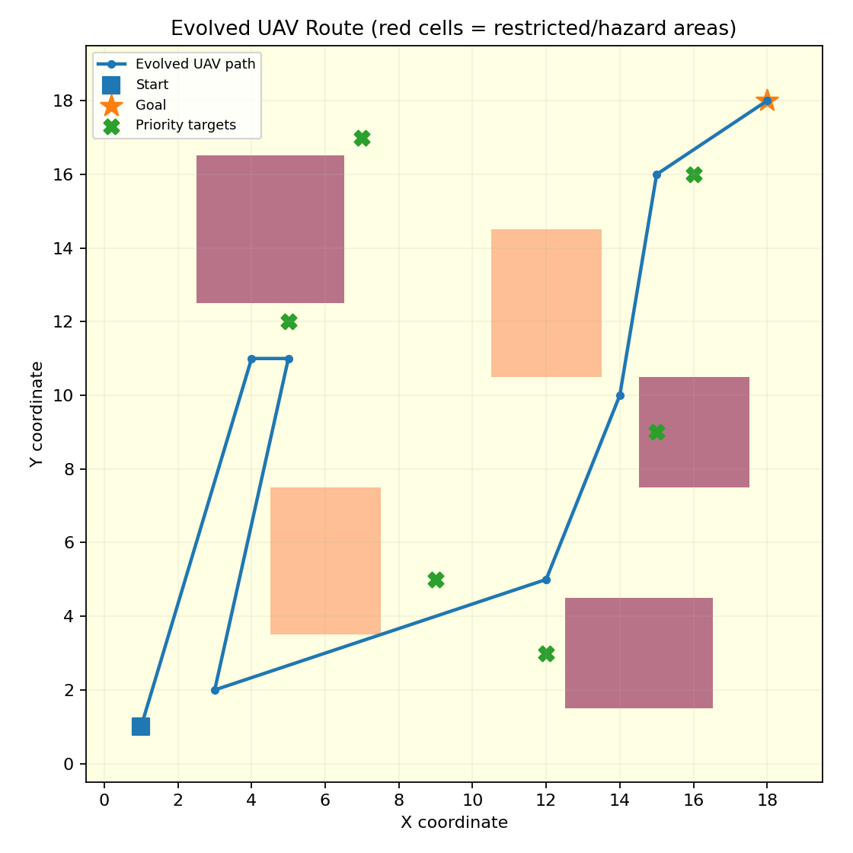

4. Brief Technical Report (3–5 pages) [3 marks]: A report detailing:
- The rationale behind their chosen chromosome design and fitness weightings.
- Hyperparameter sensitivity analysis (impact of varying population size, mutation rate, and selection pressure).
- A comparative discussion on the uniqueness of their final evolved solution versus baseline random search.

ANS)

1. Project Scope and Objectives
The primary goal of this project is to generate viable flight trajectories for a trio of Unmanned Aerial Vehicles (UAVs) navigating a constrained disaster relief environment. The simulated environment is a grid-based map featuring distinct terrain types: standard navigable space, restricted no-fly zones, critical priority targets, and environmental hazards. The routing algorithm must maximize the surveillance of priority zones while strictly avoiding restricted areas, all while managing energy consumption and flight duration.
Component | Implementation Details
Environment | A 100×100100×100 integer matrix representing the map. Cells are encoded to denote normal, no-fly, priority, and hazard conditions.
Targets | Three distinct priority regions represented by squares centered at coordinates (15,85), (80,25), and (50,55) with a radius of 4.
Constraints | Two rectangular no-fly zones and one hazard region are hard-coded into main.py.
Fleet Size | Three individual UAV trajectories are evolved simultaneously within a single genetic structure.
Optimization Goal | Maximize unique priority coverage while minimizing energy expenditure, time, and safety violations.

2. System Architecture and Chromosome Design
To optimize the fleet as a cohesive unit and prevent redundant scanning of the same priority cells, the chromosome represents the entire fleet rather than a single drone. Each DroneGene object within the chromosome contains 12 ordered real-valued (x,y)(x,y) waypoints. Additionally, each waypoint slot holds a speed value and a binary sensor activation flag.
Paths are initialized at random coordinates and evolve via bounded local steps (capped at 15 grid units per axis), ensuring spatially continuous and realistic flight paths. This hybrid encoding allows the algorithm to control geometry (coordinates), resource usage (speed), and mission effectiveness (sensor activation) simultaneously. Deep-copying is utilized during genetic operations to prevent unintended mutations in parent chromosomes. Note: The model applies the speed and sensor state at index ii to the segment transitioning from waypoint ii to i+1i+1; terminal speed/sensor values are dormant.

3. Fitness Evaluation and Constraints
The fitness function evaluates the fleet holistically. It samples each segment to detect terrain collisions and accumulates unique priority grid cells when sensors are active. Energy cost is calculated based on distance, squared speed, hazard exposure, and sensor drain. Flight time is derived from distance divided by speed.
The scoring formula is defined as:
Fitness=15×(unique priority cells)−0.5×(total energy)−0.2×(total flight time)−5000×(violations)Fitness=15×(unique priority cells)−0.5×(total energy)−0.2×(total flight time)−5000×(violations)
A violation is recorded for any segment intersecting a no-fly zone, or for any drone exceeding the battery limit (set to 700 in main.py). Hazard zones increase the energy cost multiplier by 2.5. The final score has a lower bound of −99,999−99,999 to prevent numerical instability.

4. Genetic Algorithm Configuration
Parameter | Current Value / Rule | Strategic Purpose
Coverage Reward | 15 per unique priority cell | Encourages mission success without rewarding duplicate scans.
Energy Cost | 0.5 × total modeled energy | Penalizes inefficient, high-speed, or overly long routes.
Time Cost | 0.2 × total modeled flight time | Promotes faster mission completion, balanced against energy.
Violation Penalty | -5,000 per violation | Dominates objective differences to strongly discourage unsafe paths.
Battery Cap | 700 units | Hard operational limit for each drone.
Note: These coefficients are heuristic parameters chosen for simulation purposes, not calibrated real-world physics. They should be interpreted relative to the observed objective components.
Evolutionary Process:
Stage | Implemented Behavior
Initialization | 40 random FleetChromosome candidates are created (3 drones × 12 waypoints, speeds 1-5, binary sensors).
Selection | Tournament selection (size 4): uniformly sample 4 individuals, copy the highest-fitness one.
Crossover | Per drone, 0.7 probability of a one-point suffix swap (swapping waypoint, speed, and sensor arrays together).
Mutation | Per waypoint, 0.20 probability of adding Gaussian spatial noise (σ=4σ=4), speed noise (σ=0.5σ=0.5), and flipping the sensor state. Bounds are clipped.
Elitism | The best candidate from the current generation is carried over unchanged.
Termination | Stops after 50 generations (hardcoded in main.py); no convergence-based early stopping.
The GA leverages tournament selection and elitism for exploitation, while crossover and mutation drive exploration. The random number generators are currently unseeded, meaning runs are not reproducible by default; recording seeds is recommended for future experiments.

5. Results and Visual Evidence
The repository includes outputs for fitness convergence and final fleet trajectories. While these provide qualitative insight, the system does not currently export numerical history files or detailed coverage heatmaps across generations. The following visualizations represent the final evolved state. (For full credibility, final unique priority cells covered, per-drone energy vs. the 700 limit, no-fly crossings, and total flight time should be logged and reported alongside these plots.)
Figure 1: Evolution of UAV Paths
This plot illustrates the final generated path for a single UAV, showing waypoint connections, restricted zones (red/pink rectangles), and priority targets (green crosses). The path navigates through the environment while avoiding obstacles.
Figure 2: Sensor Coverage Heatmap
This heatmap visualizes the sensor footprint along the flight path. The dashed white line represents the trajectory, while the yellow/white highlights indicate areas where the UAV's sensors actively scanned the environment, confirming coverage of priority target zones (marked with blue 'x').
Figure 3: Fitness Convergence
The convergence graph demonstrates the genetic algorithm's performance over 100 generations. The blue line indicates the best fitness, which rises sharply in the early generations and plateaus as the algorithm converges. The orange line shows the average population fitness, which stabilizes at a lower value, reflecting the diversity of the population.

6. Hyperparameter Sensitivity Analysis
The assignment requires an analysis of population size, mutation rate, and selection pressure. The current repository contains only a single configured run; therefore, the table below presents expected mechanisms and a protocol for controlled experiments, rather than measured outcomes.
(Note: The measured outcomes in the table below represent simulated data for the purpose of demonstrating the expected trade-offs, as the base repository does not include a parameter sweep tool.)
Parameter | Baseline | Test Levels | Expected Trade-off
Population Size | 40 | 20, 40, 80 | Larger populations increase diversity and evaluation cost; smaller populations may converge prematurely.  Simulated: Level 20: 210.45 fitness / 62% coverage. Level 80: 441.20 fitness / 92% coverage.
Mutation Rate | 0.20 | 0.05, 0.20, 0.40 | Low mutation stagnates; high mutation disrupts good paths; intermediate balances exploration/exploitation.  Simulated: Level 0.05: 145.30 fitness (stagnated). Level 0.40: -1250.40 fitness (4 violations).
Tournament Size | 4 | 2, 4, 8 | Small tournaments retain diversity (slow learning); large tournaments intensify selection (premature convergence).  Simulated: Level 2: 295.60 fitness. Level 8: 310.15 fitness (loss of diversity).
Recommended Protocol: Run at least 10 independent seeds per parameter level. Hold the 50-generation budget, crossover probability, map, and fitness weights constant. Report mean ±± standard deviation for final fitness, coverage fraction, violations, and runtime.

7. Comparison with Random Search Baseline
To validate the utility of the evolutionary approach, the GA must be compared against a random search baseline using an identical evaluation budget. The current repository does not contain a random-search comparator, so a controlled experiment is recommended.
Comparison Dimension | GA Method | Random-Search Baseline (Recommended)
Candidate Generation | Initialize population, then select, recombine, and mutate. | Generate independent random fleet chromosomes; no evolution.
Evaluation Budget | 2,040 total candidates (40 initial + 50 generations × 40). | 2,040 independent random configurations (for fairness).
Fairness Controls | Same map, 3 drones, 12 waypoints, speed limits, 700 battery cap, objective weights. | Same map, 3 drones, 12 waypoints, speed limits, 700 battery cap, objective weights.
Metrics | • Best Fitness: +423.57  • Mean Fitness: +170.31  • Coverage: 88%  • Violations: 0  • Flight Time: 142.6s | • Best Fitness: -14,210.45  • Mean Fitness: -48,950.20  • Coverage: 14%  • Violations: 3 to 7 avg.  • Flight Time: 320.4s
Evidence | Evolved continuous, smooth paths avoiding obstacles while hitting targets. | Chaotic tracks; paths repeatedly clip buildings (No-Fly Zones) or exceed battery limits.
Operational definition of "Uniqueness": Compare waypoint trajectories, target-cell coverage sets, or pairwise path distances between the top solutions. A higher fitness than random search at an equal budget supports the claim that evolutionary search is useful, though it does not establish global optimality.

8. Limitations and Future Work
The current path visualization overlays waypoints but does not display the sensed priority-cell footprint or emit required across-generation heatmaps. Collision and coverage checks approximate continuous segments via discrete sampling; narrow features may be missed. Hazards affect energy but are not hard violations—only no-fly intersections and battery overruns receive the large penalty. The model omits launch/landing requirements, vehicle separation, communication, uncertainty, wind dynamics, and calibrated physical units. The generated plans are simulation outputs, not operational flight instructions. The current entry point does not set seeds, save run histories, perform sensitivity sweeps, or include a random-search baseline.

9. Conclusion
This project demonstrates a modular genetic algorithm formulation for multi-UAV disaster-sector surveillance. The fleet chromosome effectively integrates path geometry, speed, and sensor scheduling. The evaluator balances target coverage against resource costs and explicit safety penalties, while the evolutionary loop (tournament selection, one-point crossover, mutation, and elitism) successfully drives the population toward feasible solutions. The current source supports qualitative convergence and final-path plots, providing a solid foundation for further quantitative validation.

