AI Lab
Predicting Shapes using Random Forest in RapidMiner

1. Dataset
The dataset used in this lab contains 16 rows and four columns: Color, Outline, Dot and shape. The shape column is the target (label) that we want to predict. For the first 14 rows the shape is known (triangle or square). For the last 2 rows (yellow, dashed, no and red, dashed, no) the shape is missing, and the model has to predict it.
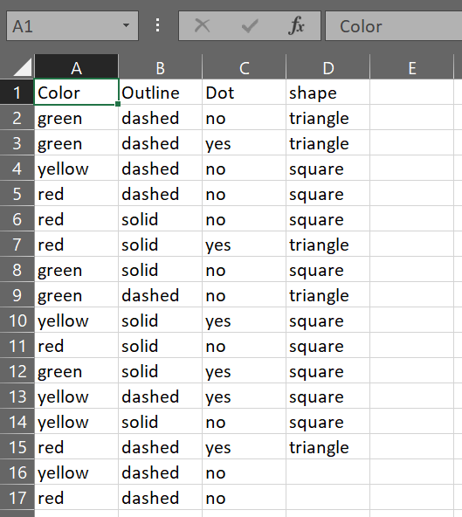
Figure 1: Dataset with 14 known rows and 2 rows to be predicted

2. Process
The process was built in RapidMiner using the following operators:
- Read CSV: loads the dataset file into RapidMiner.
- Set Role: sets the shape column as the label, so the model knows what to predict.
- Multiply: creates copies of the data so it can be sent to two different paths.
- Filter Examples: keeps only the 14 rows where shape is not missing. These rows are the training data.
- Random Forest: learns from the 14 known rows and builds the prediction model.
- Filter Examples (2): keeps only the 2 rows where shape is missing. These are the rows to be predicted.
- Apply Model: applies the trained Random Forest model to the 2 unknown rows and produces the predicted shape with confidence values.
- Write Excel: saves the predicted rows into an Excel file.
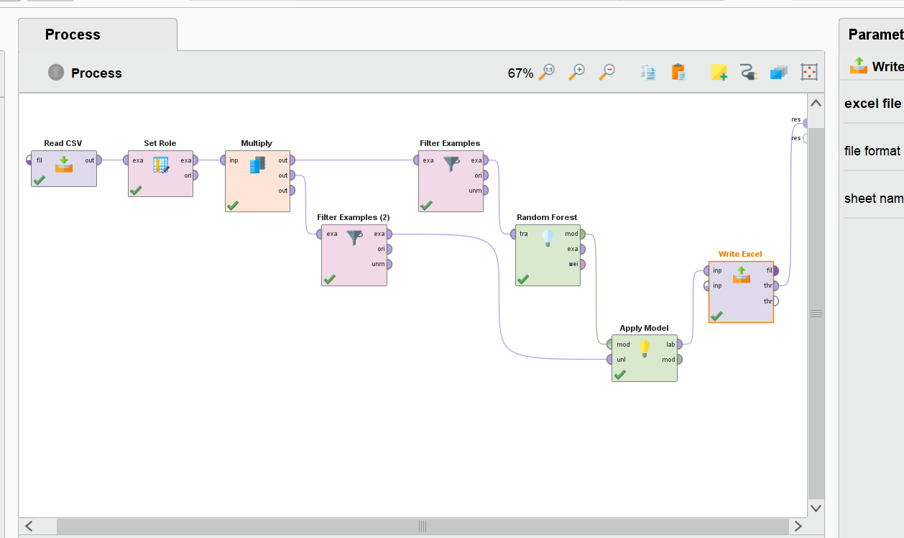
Figure 2: RapidMiner process

3. Result
After running the process, the Apply Model operator shows the predicted shape for both rows together with the confidence of the model for each class (triangle and square). The two confidence values of each row add up to 1.
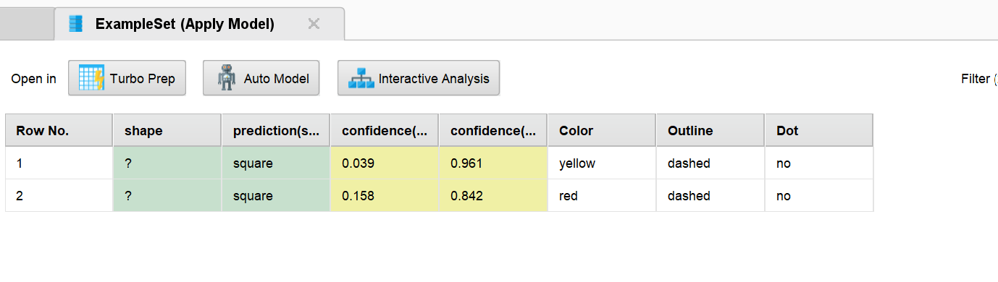
Figure 3: Prediction result in RapidMiner

4. Updated Excel Sheet
The predicted rows were written to an Excel file. The sheet contains the original attributes, the confidence values for both classes, and the predicted shape in the prediction(shape) column.
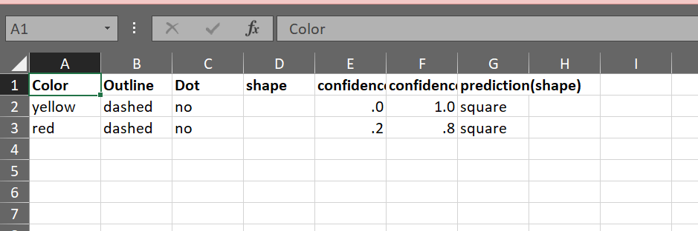
Figure 4: Excel sheet with predictions

5. Conclusion
The Random Forest model was trained on the 14 known rows and used to predict the shape of the 2 unknown rows. The model predicted a square for both rows:
- Row 1 (yellow, dashed, no): predicted shape is square, with a confidence of 96.1%.
- Row 2 (red, dashed, no): predicted shape is square, with a confidence of 84.2%.

