FINAL PROJECT REPORT
PULSEDB: BUILDING THE DATA ENGINE OF A MUSIC STREAMING SERVICE
Course Code: CMC331-L | Course Name: Database Management Systems
Institution: Iqra University (IU), Faculty of Engineering Sciences and Technology (FEST)
Project Development Team:
• M. Huzaifa Zuberi (ID: Iu05-0124-0254)
• Sheikh Uzair Ali (ID: Iu05-0124-0355)
• M Riaz Roshan (ID: Iu05-0124-0135)
• Syed Jawwad Haider (ID: Iu05-0124-0251)
SECTION 1: SYSTEM SPECIFICATION & SCHEMA DESIGN (CLO 1)
1.1 Objective and Scope
Section 1 fulfills CLO 1 by translating real-world streaming requirements into an optimized structural relational model. The database eliminates redundancy by adhering to third normal form (3NF) standards across user management, content directories, and telemetry tracking.
1.2 Entity-Relationship Diagram (ERD)
The system architecture details strong structural dependencies, capturing one-to-many configurations between artists and songs, alongside transaction logs bridging users and individual play streams.
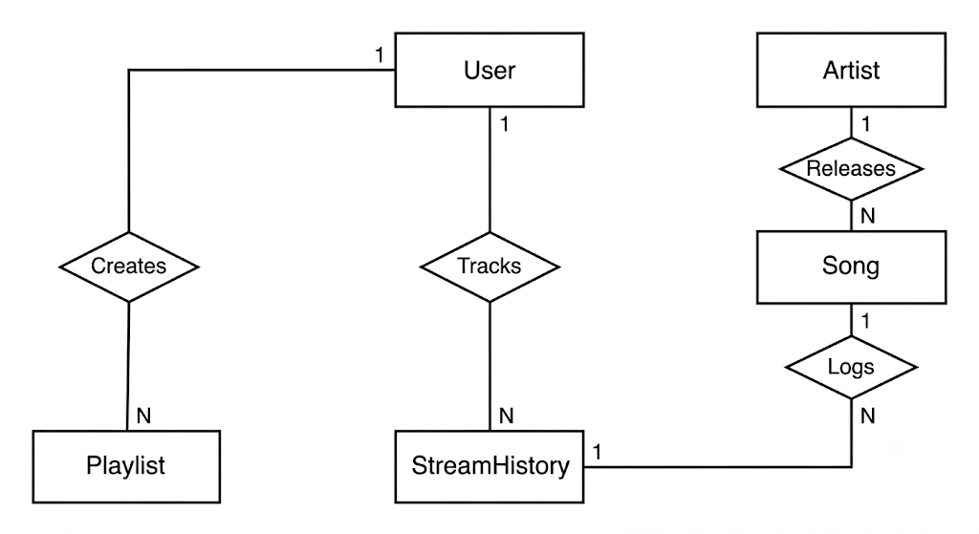

1.3 Logical Schema Definition
Below is the structural mapping of the tables detailing constraints, primary keys, and cross-reference identifiers:
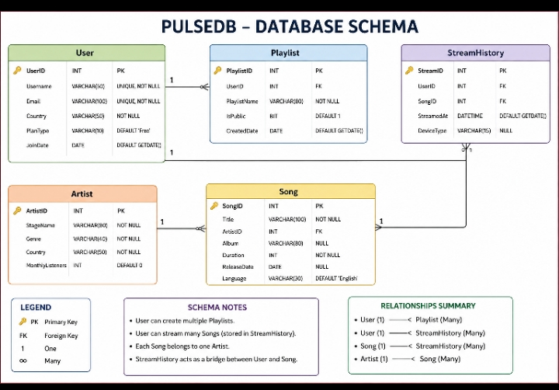

SECTION 2: APPLICATION INTERFACES & BACKEND VIEWS (CLO 2)
2.1 Reusable Modular Architecture
In accordance with CLO 2, production-grade complexity is isolated behind clean application interfaces using SQL Server Views. These views act as decoupled data contracts for frontend dashboards.
2.2 Implemented Core Views
- vw_TrendingSongs: Uses broad LEFT JOIN sequences to map global play counts, tracking low-performing assets alongside major viral hits.
- vw_ArtistDashboard: Synthesizes cross-table telemetry into single record lines providing total play counts and distinct asset indexing per artist entity.
- vw_PublicPlaylists: Joins user identification keys against playlist catalogs to populate localized search listings.
SECTION 3: SCRIPT EXECUTION & DATABASE VERIFICATION (CLO 3)
3.1 Script Verification Metrics
This section verifies compliance with CLO 3 (Database Implementation and Management). The database successfully provisions over 63 rows of interconnected data points across a centralized deployment transaction block.
3.2 Frontend & Application Simulation
The following section illustrates how the parsed data structures interact with active execution components or client interfaces:
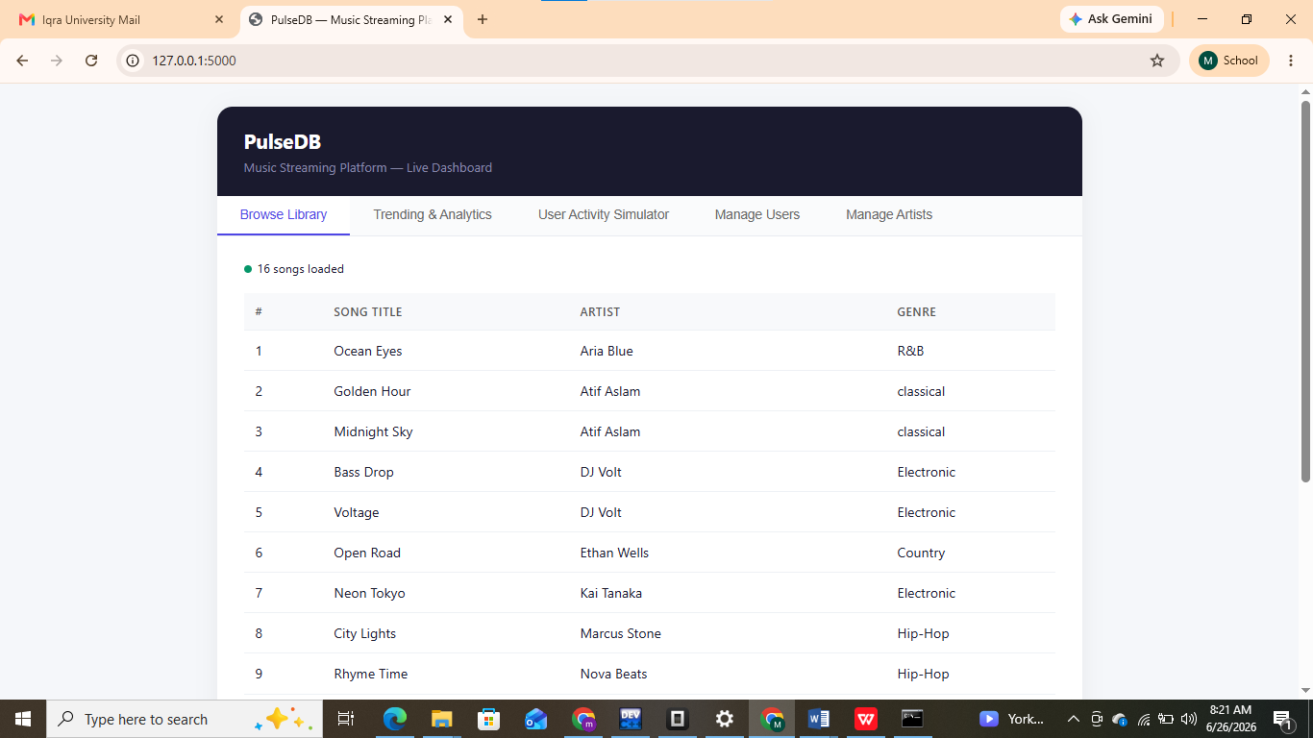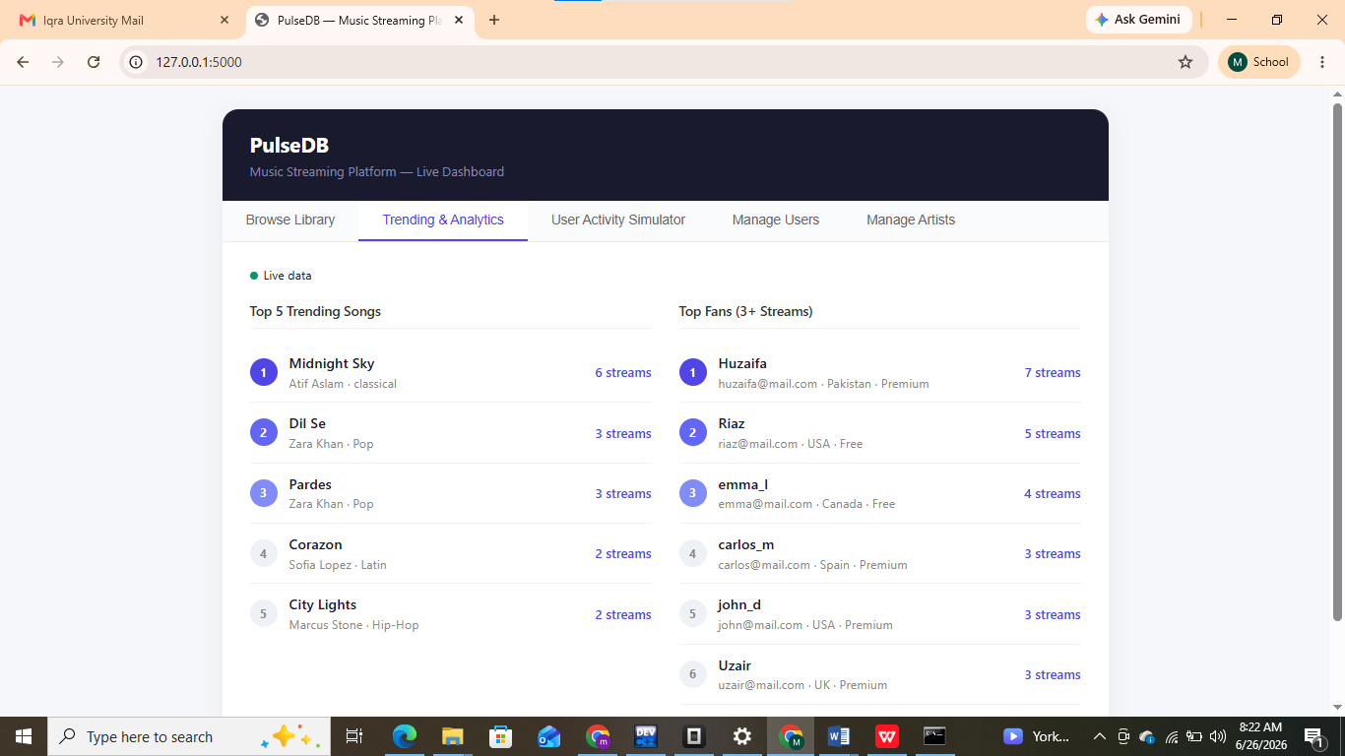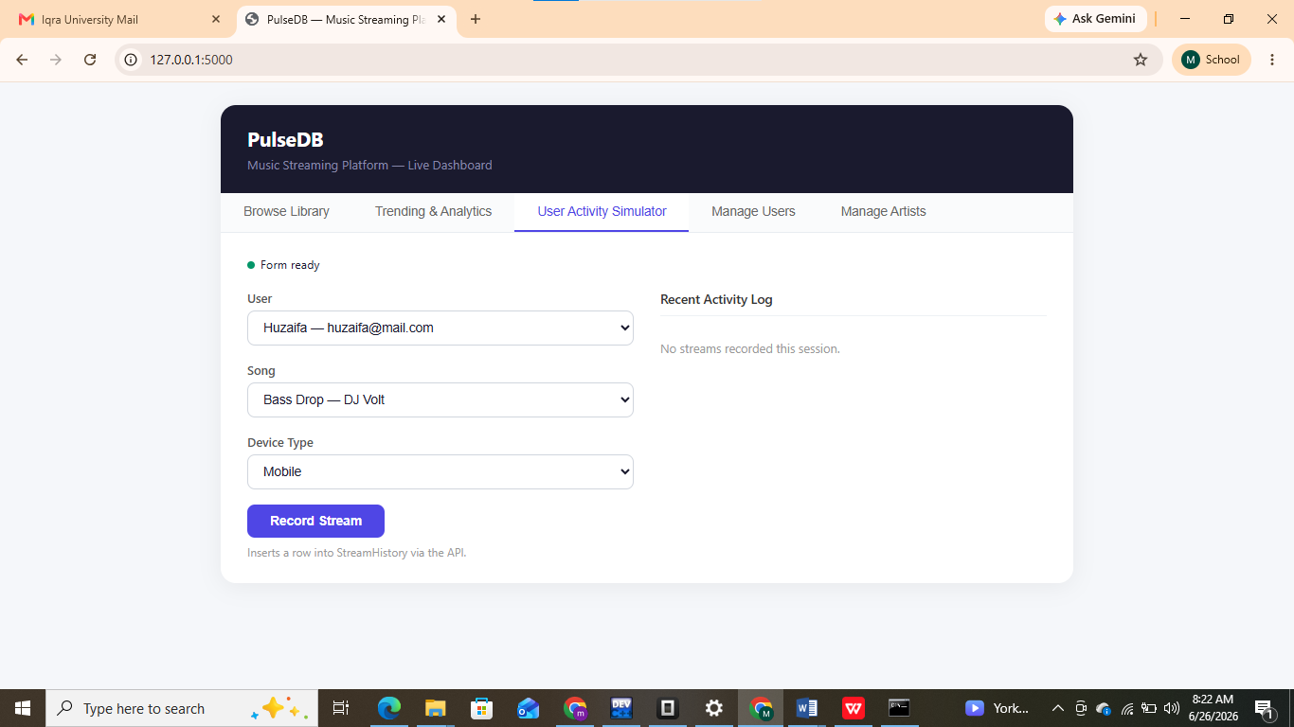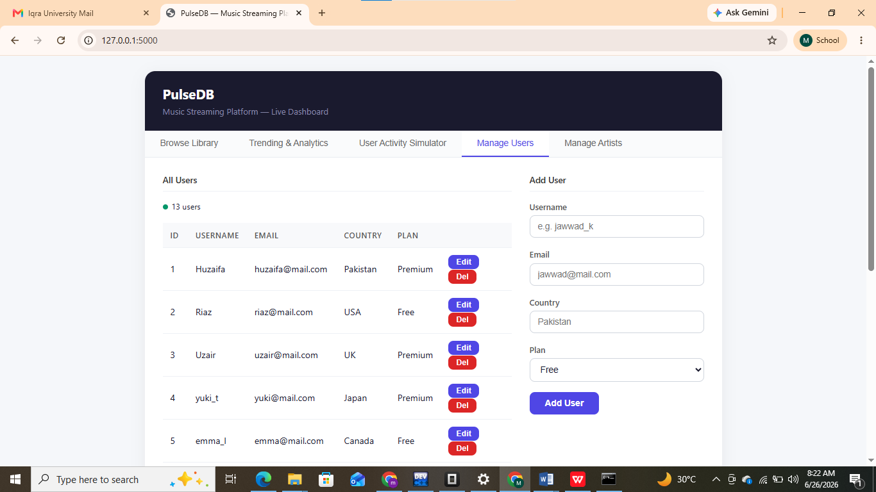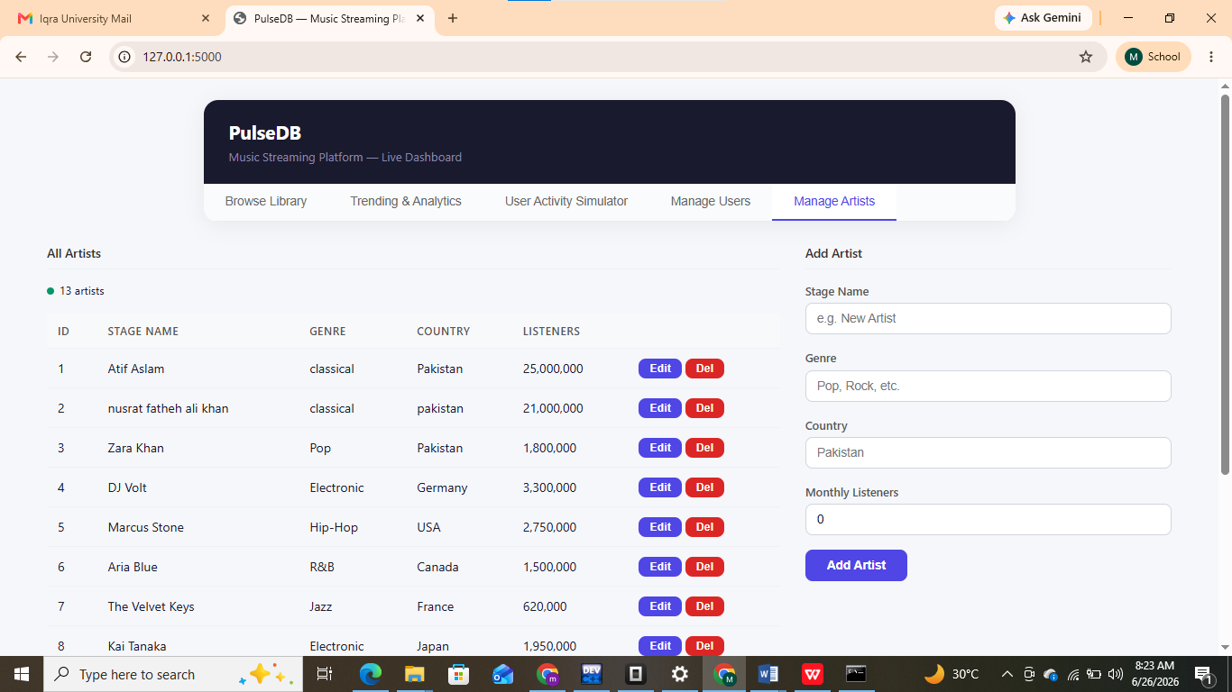

3.3 Database State & SSMS Execution Output
Below are the programmatic runtime verifications, showcasing compiling sequences inside SQL Server Management Studio (SSMS):
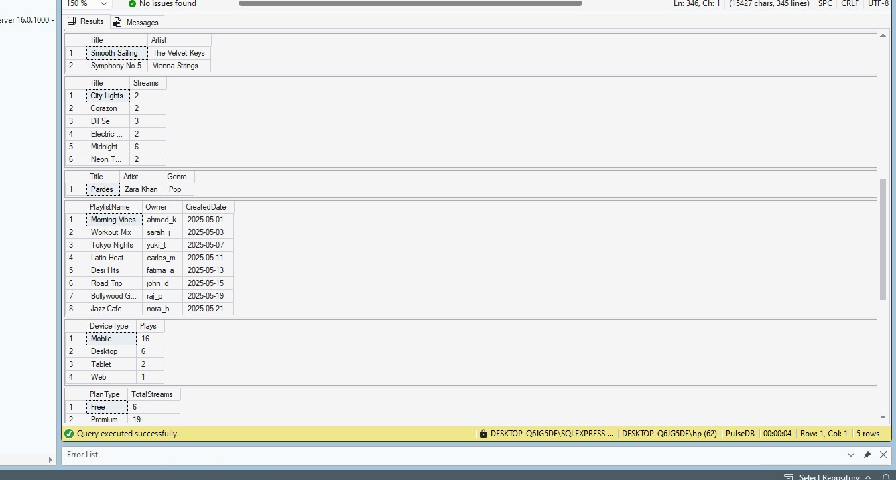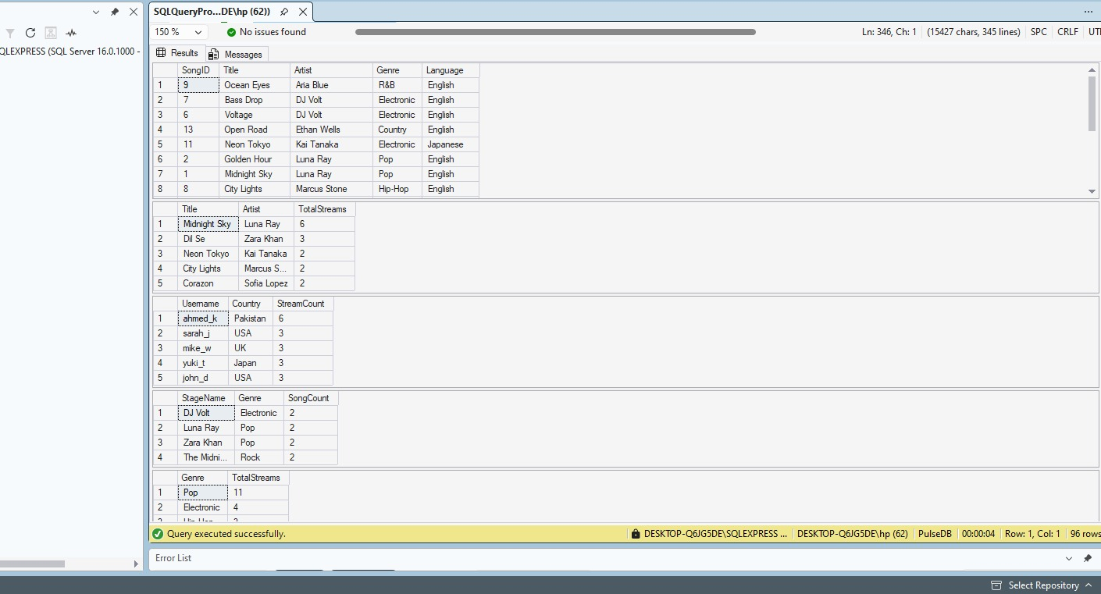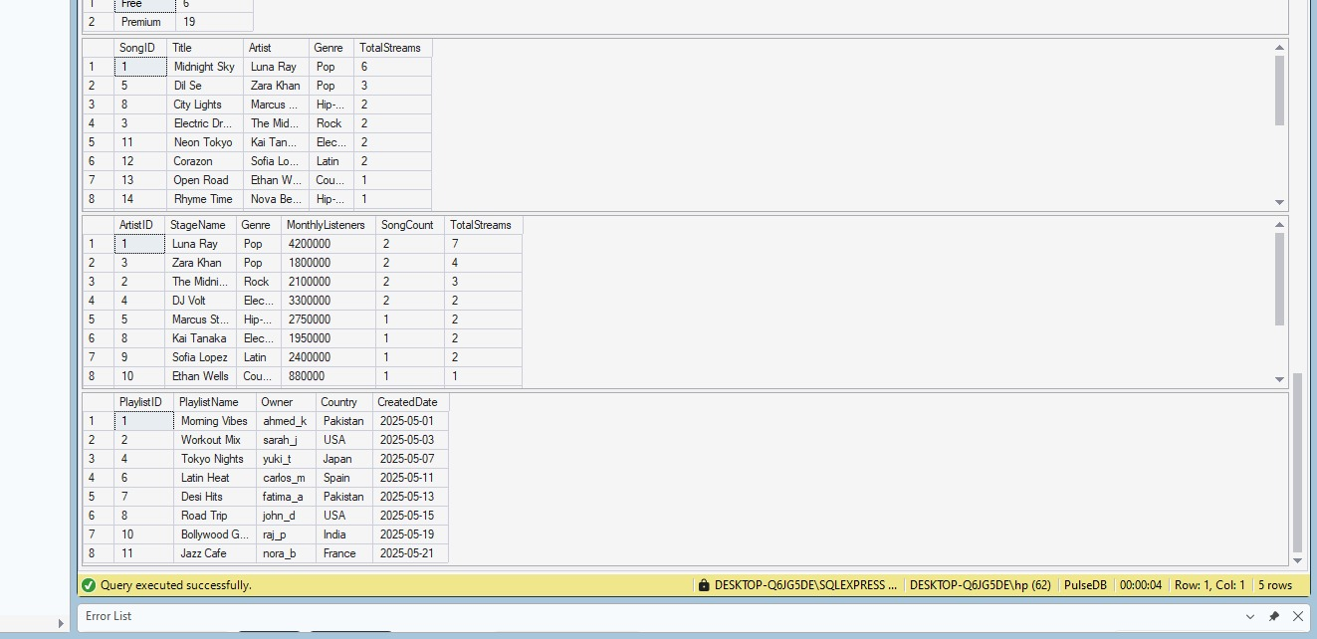

SECTION 4: CONCLUSION & LEARNING OUTCOMES
PulseDB demonstrates an end-to-end relational ecosystem mapping data tier components directly to explicit analytical needs. By executing normalization structures (CLO 1), deploying modular analytics views (CLO 2), and executing unified programmatic scripts (CLO 3), the project models real-world enterprise application workflows.

