PROJECT PROPOSAL
DESIGN AND IMPLEMENTATION OF PULSEDB:
THE RELATIONAL BACKEND FOR A MUSIC STREAMING PLATFORM
Course Name: Database Management Systems (CMC331)
Target RDBMS: Microsoft SQL Server
Development Tools: SQL Server Management Studio (SSMS), VS Code
Submitted By (Group Members):
1. M. Huzaifa Zuberi | Student ID: Iu05-0124-0254
2. Sheikh Uzair Ali | Student ID: Iu05-0124-0355
3. M Riaz Roshan | Student ID: Iu05-0124-0135
4. Syed Jawwad Haider | Student ID: Iu05-0124-0251
1. Introduction & Project Overview
PulseDB is a comprehensive relational database system engineered to model the core data architecture of a modern music streaming platform (reminiscent of services like Spotify). The primary objective of this project is to implement a unified, end-to-end SQL server script that handles schema definition, ensures data integrity, populates structural sample data, and extracts actionable business intelligence through complex feature queries and reusable database views.
2. Database Schema & Architecture (Course Alignment: CLO 1)
The schema is built around 5 core normalized tables to ensure data redundancy is minimized while maintaining operational velocity. The architecture utilizes strong Primary Key (PK) and Foreign Key (FK) constraints alongside custom CHECK and DEFAULT parameters.
- User Table: Manages subscriber profiles, subscription tiers, and geographic demographics.
- Artist Table: Tracks verified creators, genres, and monthly listener metrics.
- Songs Table: Houses individual track metadata, linking back to respective artists.
- Playlists Table: Stores community and curated user playlists.
- Streams/Interactions Table: High-volume transactional table logging user-to-song playback history.

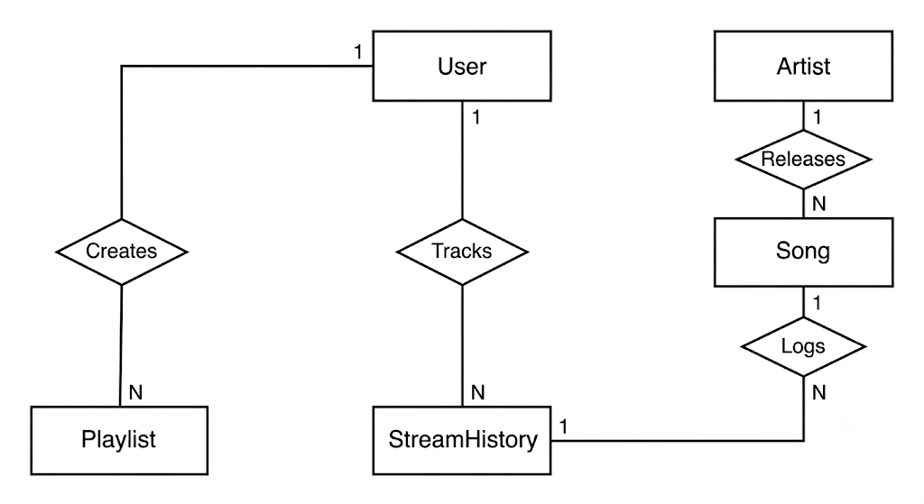

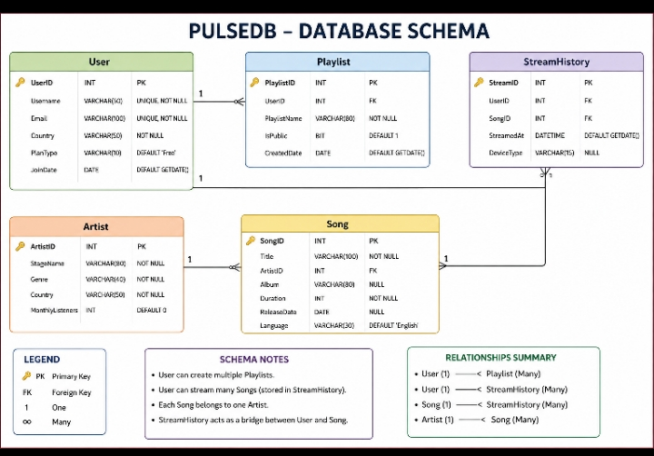

3. Feature Queries & Analytical Views (Course Alignment: CLO 2)
To simulate a live production application layer, the project implements 11 specialized feature queries and 3 reusable database views. These structures handle complex data operations, including:
- Multi-table LEFT/INNER JOIN mechanics.
- Aggregation handling (GROUP BY, HAVING) to discover power listeners and trending tracks.
- Subqueries to isolate hidden user behavior patterns.
Planned Production Views:
- vw_TrendingSongs: Leaderboard view tracking absolute streams across all catalog assets.
- vw_ArtistDashboard: Aggregated performance view tracking individual artist reach and catalogs.
- vw_PublicPlaylists: Community curation directory mapping playlist ownership across regional domains.
4. Implementation Plan & Expected Deliverables (Course Alignment: CLO 3)
- Unified SQL Execution Script: A single .sql file that cleanly executes drop/create tasks, inserts data records (63+ sample rows), and validates features seamlessly.
- Database Verification Matrix: Documentation proving operational accuracy of transactional behaviors, queries, and constraints inside SSMS.

