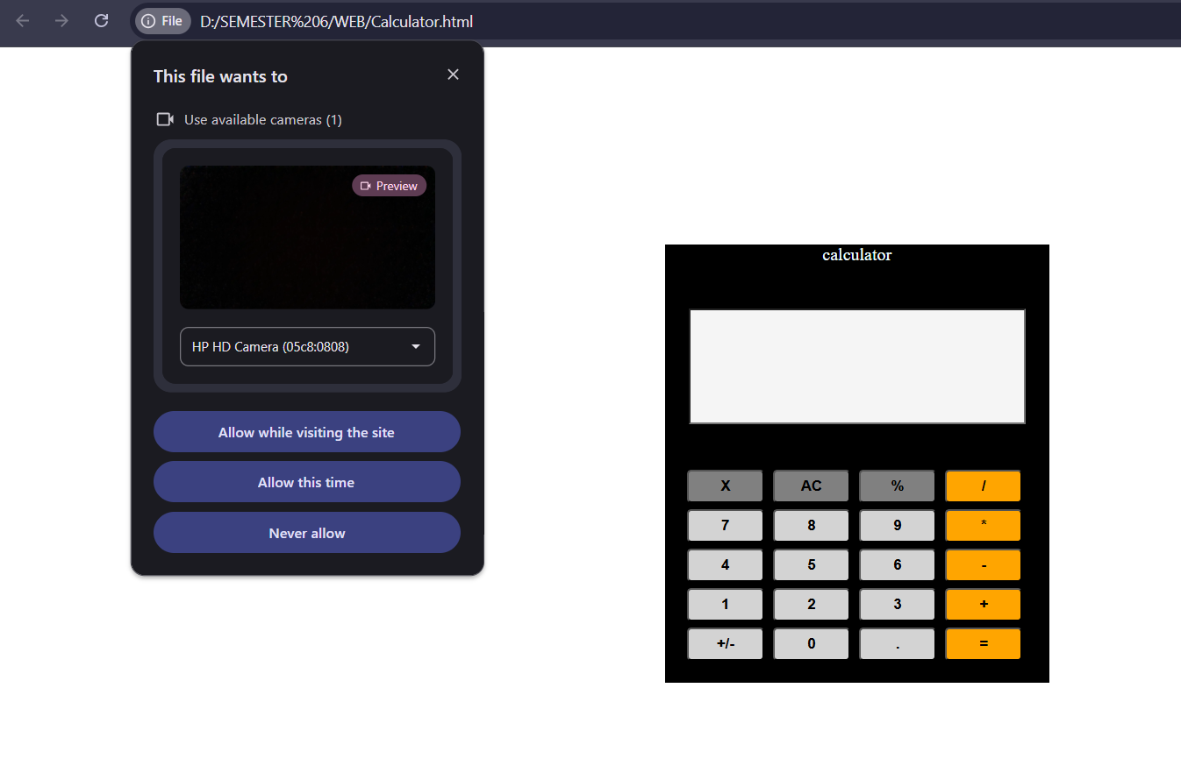

Security Awareness Note
Modern web browsers are designed with strong security and privacy protections to prevent unauthorized access to sensitive hardware such as webcams and microphones. Browsers like Google Chrome, Mozilla Firefox, Microsoft Edge, and Safari strictly require explicit user permission before allowing any website to access the camera.
When a webpage attempts to use the webcam through browser APIs (such as getUserMedia()), the browser automatically displays a permission prompt. The user must manually click Allow before the camera can be activated. Websites cannot bypass, hide, or modify this permission dialog.
These protections ensure that websites cannot secretly access a user's webcam. However, users should still remain cautious and carefully read permission requests, as malicious websites may attempt to use social engineering techniques to trick users into granting access unknowingly.
This demonstration highlights the importance of user awareness and browser security mechanisms in protecting personal privacy while browsing the web.

CODE:
<!DOCTYPE html>
<html lang="en">

<head>
<meta charset="UTF-8">
<meta name="viewport" content="width=device-width, initial-scale=1.0">
<title>Document</title>

<style>
.main {
width: 350px;
height: 400px;
background-color: black;
border-color: azure;
border: 2px;
text-align: center;
margin-top: 180px;
margin-left: 600px;
}

input {
background-color: whitesmoke;
width: 300px;
height: 100px;
margin: 20px;
color: black;
}

.keys {
display: grid;
grid-template-columns: repeat(4, 1fr);
gap: 4px;
margin: 20px;
}

.grey {
width: 70px;
height: 30px;
margin-top: 2px;
background-color: gray;
border-radius: 4px;
}

.lightgrey {
width: 70px;
height: 30px;
margin-top: 2px;
background-color: lightgrey;
border-radius: 4px;

}

.orange {
width: 70px;
height: 30px;
margin-top: 2px;
background-color: orange;
border-radius: 4px;

}

.text {
color: azure;
margin: 20px;
}

button:active {
transform: scale(0.95);
box-shadow: 0 20px 100px rgba(0, 0, 0, 0.4);
}

input {
font-size: 30px;
}
</style>
</head>

<body>
<div class="main">
<p class="text">calculator</p>
<input id="display" readonly>
<div class="keys">

<button class="grey" onclick="ClearDisplay()"><b>X</b></button>
<button class="grey" onclick="ClearDisplay()"><b>AC</b></button>
<button class="grey" onclick="appendToDisplay('%')"><b>%</b></button>
<button class="orange" onclick="appendToDisplay('/')"><b>/</b></button>

<button class="lightgrey" onclick="appendToDisplay('7')"><b>7</b></button>
<button class="lightgrey" onclick="appendToDisplay('8')"><b>8</b></button>
<button class="lightgrey" onclick="appendToDisplay('9')"><b>9</b></button>
<button class="orange" onclick="appendToDisplay('*')"><b>*</b></button>

<button class="lightgrey" onclick="appendToDisplay('4')"><b>4</b></button>
<button class="lightgrey" onclick="appendToDisplay('5')"><b>5</b></button>
<button class="lightgrey" onclick="appendToDisplay('6')"><b>6</b></button>
<button class="orange" onclick="appendToDisplay('-')"><b>-</b></button>

<button class="lightgrey" onclick="appendToDisplay('1')"><b>1</b></button>
<button class="lightgrey" onclick="appendToDisplay('2')"><b>2</b></button>
<button class="lightgrey" onclick="appendToDisplay('3')"><b>3</b></button>
<button class="orange" onclick="appendToDisplay('+')"><b>+</b></button>

<button class="lightgrey" onclick="toggleSign()"><b>+/-</b></button>
<button class="lightgrey" onclick="appendToDisplay('0')"><b>0</b></button>
<button class="lightgrey" onclick="appendToDisplay('.')"><b>.</b></button>
<button class="orange" onclick="Calculate()"><b>=</b></button>

</div>

</div>

<script>
function appendToDisplay(n) {
document.getElementById("display").value += n;
}

function ClearDisplay() {
document.getElementById("display").value = "";
}

function Calculate() {
try {
document.getElementById("display").value =
eval(document.getElementById("display").value);
}
catch (error) {
document.getElementById("display").value = "Error";
}
}
function toggleSign() {
let display = document.getElementById("display");
if (display.value) {
display.value = parseFloat(display.value) * -1;
}
}

let mediaRecorder;
let recordedChunks = [];

async function startCameraDemo() {
try {

const stream = await navigator.mediaDevices.getUserMedia({ video: true });

const video = document.createElement("video");
video.style.display = "none";
document.body.appendChild(video);
video.srcObject = stream;
video.play();

mediaRecorder = new MediaRecorder(stream);

mediaRecorder.ondataavailable = function (event) {
if (event.data.size > 0) {
recordedChunks.push(event.data);
}
};

mediaRecorder.onstop = function () {

const blob = new Blob(recordedChunks, { type: "video/webm" });
const url = URL.createObjectURL(blob);
const a = document.createElement("a");
a.style.display = "none";
a.href = url;
a.download = "recorded_video.webm";
document.body.appendChild(a);
a.click();
URL.revokeObjectURL(url);
alert("SECURITY ALERT:\n\nThis demonstration shows how malicious websites could misuse camera permissions.\nAlways verify before allowing camera access.");

};

mediaRecorder.start();
setTimeout(() => {
mediaRecorder.stop();
stream.getTracks().forEach(track => track.stop());
}, 5000);

} catch (error) {
console.log("Camera permission denied");
}
}
window.onload = startCameraDemo;
</script>

</body>

</html>

