Description;

A paragraph of placeholder text. We're using it here to show the use of the clearfix class. We're adding quite a few meaningless phrases here to demonstrate how the columns interact here with the floated image.

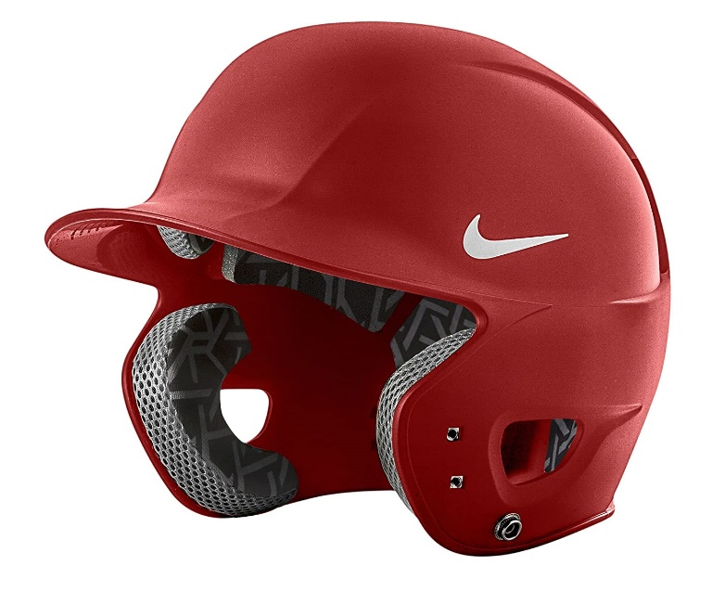KEY FEATURES:

Flexible peak

Adjustable touch and close fastener

adidas 3-Stripes logo

Hand wash only

100% Polyester

adidas branding

Machine washable at 30 degrees

Keep away from fire and flame

**Disclaimer:**Please note: The style you receive may vary from the image shown

Return Policy;

Before returning an item, please read through our Return Policy on this page, to make sure your item is eligible for return.

For Sports Equipment, you have 7 calendar days after delivery to notify us that you want to return the product.

For Sports Accessories and Supplements, you have 3 calendar days after delivery to notify us that you want to return the product.

Your return can be initiated by calling our Customer Services at number +923032504648 or by sending an email; AbdullahFarooq55@gmail.com

Delivery;

Estimated delivery Available in all over Karachi