Name --> Muhammad Huzaifa
Roll No --> 04

Assignment 4
13th August 2023
Module 2 : Front End Development
Submission Requirements: Please upload your codes in PDF File on Google Classroom in the relevant Assignment section.
Note: Plagiarism is a serious violation. Zero marks will be awarded in case plagiarism is found. You are required to perform the following tasks.

Part 1:
- Create a header that sticks to the top of the page even when scrolling.
Solution:
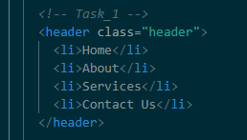
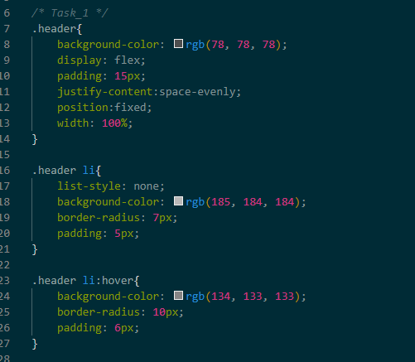
- Design a navigation menu with a fixed position on the left side of the viewport.
Solution:
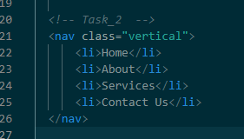
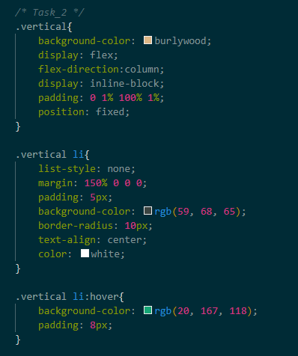
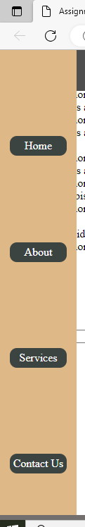
- Build a modal that appears in the center of the screen with a semi-transparent background overlay.
Solution:

- Implement a footer that sticks to the bottom of the page, regardless of content height.
Solution:
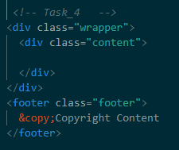
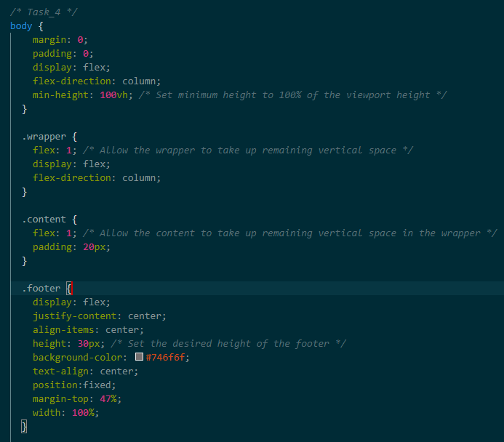

- Create an overlapping card layout where cards stack on top of each other using different z-index values.
Solution:
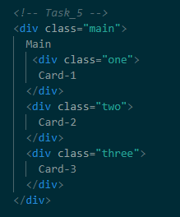
.main{
display: block;
border: 5px solid rgb(12, 11, 11);
width: 400px;
height: 400px;
color: rgb(4, 8, 4);
text-align: center;
}

.one{
display: block;
background-color: rgb(219, 181, 134);
width: 300px;
height: 300px;
margin: 10px 0 0 10px;
position: absolute;
z-index: 1;
}

.two{
display: block;
background-color: rgb(127, 87, 151);
width: 200px;
height: 200px;
margin: 30px 0 0 30px;
position: absolute;
z-index: 2;
}

.three{
display: block;
background-color: rgb(98, 163, 172);
width: 100px;
height: 100px;
margin: 50px 0 0 50px;
position: absolute;
z-index: 3;
}

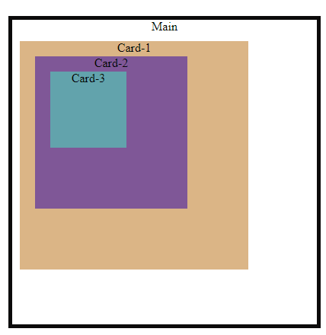

- Design a menu that appears above other content using a higher z-index value.
Solution:

- Create an element with 3 layered images and change their z dimension.
Solution:

- Style all the links within a specific div with a unique background color.
Solution:
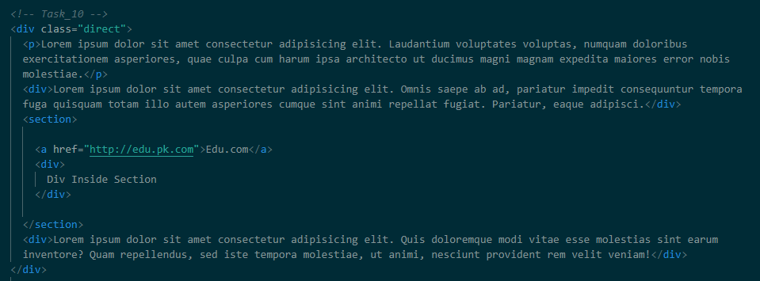
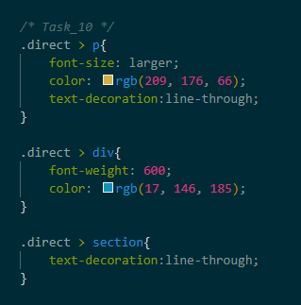
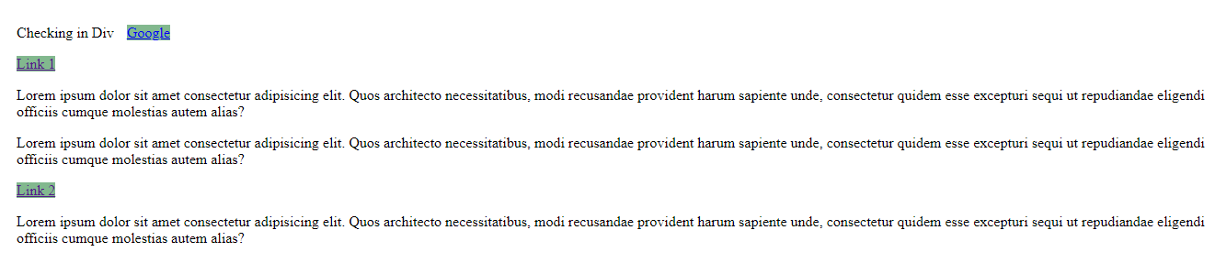

- Select and style the first child element of a certain class differently from the rest.
Solution:

- Apply styles to elements that are direct descendants of a specific parent element.
Solution:
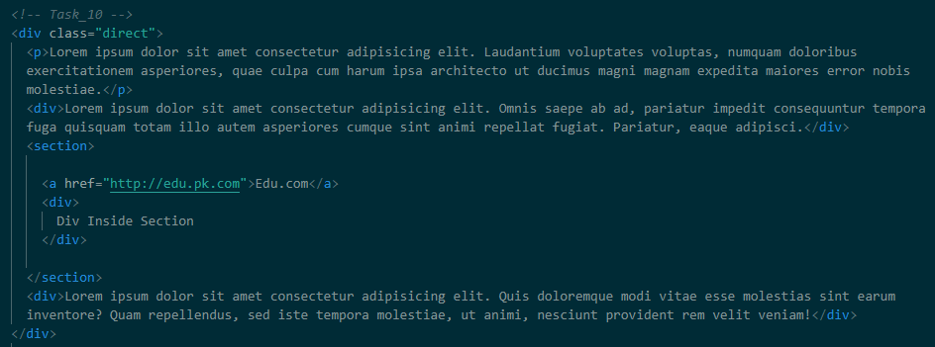
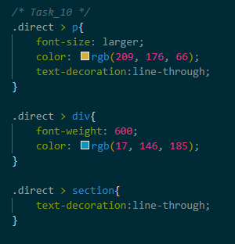
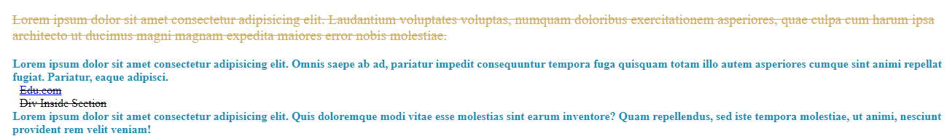
- Create a button that changes color when hovered over using a pseudo-class selector.
Solution:
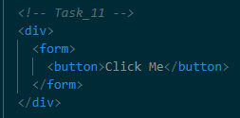
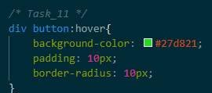
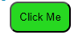

- Style only the last item in a list differently using the last-child pseudo-class.
Solution:
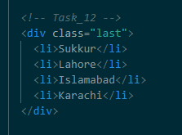
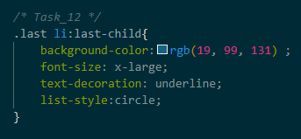
- Implement a form with input fields that change border color when they are focused.
Solution:
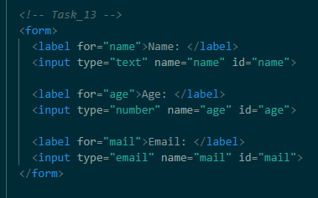
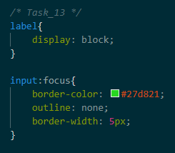
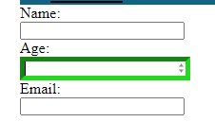

- Add custom icons before specific links in a navigation menu using pseudo-elements.
Solution:

- Create a quotation design where the opening and closing quotes are styled using pseudo-elements.
Solution:

- Design a callout box with a unique background color and pointer using pseudo-elements.
Solution:

- Design a responsive header using flexbox that aligns items horizontally and vertically.
Solution:

- Build a three-column layout where the middle column expands to fill remaining space using flexbox.
Solution:

- Create a flexible grid of cards that rearranges based on screen size using flexbox.
Solution:

- Implement a sidebar with a fixed width and a content area that adjusts using flexbox.
Solution:

Part 2:
- Implement all properties for flex container (Mentioned in flex.css)
Solution:
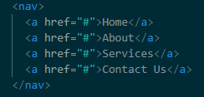 (Common)
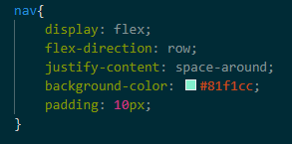
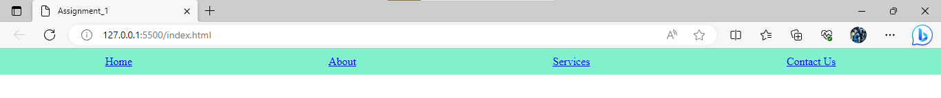
<------------------------------------------------------------->
nav{
display: flex;
flex-direction: row;
justify-content: space-between;
background-color: #81f1cc;
padding: 10px;
}
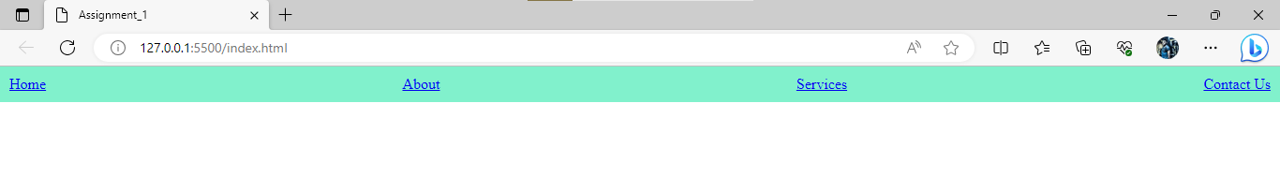
<------------------------------------------------------------->

nav{
display: flex;
flex-direction: row;
justify-content:space-evenly;
background-color: #81f1cc;
padding: 10px;
}

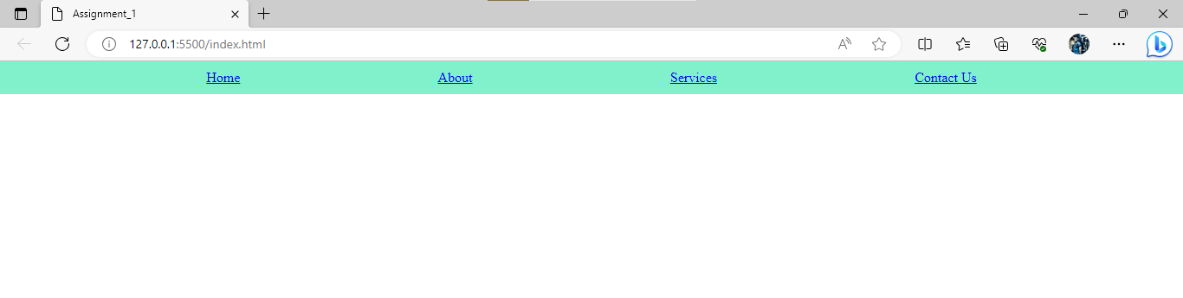
<------------------------------------------------------------->

nav{
display: flex;
flex-direction: column;
justify-content:space-evenly;
background-color: #81f1cc;
width: fit-content;
}

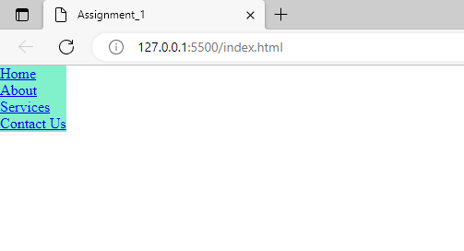
<------------------------------------------------------------->

nav{
display: flex;
flex-direction:column-reverse;
justify-content:space-evenly;
background-color: #81f1cc;
padding: 10px;
}

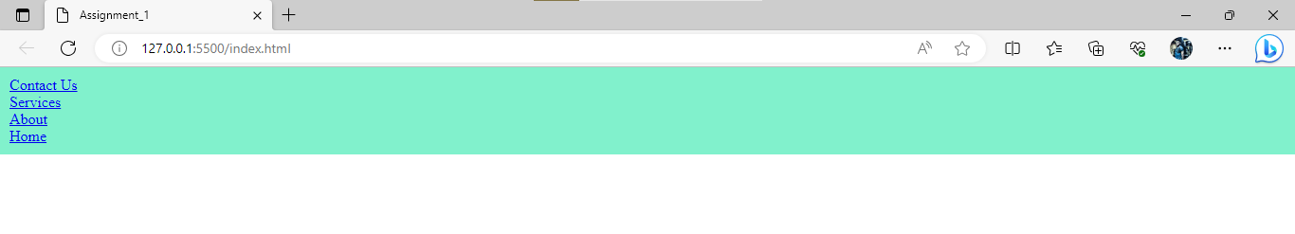

<------------------------------------------------------------->

nav{
display: flex;
flex-direction: row-reverse;
justify-content:space-evenly;
background-color: #81f1cc;
padding: 10px;
}

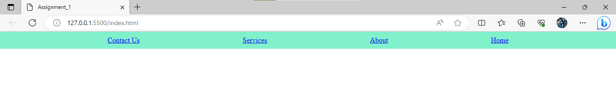
<------------------------------------------------------------->

nav{
display: flex;
flex-direction: row-reverse;
justify-content:left;
background-color: #81f1cc;
padding: 10px;
}

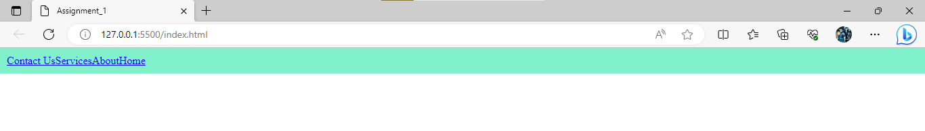
<------------------------------------------------------------->

nav{
display: flex;
flex-direction: row-reverse;
justify-content:left;
background-color: #81f1cc;
padding: 10px;
}

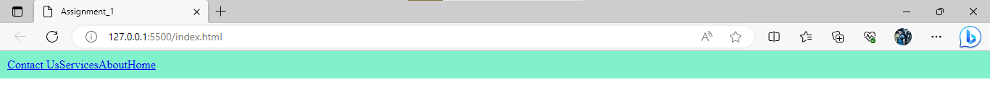

<------------------------------------------------------------->

nav{
display: flex;
flex-direction: row-reverse;
justify-content:flex-start;
background-color: #81f1cc;
padding: 10px;
}

<------------------------------------------------------------->

nav{
display: flex;
flex-direction: row;
justify-content:flex-start;
background-color: #81f1cc;
padding: 10px;
}

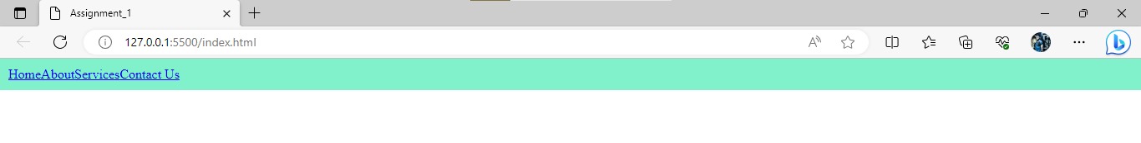

<------------------------------------------------------------->

nav{
display: flex;
flex-direction: column-reverse;
justify-content:flex-start;
background-color: #81f1cc;
padding: 10px;
}

