***Report Of Obstacle Avoiding Car***

**Team Members Name and Sap id;**

Name: Syed Huzaifa Ahmed (021000066394)

Name: Sara Khalid (021000065053)

Name: Muhammad Zain Ehtasham (021000066397)

Name: Muskan (021000063692)

Name: Muhammad Saqib Khan (021000063649)

Name: Azeefah Shoaib (021000063783)

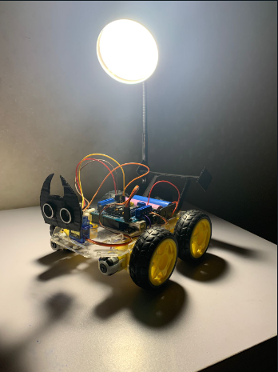

1. **Introduction**

The obstacle-avoiding car is an autonomous vehicle designed to operate in environments where obstacles might hinder its path. The primary goal is to develop a system that can identify obstacles in real-time and make intelligent decisions to avoid collisions.

2. **Methodology**

***Hardware***: The car is equipped with sensors, microcontrollers, motors, and wheels. Ultrasonic sensors are placed strategically to detect obstacles in the car's path.

***Software***: The software consists of two main components: obstacle detection and decision-making. The obstacle detection algorithm processes sensor data to identify obstacles' distance and direction. The decision-making algorithm uses this data to determine the appropriate action (turning, stopping, or continuing).

3. **Components**

Microcontroller: A Raspberry Pi is used as the brain of the car, processing sensor data and making decisions.

***Sensors***: Ultrasonic sensors (HC-SR04) are mounted on the front, left, and right sides of the car to measure distances to obstacles.

***Motors and Wheels***: The car is equipped with DC motors and wheels for movement. Motor control is integrated with the decision-making algorithm.

***Power Source***: A rechargeable battery provides power to the car and Raspberry Pi.

4. **Software Implementation**

***Obstacle Detection***: The Raspberry Pi reads data from ultrasonic sensors to calculate distances to obstacles. This data is used to create a real-time obstacle map around the car.

***Decision Making***: Based on the obstacle map, the decision-making algorithm determines the optimal action. If an obstacle is detected directly ahead, the car will stop. If obstacles are detected on the sides, the car will turn in the opposite direction.

5. **Testing**

***Obstacle Detection Test***: Obstacles of various sizes and shapes are placed in the car's path to assess the accuracy and reliability of the obstacle detection system.

***Obstacle Avoidance Test***: The car is placed in a controlled environment with obstacles. The performance of the decision-making algorithm is evaluated by observing the car's ability to navigate without collisions.

6. **Results**

The obstacle detection system performs accurately, reliably identifying obstacles within its sensor range.

The decision-making algorithm effectively guides the car to avoid obstacles by stopping or changing direction.

The car successfully navigates through complex environments, mitigating collisions with stationary obstacles.

7. **Conclusion**

The obstacle-avoiding car project demonstrates the successful integration of hardware and software components to create an autonomous vehicle capable of navigating through environments while avoiding obstacles. The accurate obstacle detection and effective decision-making algorithms are key to the car's reliable performance.