**Assignment 2: Database Operations**

**Submitted to:** Amad Mumtaz  
**Submitted by:** Huzaifa Munir  
**Dated:** 31st October 2024

**Task:**

* Prepare a database table for all the products listed under the demo tricentis application. There are around 70 items. You can use insert queries to insert values in database.
  + Table columns may include: id/ productName/ category/ price/ quantity
* Create a table for registered users.
  + Table columns can include columns like id/ email/ password/ isActive/ environment

**Tricentis Application:**Link: <https://demowebshop.tricentis.com/>

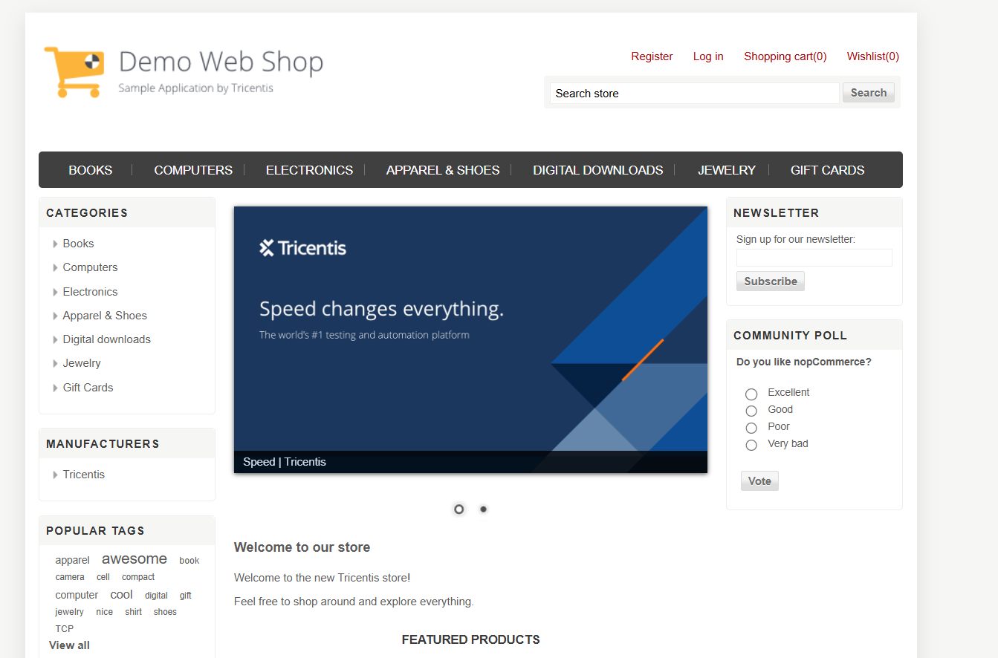

**Database Operations:**

1. **All Products t=Table:**

* Open the SQLite command line interface from this directory C:\ProgramFiles\SQLite by running it as administrator.

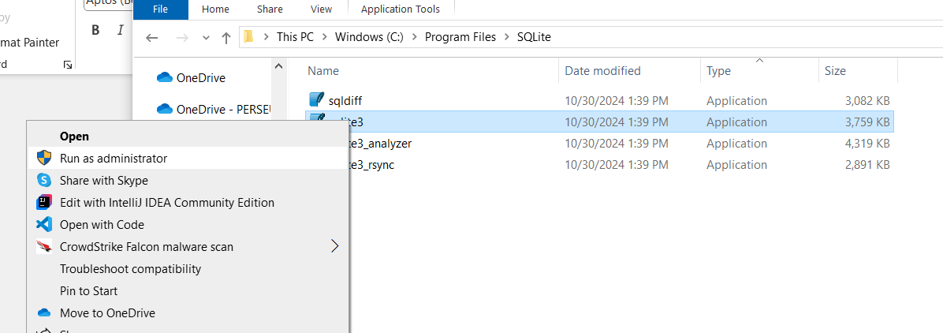

* Once open, now we will create a database table from the SQLite CLI at such a location which is easily accessible for the administrator.
* Now go that directory and create a table named products or items with the following command:   
  .open C:/Users/munirhuz/Desktop/products.db  
  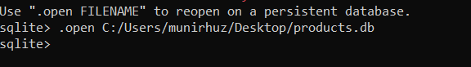
* After this, create a table in the format mentioned in the task’s problem statement and instructions with the following command:  
  CREATE TABLE products (id INTEGER PRIMARY KEY AUTOINCREMENT, productName TEXT NOT NULL, category TEXT NOT NULL, price REAL NOT NULL, quantity INTEGER NOT NULL);  
  
* As you see above, I forgot to write the semicolon at the end of the query which resulted in an error shown on the CLI.
* Then in the next step I checked id the table was created or not with the “.tables” command. And as a precaution I ran the following command to drop any tables if they existed before with this command:   
  DROP TABLE IF EXISTS products;
* Then run the CREATE TABLE products command again. Now, it will run. You can verify it by running the “.tables” command again.
* Now, we start the insertions in this table.

**Insertion Queries:**

* **Books:**

Enter the following the commands.

INSERT INTO products (productName, category, price, quantity) VALUES ('Computing and Internet', 'General', 30.0, 10);

INSERT INTO products (productName, category, price, quantity) VALUES ('Copy of Computing & Internet EX', 'General', 30.0, 20);

INSERT INTO products (productName, category, price, quantity) VALUES ('Fiction', 'General', 35.0, 30);

INSERT INTO products (productName, category, price, quantity) VALUES ('Fiction EX', 'General', 35.0,20);

INSERT INTO products (productName, category, price, quantity) VALUES ('Health Book', 'General', 27.0,10);

INSERT INTO products (productName, category, price, quantity) VALUES ('Science', 'General', 67.0,40)



Now, check if all the entries were entered correctly with this query:  
SELECT * FROM products WHERE category = 'General';

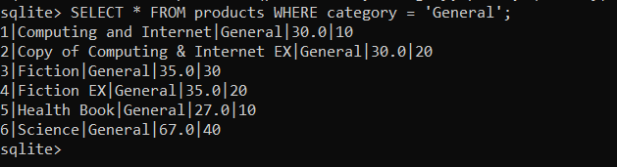

Now, I am thinking to change the category of the above queries because general won’t really define what a product is. So, I am changing it to ‘Books’.

UPDATE products SET category = 'Books' WHERE category = 'General';

SELECT * FROM products WHERE category = 'Bo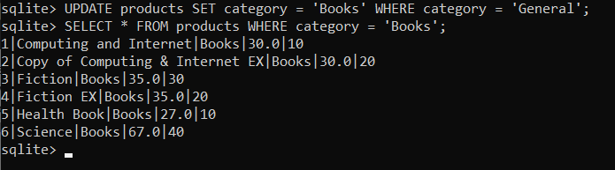

* **Computers:**

The computers category has following categories in it:

**Desktops:**

INSERT INTO products (productName, category, price, quantity) VALUES ('Build your own cheap computer', 'Desktops', 800.0,10);

INSERT INTO products (productName, category, price, quantity) VALUES ('Build your own computer', 'Desktops', 1200.0,20);

INSERT INTO products (productName, category, price, quantity) VALUES ('Build your own expensive computer', 'Desktops', 1800.0,30);

INSERT INTO products (productName, category, price, quantity) VALUES ('Desktop PC with CDRW', 'Desktops', 500.0,10);

INSERT INTO products (productName, category, price, quantity) VALUES ('Elite Desktop PC', 'Desktops', 1350.0,10);

INSERT INTO products (productName, category, price, quantity) VALUES ('Simple Computer', 'Desktops', 800.0,20);

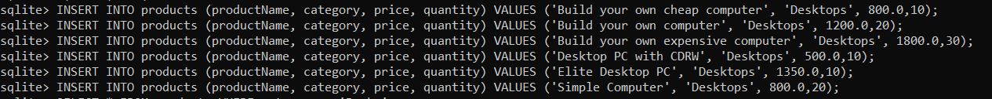

Now, let’s verify if they have been properly interested.

SELECT * FROM products WHERE category = 'Desktops';

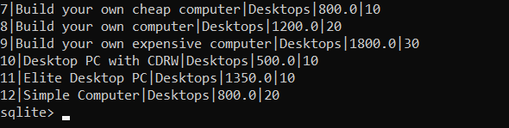

**Notebooks:**

Now, type the following commands to insert notebook products:

INSERT INTO products (productName, category, price, quantity) VALUES ('14.1-inch Laptop', 'Notebooks', 1590.0, 10);

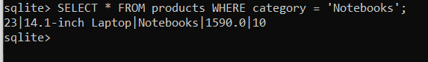

**Accessories:**

INSERT INTO products (productName, category, price, quantity) VALUES ('TCP Coaching day', 'Accessories', 1000.0, 10);

INSERT INTO products (productName, category, price, quantity) VALUES ('TCP Instructor Led Training', 'Accessories', 9000.0, 10);

INSERT INTO products (productName, category, price, quantity) VALUES ('TCP Public Complete', 'Accessories', 3000.0, 10);

INSERT INTO products (productName, category, price, quantity) VALUES ('TCP Public MT/AT', 'Accessories', 1700.0, 10);

INSERT INTO products (productName, category, price, quantity) VALUES ('TCP Public RPA/TCD', 'Accessories', 1700.0, 30);

INSERT INTO products (productName, category, price, quantity) VALUES ('TCP Self-Paced Training', 'Accessories', 400.0, 20);

INSERT INTO products (productName, category, price, quantity) VALUES ('TCP Self-Paced Training additional month', 'Accessories', 400.0, 40);

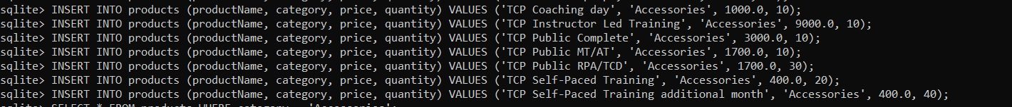

Now, let’s verify:

SELECT * FROM products WHERE category = 'Accessories';

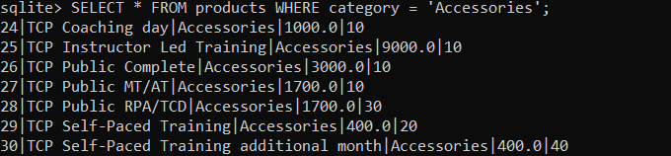

* **Electronics:**

**Camera-Photo:**

INSERT INTO products (productName, category, price, quantity) VALUES ('1MP 60GB Hard Drive Handycam Camcorder', 'Camera-photo', 349.0, 20);

INSERT INTO products (productName, category, price, quantity) VALUES ('Camcorder', 'Camera-photo', 530.0, 10);

INSERT INTO products (productName, category, price, quantity) VALUES ('Digital SLR Camera 12.2 Mpixel', 'Camera-photo', 500.0, 30);

INSERT INTO products (productName, category, price, quantity) VALUES ('High Definition 3D Camcorder', 'Camera-photo', 1300.0, 10);



Now, let’s verify:

SELECT * FROM products WHERE category = ‘Camera-photo'';

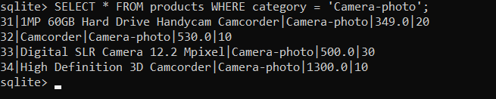

**Cell-Phones:**

INSERT INTO products (productName, category, price, quantity) VALUES ('Smartphone', 'Cell-phones', 100.0, 40);

INSERT INTO products (productName, category, price, quantity) VALUES ('Used phone', 'Cell-phones', 5.0, 10);

INSERT INTO products (productName, category, price, quantity) VALUES ('Phone Cover', 'Cell-phones', 10.0, 20);



Now, let’s verify:

SELECT * FROM products WHERE category = ‘Cell-phones'';

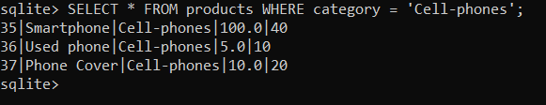

* **Apparel & Shoes:**

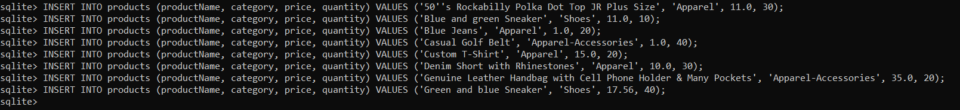

When entering the first query with the name “50’s Rockabilly Polka Dot” I got the error:

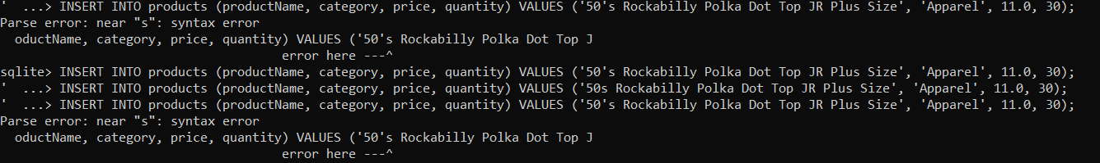

To resolve this issue, look at the query under apparel. Just use 2 apostrophes’ instead of one with 50 like this: 50’’s. The error occurs because SQLite interprets the single quote (') in "50's" as the end of the string, causing a syntax issue.

**Apparel:**

INSERT INTO products (productName, category, price, quantity) VALUES ('50''s Rockabilly Polka Dot Top JR Plus Size', 'Apparel', 11.0, 30);

INSERT INTO products (productName, category, price, quantity) VALUES ('Blue Jeans', 'Apparel', 1.0, 20);

INSERT INTO products (productName, category, price, quantity) VALUES ('Custom T-Shirt', 'Apparel', 15.0, 20);

INSERT INTO products (productName, category, price, quantity) VALUES ('Denim Short with Rhinestones', 'Apparel', 10.0, 30);

Now, let’s verify:

SELECT * FROM products WHERE category = ‘Apparel’;

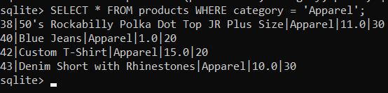

**Apparel-Accessories:**

INSERT INTO products (productName, category, price, quantity) VALUES ('Casual Golf Belt', 'Apparel-Accessories', 1.0, 40);

INSERT INTO products (productName, category, price, quantity) VALUES ('Genuine Leather Handbag with Cell Phone Holder & Many Pockets', 'Apparel-Accessories', 35.0, 20);

Now, let’s verify:  
SELECT * FROM products WHERE category = ‘Apparel-Accessories';

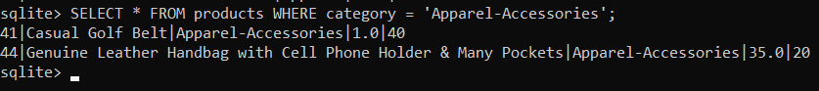

**Shoes:**

INSERT INTO products (productName, category, price, quantity) VALUES ('Blue and green Sneaker', 'Shoes', 11.0, 10);

INSERT INTO products (productName, category, price, quantity) VALUES ('Green and blue Sneaker', 'Shoes', 17.56, 40);

Now, let’s verify:

SELECT * FROM products WHERE category = 'Shoes';

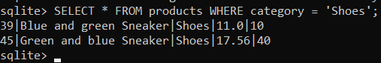

* **Digital Downloads:**

INSERT INTO products (productName, category, price, quantity) VALUES ('3rd Album', 'General', 1.0, 10);

INSERT INTO products (productName, category, price, quantity) VALUES ('Music 2', 'General', 10.0, 20);

INSERT INTO products (productName, category, price, quantity) VALUES ('Music 2', 'General', 3.0, 40);

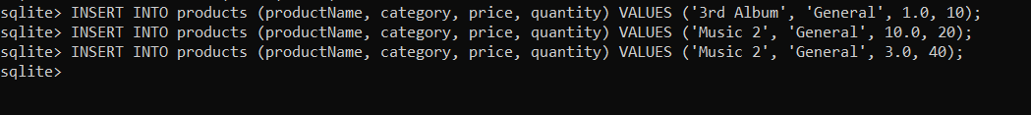

Now, verify:  
SELECT * FROM products WHERE category = 'General';

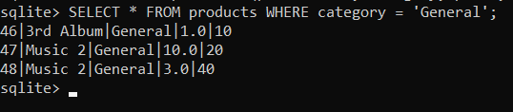

* **Jewelry:**

INSERT INTO products (productName, category, price, quantity) VALUES ('Create Your Own Jewelry', 'Jewelry', 100.0, 10);

INSERT INTO products (productName, category, price, quantity) VALUES ('Black & White Diamond Heart', 'Jewelry', 130.0, 20);

INSERT INTO products (productName, category, price, quantity) VALUES ('Diamond Pave Earrings', 'Jewelry', 350.0, 20);

INSERT INTO products (productName, category, price, quantity) VALUES ('Diamond Tennis Bracelet', 'Jewelry', 360.0, 10);

INSERT INTO products (productName, category, price, quantity) VALUES ('Vintage Style Three Stone Diamond Engagement Ring', 'Jewelry', 2100.0, 10);



Now, verify:

SELECT * FROM products WHERE category = 'Jewelry';

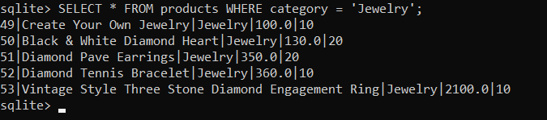

* **Gift Cards:**

**Virtual Gift Cards:**

INSERT INTO products (productName, category, price, quantity) VALUES ('$5 Virtual Gift Card', 'VGiftCards', 5.0, 10);

INSERT INTO products (productName, category, price, quantity) VALUES ('$25 Virtual Gift Card', 'VGiftCards', 25.0, 10);



Now, verify:

SELECT * FROM products WHERE category = 'VGiftCards';

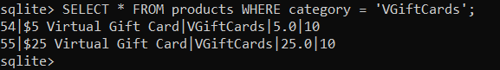

**Physical Gift Cards:**

INSERT INTO products (productName, category, price, quantity) VALUES ('$50 Physical Gift Card', 'PGiftCards', 50.0, 10);

INSERT INTO products (productName, category, price, quantity) VALUES ('$100 Physical Gift Card', 'PGiftCards', 100.0, 10);



Now, verify:

SELECT * FROM products WHERE category = 'PGiftCards';

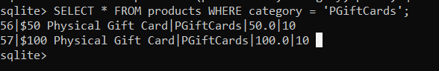

1. **All Registered Users Table:**

Create the table for registered users.

CREATE TABLE registered_users (id INTEGER PRIMARY KEY AUTOINCREMENT, email TEXT NOT NULL UNIQUE, password TEXT NOT NULL, isActive INTEGER NOT NULL, environment TEXT NOT NULL);



Insert values into the above created table with the query.  
INSERT INTO registered_users (email, password, isActive, environment) VALUES ('hf.2024qab2@gmail.com', 'password123', 1, 'production'), ('akh.2024qab2@gmail.com', 'securepass', 1, 'testing'), ('ril.2024qab2@gmail.com', 'anotherpass', 0, 'production'), ('am.2024qab2@gmail.com', 'secretpass', 0, 'testing'), ('hm.2024qab2@gmail.com', 'confidentialpass', 1, 'peoduction');

Now, let’s verify:

SELECT * FROM registered_users;

