Sauce Demo
Project Domain Profile Document:
Project Title:
Sauce Demo
Prepared By:
Huzaifa Bin Munir
Senior Dev: Subhan Rauf
Date: 16th March, 2026
1. Website Overview
The website analysed for this assignment is the Sauce Demo Shopify store, a demonstration e-commerce platform designed to showcase a standard online retail workflow. The site includes common components found in modern e-commerce systems such as product listings, product detail pages, a shopping cart, and navigation between catalog pages.
From a functional perspective, the site allows users to browse products, view item details, add products to a shopping cart, modify item quantities, and remove products from the cart. These interactions represent the core user journey for most online shopping platforms.
The focus of this analysis is the Add to Cart feature, which is one of the most critical functionalities within any e-commerce system. This feature directly impacts the purchasing workflow and therefore must function reliably under various user interactions.
Testing and analysing this feature provides a practical opportunity to apply Agile development practices, user story definition, sprint planning concepts, and manual testing techniques.

2. Agile vs Waterfall Development Approaches
Software development projects are commonly managed using either the Waterfall model or Agile methodologies. Each approach structures the development lifecycle differently and influences how teams plan, build, and test software features.
2.1 Waterfall Approach
The Waterfall model follows a linear and sequential development process. In this model, each phase of development must be completed before the next phase begins. Typical phases include:
- Requirements gathering
- System design
- Implementation
- Testing
- Deployment
- Maintenance
Because testing occurs late in the development lifecycle, issues discovered during testing can be costly and time-consuming to fix. Changes to requirements after development begins are also difficult to accommodate.
While this model works well for projects with stable and well-defined requirements, it can be less flexible in dynamic product environments.
2.2 Agile Approach
Agile development focuses on iterative development and continuous improvement. Instead of delivering the entire product at once, teams deliver features in small increments called sprints.
Key characteristics of Agile development include:
- Incremental feature delivery
- Frequent stakeholder feedback
- Adaptive planning
- Continuous testing and improvement
Work is organized into user stories within a product backlog, and teams deliver working software at the end of each sprint.
Because Agile allows teams to adjust requirements and priorities during development, it is particularly effective for digital products that evolve based on user feedback.
For the purpose of this assignment, the Add to Cart feature is treated as a backlog item that is implemented and validated within a sprint.
2.3 Scrum roles and events
Scrum is an agile framework that organises work into sprints (typically 2–4 weeks). Key roles include:
- Product Owner – prioritises and clarifies work; owns the product backlog.
- Scrum Master – facilitates the process, removes impediments, ensures adherence to Scrum.
- Developers (team) – build the product increment.
Scrum uses several recurring ceremonies. Their purpose and guidance are summarised below using information from the Parabol guide, which quotes the official Scrum Guide.
Ceremony | Purpose & timing | Participants
Sprint Planning | Initiates the sprint by laying out the work to be performed. The resulting plan is created by collaborative work of the entire Scrum team. During planning, the team commits to tasks for the upcoming sprint and moves items from the product backlog to the sprint backlog. It is held at the start of the sprint and may last from one to eight hours depending on sprint length. | Product Owner, Scrum Master and developers
Daily Scrum (Daily Stand-up) | A short meeting (no more than 15 minutes) held at the same time every working day of the sprint. Its purpose is to inspect progress toward the sprint goal and adapt the plan as needed. Team members share what they completed, what they plan to do and any blockers. | Developers, Scrum Master (Product Owner optional)
Sprint Review | Held at the end of the sprint to inspect the outcome of the sprint and determine future adaptations. The team presents completed work to stakeholders, discusses whether the sprint goal was met and gathers feedback for the product backlog. Reviews typically last 30–60 minutes for a two-week sprint. | Developers, Scrum Master, Product Owner and stakeholders
Sprint Retrospective | Planned ways to increase quality and effectiveness. During the retrospective the team reflects on the last sprint—what went well, what didn’t and how processes can improve. It usually lasts 30–45 minutes per week of sprint. | Developers, Scrum Master (Product Owner optional)
Backlog Refinement | Ongoing activity where backlog items are broken down and defined into smaller, more precise items. This helps ensure that items selected for the next sprint are well understood. | Product Owner and developers

3. Agile Sprint Simulation for the Add to Cart Feature
To demonstrate how Agile development can be applied to the Sauce Demo store, a simplified sprint simulation was created focusing on the Add to Cart functionality.
3.1 Product Backlog Item
The feature is first defined as a backlog item within the product backlog.
Feature: Add products to shopping cart
Description:
Users should be able to select a product and add it to their shopping cart so that they can proceed toward purchasing items.

3.2 User Stories
User stories define functionality from the user's perspective.
User Story 1
As a customer,
I want to add a product to my cart
so that I can purchase it later.
User Story 2
As a customer,
I want to view items inside my cart
so that I can review my selected products.
User Story 3
As a customer,
I want to modify item quantities in my cart
so that I can adjust my order before checkout.
User Story 4
As a customer,
I want to remove items from my cart
so that I can manage the products I intend to purchase.

3.3 Acceptance Criteria
Each user story must have clear acceptance criteria to determine whether the feature behaves as expected.
Add Product to Cart
- User can click the Add to Cart button on a product page.
- The cart indicator updates to reflect the number of items added.
- The product appears in the cart with correct name, price, and quantity.
View Cart Contents
- Users can open the cart page.
- All added items are displayed with their details.
Update Product Quantity
- Users can increase or decrease the quantity of items in the cart.
- The total price updates automatically.
Remove Product
- Users can remove items from the cart.
- Cart totals update immediately after removal.

3.4 Sprint Backlog
For the sprint simulation, the following tasks were defined.
- Analyze product pages and cart interface
- Define user stories and acceptance criteria
- Identify possible user interaction scenarios
- Design manual test cases
- Execute manual tests
- Document test results and observations

3.5 Daily Stand-Up Example
During the sprint, the development and QA team would conduct a daily stand-up meeting to review progress.
Typical updates include:
Yesterday
Reviewed the product catalog and identified the Add to Cart workflow.
Today
Executing manual test cases for cart functionality.
Blockers
No major blockers identified.

3.6 Sprint Retrospective
At the end of the sprint, the team reviews what went well and what could be improved.
What went well
- Clear feature scope allowed focused testing.
- Core cart functionality performed consistently.
What could be improved
- Edge cases such as repeated item additions should be tested earlier in development.
Action items
- Include automated testing for cart functionality in future sprints.

4. Manual Test Cases
The following manual test cases were designed to validate the Add to Cart functionality of the Sauce Demo Shopify store.
Each test case verifies a specific user interaction within the cart workflow to ensure the feature behaves correctly under normal and edge conditions.
TC ID | Test Case Title | Preconditions | Steps | Expected Result | Status
TC-01 | Add a valid product to cart | Product page is accessible | 1. Open a product page. 2. Select required options. 3. Click Add to Cart. | The cart counter increases and the product appears in the cart with correct price and quantity. | Passed
TC-02 | Add product without selecting required option | Product requires variant selection | 1. Leave variant unselected. 2. Click Add to Cart. | The system prevents the item from being added and displays a validation prompt. | Passed
TC-03 | Add multiple different products | Catalog page available | 1. Add the first product to cart. 2. Return to catalog. 3. Add a second product. | Both products appear in the cart with correct prices and quantities. | Passed
TC-04 | Increase quantity of an item | Cart contains at least one item | 1. Navigate to the cart page. 2. Increase quantity value. 3. Click Update. | Line item subtotal updates and cart total recalculates correctly. | Passed
TC-05 | Remove item from cart | Cart contains multiple items | 1. Click the Remove (X) option next to a product. | Selected products are removed and cart total updates accordingly. | Passed
TC-06 | Add the same product multiple times | Product page accessible | 1. Click Add to Cart multiple times. | Product quantity increases rather than creating duplicate line items. | Passed
TC-07 | Continue shopping from cart | Cart contains items | 1. Click Continue Shopping from the cart page. | The user is redirected back to the product catalog. | Passed
TC-08 | Add order note in cart | Cart page open | 1. Enter text in Add a note to your order field. 2. Click Update. | Note remains saved and visible after update. | Passed
TC-09 | Validate price calculation | Cart contains multiple items | 1. Verify unit price of each item. 2. Confirm totals equal unit price × quantity. | Cart totals match calculated values. | Passed
TC-10 | Cart session persistence | Cart contains items | 1. Refresh the page. 2. Reopen cart. | Items and quantities remain stored in the cart. | Passed

5. Reflection
This exercise demonstrated the practical application of Agile planning and manual QA testing on a real e-commerce feature.
The Add to Cart workflow was selected because it represents a critical user journey in any online retail system. From a product management perspective, ensuring reliability in this feature directly affects conversion rates and overall user experience.
The process began with identifying the key user interactions within the shopping workflow:
- Selecting a product
- Adding the product to the cart
- Updating item quantities
- Removing items
- Navigating back to the catalog
- Persisting cart data across sessions
Each interaction was translated into structured manual test cases. The goal was to ensure both normal usage scenarios and potential edge cases were covered.
From a QA perspective, the testing confirmed that:
- Cart totals update accurately when quantities change
- Products can be added multiple times without creating duplicate entries
- Items can be removed correctly
- Order notes are stored without affecting pricing
- Cart contents persist during page refresh
From a project management perspective, the testing process highlights the importance of defining clear acceptance criteria during sprint planning. When stories are properly defined, QA validation becomes straightforward and measurable.
Key observations from the exercise include:
What worked well
- The cart interface behaved consistently during normal interactions
- Pricing and subtotal calculations were accurate
- Navigation between catalog and cart was smooth
Areas for improvement
- Some validation scenarios (such as variant selection enforcement) could be improved with clearer user feedback
- Automated test coverage could be introduced to improve regression testing efficiency
Future iterations of this feature could include testing the checkout process, payment flow, and order confirmation workflow, as well as implementing automated UI tests using tools such as Cypress or Playwright.
Overall, the exercise demonstrates how structured planning, user stories, and systematic testing contribute to delivering a stable product feature.

6. Screenshots of Manual Test Execution
The following screenshots document the execution of key test cases performed on the Sauce Demo website.

TC-01 — Adding Valid Products to Cart
Two products were successfully added to the cart.
The cart displays both items with correct pricing and quantities.
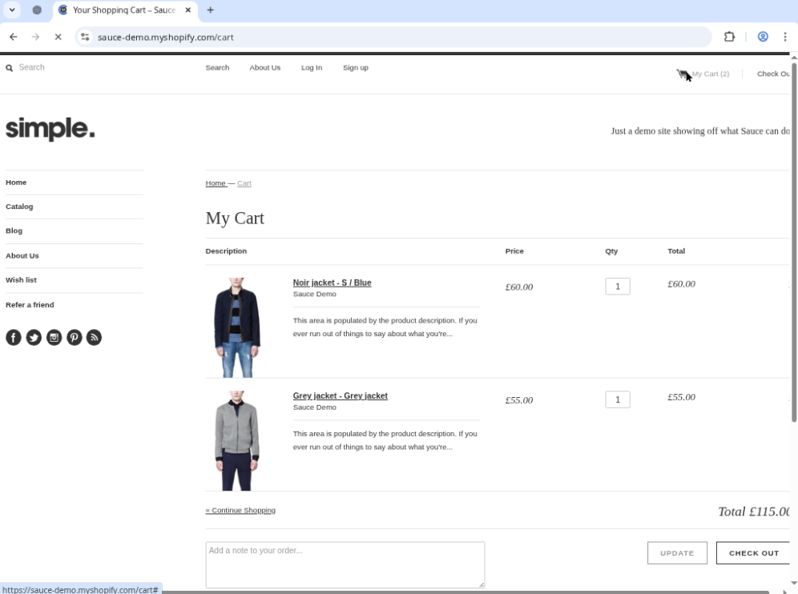
TC-04 — Updating Item Quantity
The quantity of the Noir Jacket was increased from 1 to 2.
After clicking Update, the line item subtotal and cart total recalculated correctly.
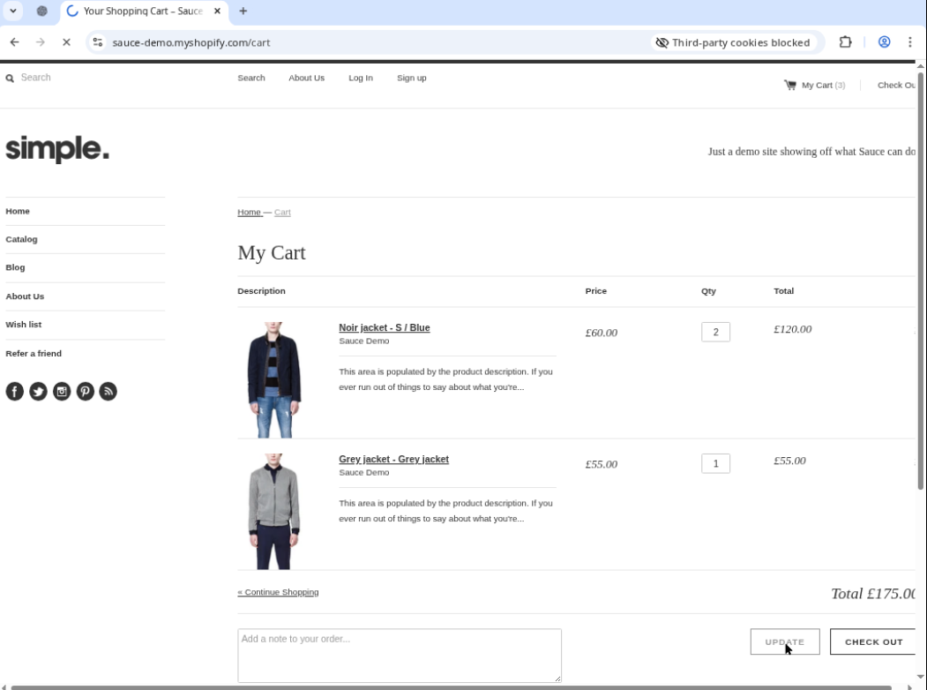
TC-05 — Removing Item from Cart
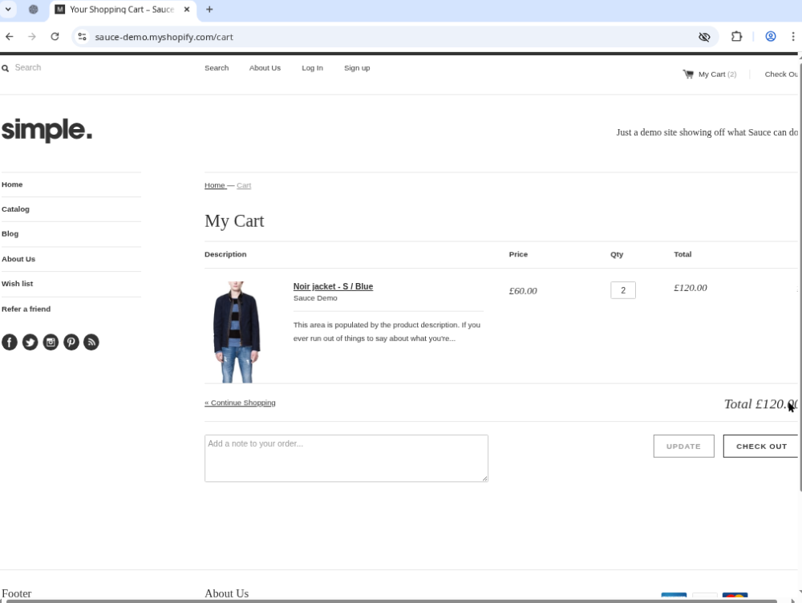
The Grey Jacket was removed using the remove option.
The cart updated immediately and recalculated the total based on remaining items.

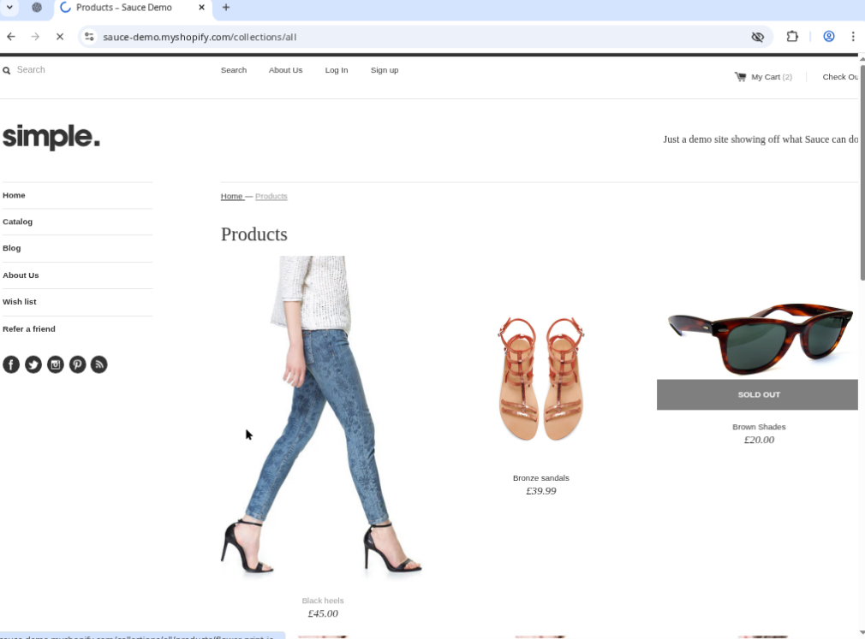
TC-07 — Continue Shopping Functionality
Selecting Continue Shopping redirected the user back to the product listing page where additional items could be browsed and addedTC-06 — Adding Same Product Multiple Times
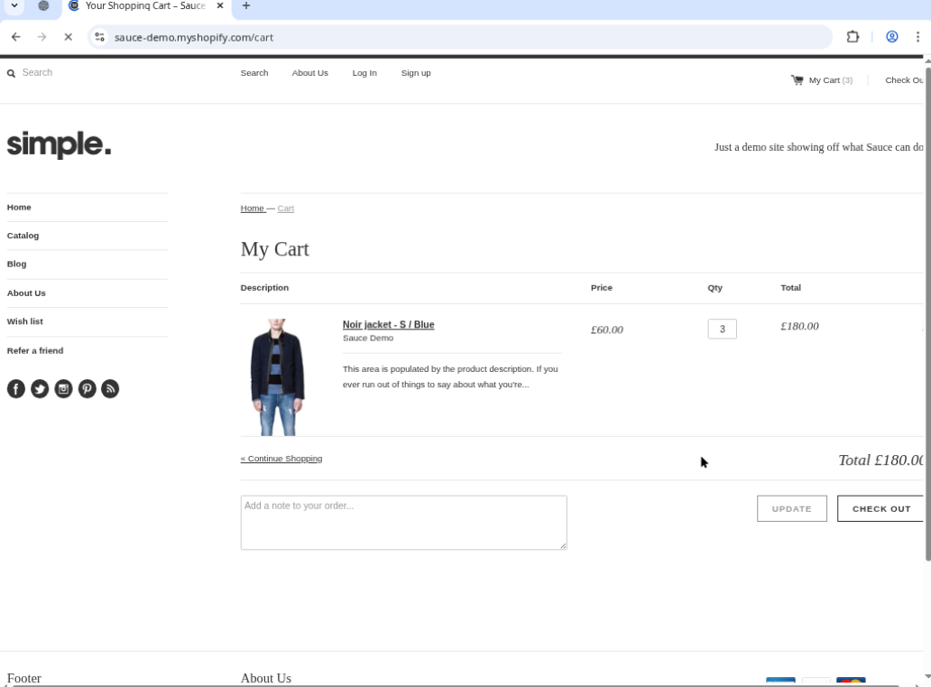
Adding the same product multiple times resulted in an increased quantity value within the cart instead of duplicate entries.
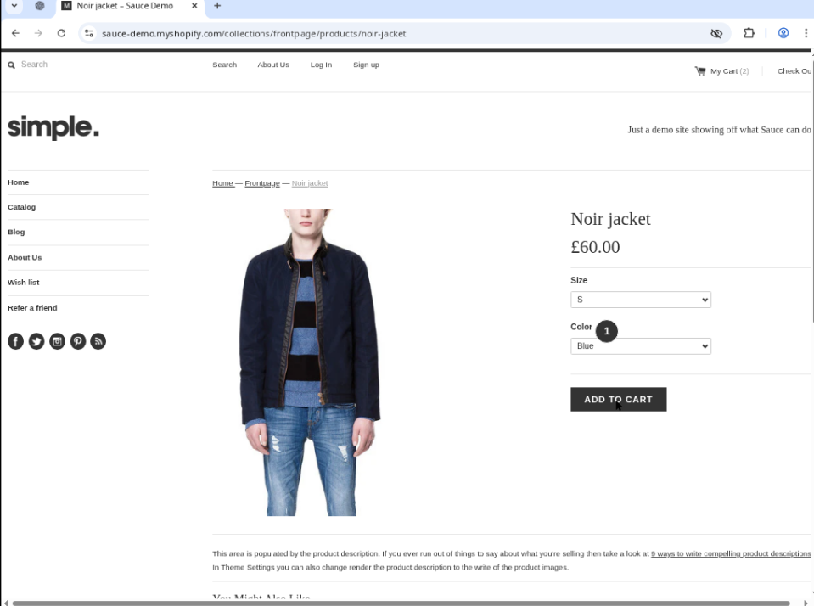

TC-08 — Order Note Feature
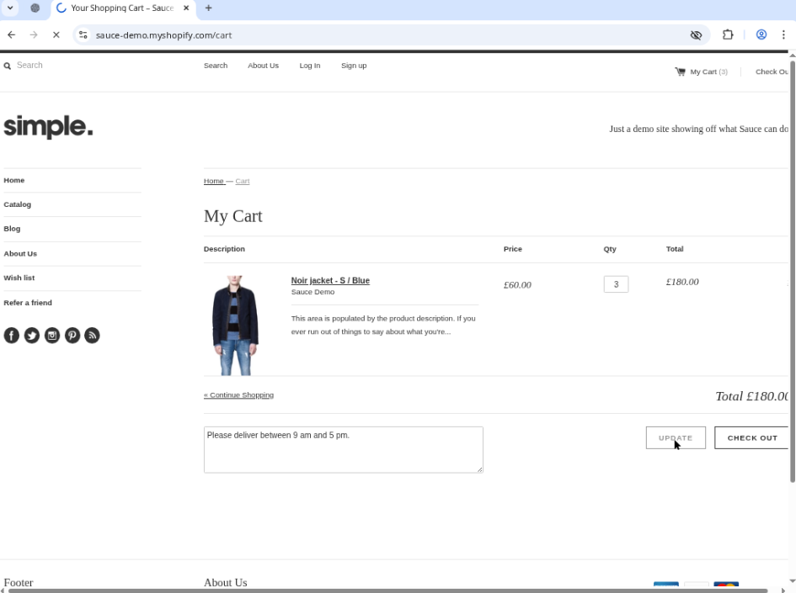
A delivery note was entered into the Add a note to your order field.
The note remained saved after clicking Update, confirming that cart notes are persisted correctly.TC-10 — Cart Session Persistence
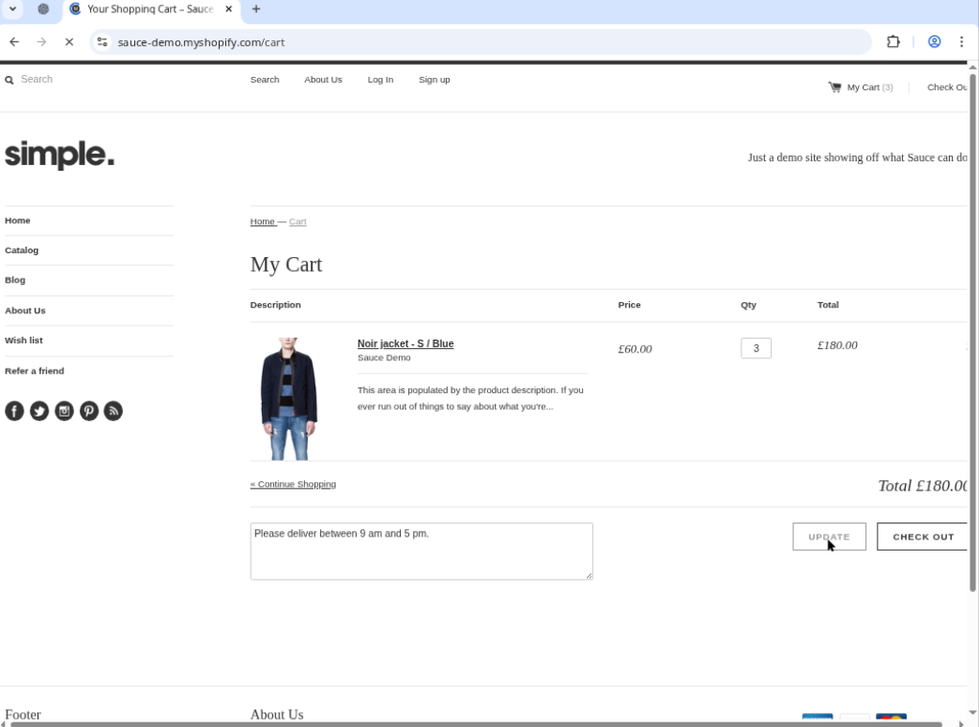
After refreshing the page, the cart retained all items and quantities, confirming that session storage or cookies maintain the cart state.

