Friend Group Expense App Product Plan and Architecture
Build the first version as a mobile first React Native application centered on one unusually clear workflow: a member records a shared expense with a required event name and event date, the app calculates who owes whom, the debtor marks the payment as sent with optional proof, and the recipient confirms that the money arrived. Voice dictation, receipt OCR, and photos explicitly shared from WhatsApp should enter the same reviewed expense form without a transcription key, WhatsApp API, or media processing server. The product should track payments made elsewhere and must not hold money in the MVP.
The product should not compete by copying every feature in Splitwise or tricount. The closest current competitor already supports browser joining, nudges, mark as paid, and recipient confirmation. The opportunity is a more focused verification inbox, safer proof handling, and a friend group personality layer that makes reminders warm without becoming harassment.^{1,4,8,9}

Recommended product direction
- Positioning Shared expenses that close only when both people agree the payment landed.
- MVP platform React Native with an Expo development build for iOS and Android, plus a small web invite and deep link fallback.
- Account model Name and verified email only, using a passwordless magic link or email code.
- Primary wedge A settlement review queue with proof, confirmation, rejection, audit history, and reminders that automatically pause when a payment is under review.
- Smart entry On device speech, receipt OCR, and share sheet photo intake that suggest field values but never save financial data without review.
- Default visual theme Dusk Blend, with a charcoal summary band, warm off white working surfaces, mint actions, coral debt states, and amber humor accents.
- Working name OweYaar, pending trademark, domain, social handle, and app store clearance.

Contents
1. Research findings and competitive benchmark
2. Product strategy and intended users
3. MVP scope and core journeys
4. Information architecture and screen design
5. On device voice transcription and OCR
6. WhatsApp and native share import
7. Visual system and theme behavior
8. Settlement state model
9. Technical architecture and data model
10. Email reminders and friend group tone
11. Privacy security and abuse prevention
12. Delivery roadmap and success metrics
13. Naming recommendations and risk decisions

Research findings and competitive benchmark
Current products prove that group expense tracking is a well understood behavior. Splitwise offers broad split methods, groups, external settlements, recurring expenses, and receipt scanning in its paid tier. Tricount emphasizes shared entry, offline use, uneven splits, photos, multiple currencies, and payment requests. Settle Up and Splid compete on understandable balances, reduced transaction counts, offline use, and low sign up friction.^{1,2,3,4,5,6,7}
The proposed verification loop is not unique by itself. KittyPot publicly describes a five step sequence that ends with the debtor marking a payment as paid and the recipient confirming that it landed. It also supports browser joining, links, codes, QR invitations, receipts, and nudges. Bexbox presents proof backed IOUs and partial payments. These products validate the need but narrow the differentiation available.^{8,9}
Product | Strength | Relevant features | Opening | Design lesson | Sources
Splitwise | Breadth and mature balance tracking | Groups, flexible splits, external settlement, recurring expenses | Feature density and paid gating leave room for a calmer core flow | Use as a completeness benchmark, not a screen template | 1 2 3
tricount | Fast group collaboration | Link invites, shared entry, offline use, photos, currencies, payment requests | Bank request availability is regional | Copy its plain language and fast group entry | 4 5
Settle Up | Clear settlement suggestions | Sync across a group and fewer suggested transfers | Public material emphasizes accounting over verification | Make the final who pays whom answer equally obvious | 6
Splid | Very low friction | No sign up, offline mode, more than 150 currencies, export | Lower identity assurance is a poor fit for proof confirmation | Preserve its speed while verifying email ownership | 7
KittyPot | Closest workflow match | Browser join, link code and QR invite, receipts, nudges, mark paid and recipient confirms | The proposed idea needs a sharper reason to switch | Differentiate through verification inbox, proof privacy, and email personality | 8
Bexbox | Evidence first ledger | Proof attachments, partial payments, private ledgers, link and QR invites | Narrow and Android focused public positioning | Treat payment evidence as sensitive content | 9

What the market evidence changes
- Do not describe bilateral payment confirmation as a first in the category.
- Make the settlement inbox the fastest and best explained part of the product, because that is where the proposed app can feel meaningfully different.
- Keep the first version small. Mature competitors already cover currencies, charts, exports, and payment integrations; matching that breadth would delay learning. Include voice and OCR only as assisted entry, not as an automatic bookkeeping system.
- Remove app download as a condition for invite acceptance. Current competitors show that browser based joining is expected.
- Avoid a public trust score. The useful outcome is a shared record, while a reputation score can turn friendly debt into social punishment.

Product strategy and intended users

Product promise
The product keeps a shared record of who paid, who owes a share, the name and calendar date of the event, what the share covers, and whether repayment has been confirmed. It removes repeated calculation and gives both sides a clear closing action. It does not replace a bank, wallet, or cash payment method.

Initial users
User | Current difficulty | Required outcome
Friend group organizer | Pays for bookings or meals and currently chases people in chat | Add an expense in under one minute and see every open settlement
Debtor | Wants the exact amount and an easy way to show payment | Open one link, review the share, tap I paid, and attach proof
Expense recipient | Needs to know which transfers arrived | Review a compact queue and confirm or flag each payment
Occasional guest | Does not want another installed app | Join from a secure browser link and verify email

Jobs the MVP should solve
- When I cover a group cost, give the event a recognizable name and date, record it before I forget, and divide it without doing arithmetic in chat.
- When a receipt photo is already in WhatsApp, share that one photo into the app and continue from a prepared expense draft instead of downloading and uploading it again.
- When I owe money, show exactly why, where to pay outside the app, and what remains after a partial payment.
- When I send money, let me mark the payment as sent and provide evidence without exposing that evidence to the entire group.
- When someone says they paid me, let me confirm receipt or explain the problem without changing the ledger incorrectly.
- When a balance stays open, remind the right person at a reasonable cadence and stop as soon as the state changes.

Positioning boundaries
The app should use words such as track, record, claimed, and confirmed. It should not say that it processed, transferred, secured, or guaranteed a payment. Every settlement screen should state that money moves outside the app.
The original expense payer is the recipient or creditor during repayment. The member who owes the share is the debtor. Interface labels should be written from the viewer's perspective: I paid for the debtor and Money received for the recipient. This avoids the ambiguous word payer.

MVP scope and core journeys

MVP capability list
Area | Included behavior
Identity | Name, verified email, magic link or six digit email code, profile theme
Groups | Create group, base currency, group accent, roles, invite link, invite email, revoke invite
Expenses | Required event name and event date, amount, optional merchant or note, one expense payer, equal, exact value, or percentage split, optional receipt, edit history
Assisted entry | Field dictation, receipt OCR, camera capture, and one image received from the native share sheet, with mandatory review
Balances | Per group and overall amounts, who owes whom, expense level explanation, no hidden simplification
Settlements | Full or partial amount, I paid, optional proof, awaiting review, confirm, needs attention, reversal
Notifications | Invite, new expense, reminder, proof submitted, confirmed, needs attention, bounce handling
Controls | Reminder cadence, quiet hours, mute group, tone preference, data export, account deletion

Defer until after product validation
- Conversational expense parsing Do not promise that one spoken sentence can reliably identify every payer, member, amount, and split across every language. Start with field level dictation and reviewed suggestions.
- Downloaded OCR language packs Add Tesseract based packs only for launch languages that the native OCR engines do not cover and only after device testing.
- Multiple currencies Use one currency per group at launch. Add conversion only with a dated exchange rate and an explicit source.
- Recurring expenses Useful for flatmates, but not required to test the verified settlement loop.
- Payment app links Add region specific deep links after selecting a launch country and checking platform rules.
- Desktop application Keep the web surface focused on invitations and essential review until the native mobile workflow is validated.
- Debt simplification Keep off by default because redirected debts are harder to explain and verify.

Explicitly out of scope
The MVP should not hold funds, connect bank accounts, provide credit, arbitrate disputes, expose public payment feeds, calculate a social credit score, or let a member send unlimited reminders. These features raise compliance, security, or relationship risk without proving the main value.

Core journey
1. Create or join A member enters an email address, uses a one time link or code, adds a display name, and enters the group.
2. Record The expense payer types, dictates, scans a receipt, or shares one photo from WhatsApp. The member confirms a required Event name and Event date, then chooses the amount, group, payer, participants, and split method before saving. On device tools may suggest the merchant, printed date, and total.
3. Review Every affected member receives a concise notice and can open the expense explanation or raise an issue.
4. Settle The debtor pays elsewhere, returns to the app, taps I paid, enters the amount, and optionally uploads proof.
5. Confirm The recipient reviews the settlement and taps Money received or Needs attention.
6. Close The balance changes only after confirmation. Both members receive a short success message and the audit trail remains visible.

Information architecture and screen design
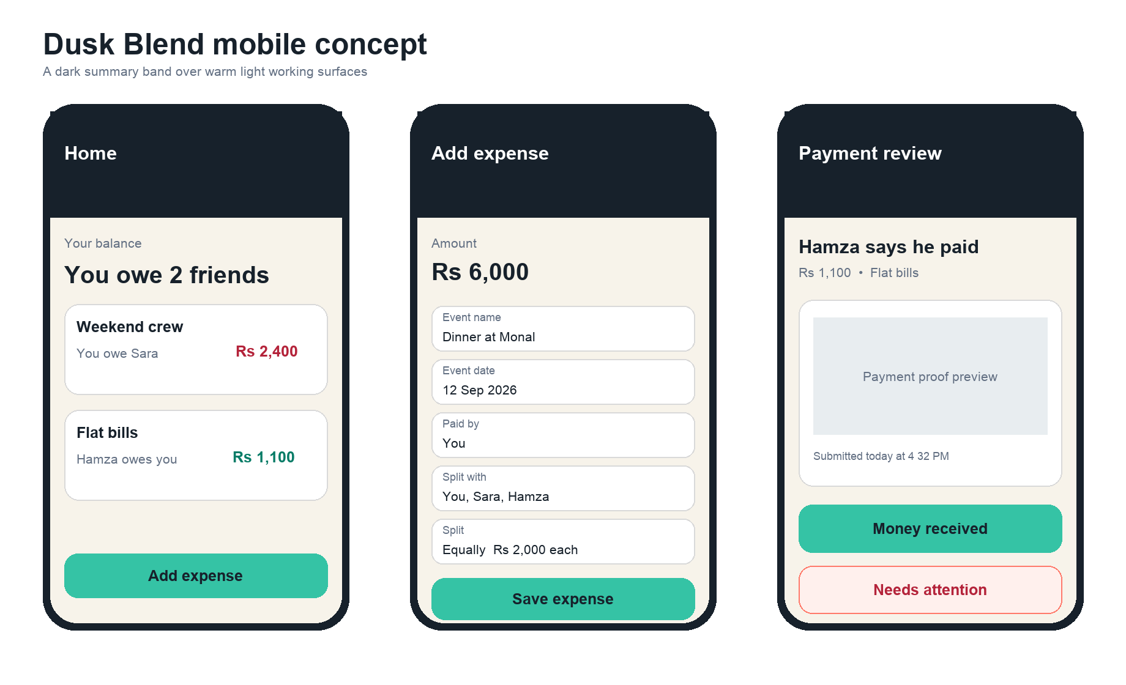
Original concept showing the recommended dark and light blend across the three most important mobile screens

Navigation
Use four bottom navigation items on mobile: Home, Groups, Activity, and You. A persistent Add expense action appears above the navigation on Home and Group screens. Settlement reviews appear at the top of Home until cleared. Desktop uses the same destinations in a left rail.
Screen | Primary content | Acceptance standard
Sign in | Email field, Continue button, code or link confirmation, name only for first use | A new member reaches the invited group without creating a password
Home | You owe, Owed to you, Review payments, recent groups, primary Add expense action | The screen answers what needs attention before showing history
Group | Group balance, settle suggestion, members, chronological ledger, invite | A member can explain any number by opening its expenses
Add expense | Event name, event date, image preview, amount, microphone, Scan receipt, merchant or note, paid by, participants, split method | Typed, dictated, scanned, and shared photo entry all end in the same reviewable form
Import expense | Source image, discard, keep as receipt, group, event name, event date, OCR suggestions, Continue | A WhatsApp share opens a draft without saving or uploading anything automatically
Settle | Recipient, amount, external payment note, I paid, optional proof | Payment evidence is not required when friends trust each other
Payment review | Amount, sender, group, proof, timestamp, Money received, Needs attention | No unrelated actions compete with the decision
Activity | Expenses, edits, reminders, claims, confirmations, reversals | Financial history is readable and attributable
You | Name, email, theme, tone, reminders, quiet hours, exports, deletion | People control their own inbox and theme

Event identity fields
Field | Member experience | Validation and meaning
Event name | Required short title such as Birthday dinner or Murree weekend | Editable text, 1 to 80 visible characters; never use a receipt filename as the title
Event date | Required calendar date on which the meal, trip, booking, or shared cost occurred | Default to today for manual entry; OCR may suggest a printed date, but the member must confirm it
Merchant or note | Optional supporting detail such as Monal or Advance tickets | Keep separate from the event name so reminders remain understandable
System timestamps | Created at and updated at record application activity | Do not replace the event date when an expense is imported late or edited later

Store Event date as a date only value interpreted in the group's timezone, separate from created at and updated at timestamps. Show Event name and Event date together on expense details, activity items, settlement reviews, and reminder emails so friends can recognize what the balance refers to.

Interaction rules
- Show the amount before every confirmation action and use the group currency symbol plus ISO code when ambiguity is possible.
- Keep destructive or corrective actions behind a More menu, but never hide the dispute action on an open settlement.
- Use optimistic updates only for reversible local actions. A confirmed settlement should wait for a committed server response.
- Never rely on green and red alone. Pair every state color with a label and icon.
- Show the calculation behind every share, including rounding, in one tap.
- When a proof is submitted, replace reminder actions with Awaiting review and stop scheduled nudges immediately.
- Treat voice, OCR, and shared image output as suggestions. Highlight every inserted field and require the member to review the final event name, event date, amount, payer, people, and split before saving.

On device voice transcription and OCR
The app can provide useful multilingual dictation and OCR without an application owned transcription service or API key. The React Native layer does not perform recognition itself; it bridges the operating system or a bundled native engine. These engines use machine learning internally, so the accurate product promise is on device processing with no cloud AI account, not no AI. Language and offline availability vary by device, operating system, installed models, and script.^{26,27,29,30}

Voice dictation design
Use expo speech recognition in an Expo development build. It wraps Apple Speech on iOS and Android SpeechRecognizer behind one React Native interface and exposes on device capability and locale checks. Do not start with the archived React Native Voice package. Native libraries require a development build because Expo Go cannot contain arbitrary native code.^{28,31,32}
Concern | MVP behavior | Guardrail
Language choice | Default to the app language but let the member choose a BCP 47 locale before recording | Never label the feature as every language; display only locales reported by the device
Offline gate | Check on device support and installed locale assets before activating the microphone | If unavailable, offer model download where supported or return to keyboard entry
Recording | Short field level dictation for event name, note, merchant, date, or amount | Do not upload or retain audio; stop immediately when the member leaves the screen
Review | Show partial text while listening, then place the final transcript in an editable preview | Apply only after the member taps Use text
Parsing | Use locale aware number and date parsing plus exact group member name matching | No free form command may silently choose participants or save a split

On iOS, require on device recognition only when SFSpeechRecognizer reports that the selected locale supports it. On Android, check isOnDeviceRecognitionAvailable and the supported locale list, then use the on device recognizer. The ordinary Android recognizer may stream audio to a provider, so strict local mode must not silently fall back to it. Automatic language detection is device dependent and should not replace a visible language selector.^{26,27,28}

Receipt OCR design
Capture a still image with React Native Vision Camera, then run OCR after the member crops and rotates the receipt. Avoid continuous frame processing in the MVP. On Android, ML Kit Text Recognition v2 can run from a bundled model or a model downloaded through Google Play services. It supports Latin, Chinese, Devanagari, Japanese, and Korean scripts. On iOS, Apple Vision performs text recognition on device and can report the languages supported by the current request revision.^{29,30,35}
Stage | MVP behavior | Privacy and accuracy rule
Capture | Edge guide, focus warning, flash control, crop and rotate | Keep the original local until the member decides whether to attach it
Recognize | Return text blocks and positions on device | Do not send the image to an OCR server
Extract | Use deterministic patterns for totals, printed event dates, tax, and currency; use a detected merchant only as a starting point for Event name | A rule can suggest a value but cannot replace user confirmation
Review | Overlay detected candidates and let the member tap the correct total and merchant | Show the source crop beside each suggestion
Persist | Save confirmed structured fields; upload the receipt only when the member explicitly keeps it | Delete temporary images and raw OCR text after the flow completes

Language coverage strategy
Ship a tested language matrix rather than a universal claim. The first release should support every locale that the phone reports as available for on device dictation and the scripts supported by the selected native OCR engine. For important launch scripts outside that set, a later native Tesseract module can use downloadable or bundled language packs. Tesseract provides data for more than 130 languages and over 35 scripts, including Urdu, but accuracy, binary size, right to left layout, and receipt formatting must be tested per language. Tesseract.js is not the React Native solution because its own documentation says React Native lacks the required WebAssembly support.^{33,34}
Tier | Implementation | Product promise
Tier 1 | Device native speech and OCR | Fastest path, lowest app size, best privacy; exact coverage varies by device
Tier 2 | Optional native Tesseract language pack | Broader OCR scripts such as Urdu; larger downloads and more QA
Fallback | Keyboard, camera attachment, and manual amount entry | Always available when recognition is unsupported or uncertain

WhatsApp and native share import
Treat WhatsApp as an example source application, not as a data integration. A member opens a receipt photo in WhatsApp, taps the operating system Share action, chooses OweYaar, and continues in an Import expense screen. The app receives only that selected image through the iOS share extension or Android share intent. It does not request chat access, infer the people in the conversation, read message history, or require a Meta or WhatsApp API key.^{36,37,38}
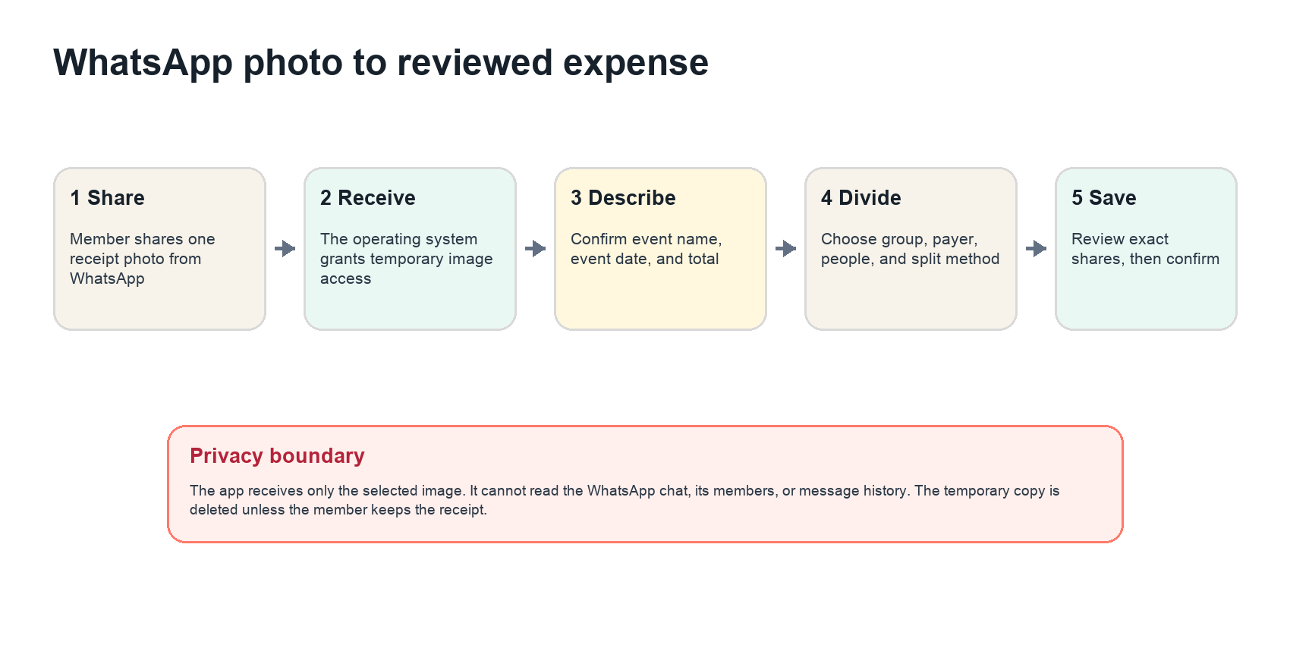
A shared WhatsApp photo becomes a local draft and reaches the ledger only after the member verifies every financial field

Import journey
Step | Member experience | Required guardrail
Share | In WhatsApp, open one receipt photo, tap Share, and select OweYaar | The app accepts one JPEG, PNG, or WebP image in the MVP
Receive | Copy the granted image into an application cache entry with a short local expiry | Do not upload, create an expense, or retain the source URI automatically
Unlock | If the app is locked, preserve the local draft while the member verifies email or unlocks the app | Show the image only after local authentication; expire abandoned drafts
Review image | Preview, rotate, crop, replace, discard, or choose Keep as receipt | Warn when the image may contain chat names, phone numbers, bank details, or unrelated text
Event details | Enter a required Event name and Event date; OCR may suggest the merchant as a starting title and the printed receipt date | Both fields remain editable and Save stays disabled until the member confirms them
Choose people | Select a group, Paid by, and the members included in the expense | Default Paid by to Me but never infer chat participants or silently select a group
Divide | Choose Equal, Exact values, or Percentages and inspect the calculated amount for each member | Disable Save until the allocation is mathematically complete
Confirm | Review Event name, Event date, total, payer, people, and exact shares, then tap Save expense | Only confirmed structured data reaches the backend; upload the image only if Keep as receipt is selected

Split methods
Method | Interaction | Validation and rounding
Equal | Select the included members; include the expense payer by default with a visible toggle | Divide integer minor units evenly and assign any leftover units deterministically
Exact values | Enter the amount assigned to every included member and show Remaining at all times | The entered values must be nonnegative and sum exactly to the expense total
Percentages | Enter a percentage for every included member and show the calculated money amount beside it | Percentages must total 100.00 percent; allocate rounding by largest remainder with stable member order as the tie break

Weighted shares such as one share versus two shares and item by item receipt assignment are useful follow ups. They should reuse the same allocation engine, but should not make the launch form harder to understand. Every method must end with a per member preview whose minor units sum exactly to the total.

React Native implementation
Create an IncomingShareAdapter so the expense form does not depend on one package. Expo Sharing now documents inbound shared data and MIME type configuration, but it labels the receive path experimental and notes an iOS behavior that Apple does not officially support. Use it for the technical spike, then keep the production gate explicit: Android receives ACTION SEND with image MIME types, while iOS uses a dedicated Share extension and App Group handoff if the official Expo path does not pass store and cold start testing.^{36,37,38}
Layer | Implementation | Reliability rule
Android | ACTION SEND intent filter for image JPEG, PNG, and WebP; read the granted content URI | Copy immediately to cache because the temporary grant may disappear after the activity ends
iOS | Small Share extension accepts one image and places a transient reference in an App Group container | Keep the extension UI minimal and move OCR, group selection, and splitting into the main app
Navigation | Normalize warm start, cold start, and locked app shares into one Import expense route | Consume every payload once and prevent a stale image from reopening after Save or Discard
Local queue | Random import identifier, MIME, byte size, checksum, created time, and expiry | Never synchronize device paths, WhatsApp metadata, or raw OCR text
Unsupported input | Explain that launch supports one receipt image and offer camera or gallery import | Reject multiple images, text, PDFs, video, oversized images, and malformed data in the MVP

Share import acceptance tests
- A single WhatsApp photo opens the same Import expense screen on a recent iPhone and two supported Android devices when the app is closed, backgrounded, and already open.
- Sharing does not create an expense, notify a group, or upload an image before the member taps Save expense.
- Save remains disabled until a nonblank Event name and valid Event date are confirmed, even when OCR fills other fields.
- Discard, successful save without Keep as receipt, timeout, and sign out remove the temporary image and OCR text.
- Equal, exact value, and percentage modes always display allocations that sum to the imported total in integer minor units.
- A forwarded image cannot expose another group, and a member cannot select people outside the chosen group unless they explicitly create and send a new invitation.
- The app behaves clearly when WhatsApp supplies an unreadable image, revokes the temporary URI, or the device has no supported OCR engine.

Visual system and theme behavior
The default theme should be neither a conventional light theme nor a full dark theme. Dusk Blend uses a dark summary layer for orientation and warm light surfaces for data entry and reading. This gives the app a distinctive mixed appearance while keeping dense financial details easy to scan.
Token | Hex | Role | Text pairing
Ink | 17212B | Top bars, summary areas, primary text | White or warm canvas
Warm canvas | F7F3EA | Main working background | Ink
Mint | 35C3A5 | Primary actions and confirmed status | Ink, not white
Coral | FF7A6B | Amount owed and needs attention accents | Ink or dark red text
Amber | F5C451 | Reminder and playful tone accents | Ink
Slate | 637083 | Secondary text and inactive icons | White or warm canvas after contrast testing

Theme choices
Theme | Availability | Behavior
Dusk Blend | Default | Dark summary band plus warm light content surfaces
Cloud | Manual option | Light surfaces throughout, with Ink navigation and text
Midnight | Manual option | Dark surfaces with softened white text and the same semantic status labels
System | Manual option | Follows the operating system light or dark preference
Group accent | Per group | Changes decorative accent only; it never redefines debt, warning, or success colors

Material Design 3 recommends semantic color roles and design tokens rather than assigning raw colors ad hoc, and it supports dynamic color on compatible Android experiences. The React Native theme layer should map the same semantic tokens to iOS and Android. System and manual themes remain the launch commitment; Android dynamic color can be added as an optional platform enhancement.^{20,21}
Target WCAG 2.2 AA. Maintain at least 4.5 to 1 contrast for normal text, provide visible keyboard focus, use comfortably sized targets, label all controls, and make authentication usable without memory tests or puzzles. WCAG 2.2 adds guidance for minimum target size and accessible authentication.²⁰

Writing style
Use short direct labels: Add expense, You owe Sara, I paid, Awaiting review, Money received, and Needs attention. Humor belongs in optional email or celebration copy, not in amounts, error messages, disputes, or privacy controls.

Settlement state model
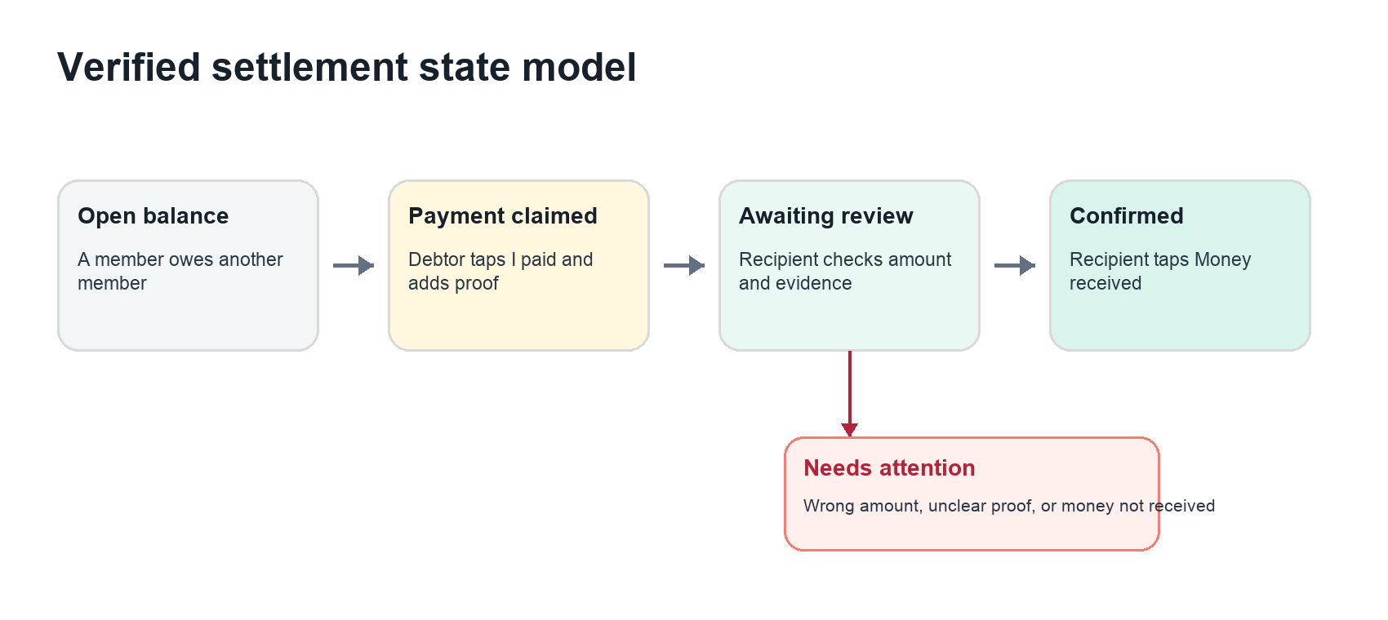
Balances change only after recipient confirmation; a problem path returns the settlement to an actionable state

State definitions
State | Meaning | System behavior
Open | A confirmed expense creates an amount owed | Debtor can start a full or partial settlement
Claimed | Debtor states that money was sent | Amount, time, method note, and optional proof are recorded
Awaiting review | Recipient has not decided | Automatic reminders to the debtor stop; recipient receives a review notification
Confirmed | Recipient says the money arrived | Settlement is posted to the ledger and the remaining balance is recalculated
Needs attention | Recipient reports missing money, wrong amount, or unclear evidence | Settlement does not change the balance; both people can add a note or submit corrected proof
Reversed | A confirmed record was entered incorrectly | A compensating ledger entry restores the amount and preserves the audit history

Integrity rules
- Only the debtor can create a payment claim for their own balance unless the recipient records a cash payment on their behalf and the activity log names that action.
- Only the intended recipient can confirm or reject the claim.
- Confirmation and reversal endpoints require idempotency keys so double taps and retries cannot post twice.
- A partial settlement cannot exceed the currently open amount without a second explicit confirmation.
- Edits to expenses that already have settlements create an adjustment entry and notify affected members.
- Debt simplification remains disabled at launch. Traceable pairwise balances are easier to explain when evidence and confirmation matter.

Rounding
Store all money as integer minor units with an ISO 4217 currency code. For an equal split, divide the total minor units, assign the same base share to each participant, and distribute remaining units deterministically in participant order. For percentage splits, store percentages as integer basis points, calculate exact fractional shares, and use the largest remainder method with stable participant order as the tie break. Display every allocated amount before save. Never use binary floating point for persisted money.

Technical architecture
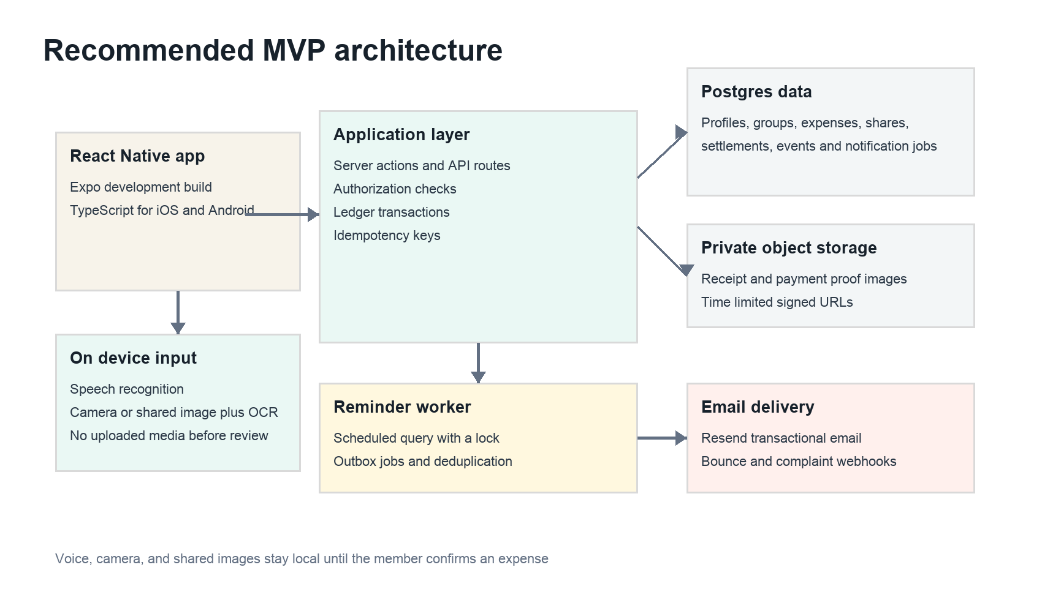
The mobile app handles voice, camera, and share sheet images locally while the managed backend synchronizes only confirmed financial records and notifications

Recommended stack
Layer | Choice | Reason
Mobile client | React Native, TypeScript, Expo development build, React Navigation | One native codebase for iOS and Android with custom native modules
Web companion | Small Next.js invite, authentication callback, and deep link fallback | Keeps invitation links usable before the app is installed
Voice | expo speech recognition with strict on device capability checks | No transcription API key; audio stays on the phone when local mode is available
Camera and OCR | React Native Vision Camera plus Apple Vision or Google ML Kit through a local Expo module | Native capture and recognition with explicit script and device support
Inbound sharing | IncomingShareAdapter with Expo Sharing spike, Android ACTION SEND, and an iOS Share extension fallback | One reviewed image from WhatsApp or another app without a WhatsApp API or media server
Application | Next.js route handlers or Supabase Edge Functions | Server side authorization for settlements, invitations, files, and email jobs
Database | Supabase Postgres | Transactions, constraints, audit records, and row level security
Authentication | Supabase email magic link or OTP | Verified email without passwords; redirect URLs must be allowlisted
Files | Private Supabase Storage bucket | Receipt and proof objects protected by membership policies and short lived signed URLs
Email | Resend transactional delivery | Templates, domain authentication, delivery events, bounces, and complaints
Hosting | Vercel for web and jobs; local or EAS builds for mobile binaries | Speech, OCR, and share intake do not require a media processing server
Operations | Structured logs, error tracking, uptime checks, database backups | Enough observability to investigate money state and email delivery

Expo development builds are required because speech, OCR, camera, and inbound share features include native iOS and Android code. Builds can run locally; EAS is optional. Keep the Next.js surface small and use it for invite links, authentication callbacks, and essential browser fallback rather than duplicating the full mobile application. The native share route is mobile only; it should not be presented as a web feature.^{31,36}
Supabase Auth supports passwordless email links and codes. Magic links are single use, and its hosted defaults include request rate limits and expiry. Supabase also integrates authentication with Postgres row level security, which is suitable for group scoped records when policies and database grants are both configured deliberately.^{10,11}

Notification execution
Use a database outbox instead of sending email inside the expense transaction. The transaction writes the expense, shares, activity event, and pending notification job together. A worker claims jobs, sends through Resend, stores the provider message ID, and marks the job sent. Delivery webhooks then update delivered, delayed, bounced, failed, or complained states.¹⁸
A scheduled reminder worker must use a database lock and a unique key such as settlement member reminder type and cadence date. Vercel documents that scheduled events can overlap or be delivered more than once and recommends locks plus idempotency. Its scheduler does not retry failed runs, so failed jobs must remain in the outbox for the next run.¹⁶

Data model and application interfaces
Entity | Key fields | Constraint
profiles | id, auth user id, display name, verified email, theme, timezone, preferred locale | One row per account
input preferences | profile id, dictation locale, strict local mode, OCR script | Stores settings only, never audio or raw OCR images
groups | id, name, base currency, accent, created by, archived at | A group owns expenses and memberships
group members | group id, profile id or invited email, role, state, joined at | Unique active member per group and identity
invites | group id, email optional, token hash, expires at, max uses, revoked at | Raw tokens are never stored
expenses | group id, event name, event date, amount minor, currency, merchant or note, paid by, created at, updated at, version, source type | Event name and date are required; event date is distinct from system timestamps; one expense payer
expense shares | expense id, member id, owed minor, split method, basis value | Owed minor units sum to the expense; percentage basis points sum to 10000
settlements | group id, from member, to member, amount minor, state, claimed at, confirmed at | Supports partial settlement and one currency
settlement proofs | settlement id, storage key, mime, size, hash, submitted by | Private object metadata only
ledger entries | group id, member pair, amount minor, currency, source type, source id, reversed by | Append only financial effect
activity events | group id, actor, event type, subject, safe metadata, created at | Human readable audit history
notification jobs | recipient, type, payload reference, due at, state, dedupe key, provider id | Reliable email outbox
notification preferences | profile, group optional, channel, cadence, quiet hours, tone, muted | Recipient controls override group defaults

Event name and Event date belong to the expense in the MVP, so entering them does not require a separate event creation screen. A later multi expense trip feature may normalize reusable events into their own table. Incoming share payloads remain in a short lived device cache; the server receives only the final confirmed expense and an image only when Keep as receipt is selected.

Core server interfaces
Interface | Responsibility
POST groups | Create a group and owner membership
POST groups id invites | Issue an email bound or limited use invite token
POST invites accept | Validate token, verify email, and join idempotently
POST expenses | Require Event name and Event date, validate shares, and commit expense ledger entries
PATCH expenses id | Create a versioned adjustment and notifications
POST settlements | Create a full or partial payment claim
POST settlements id proof | Validate and attach a private image
POST settlements id confirm | Authorize recipient and post settlement ledger entry
POST settlements id attention | Pause closure and record a structured reason
POST notifications preferences | Set personal cadence, tone, mute, and quiet hours

Authorization policy
Every group scoped query must require an active membership. A member may read group ledger data but can read a settlement proof only when they are the settlement sender or recipient. File paths should include opaque IDs, and access should use short lived signed URLs. Service role keys stay server side because they bypass row level security.^{11,12}

Email reminders and friend group tone
Email is a core workflow channel, not decoration. Every expense or reminder message should identify the group, Event name, Event date, amount, current state, and one safe action. Do not attach or preview payment proof in email. The message should link to an authenticated in app review page.

Email events
Event | Default timing | Primary action | Guardrail
Invitation | Immediately | Join group | One reminder after 48 hours; expire after seven days
New expense | Immediately or daily digest | Review share | Affected members only
Friendly reminder | Day 3 after amount becomes open | View and settle | Skip if muted, disputed, or awaiting review
Cheeky reminder | Day 7 | View and settle | Recipient selected tone controls the wording
Final automatic reminder | Day 14 | View and settle | Then weekly only if the recipient explicitly enables it
Payment claimed | Immediately | Review payment | Sent to the recipient, not the group
Payment confirmed | Immediately | View receipt record | Sent to both people
Needs attention | Immediately | Resolve issue | No humor and no automated debtor reminders

Tone controls
- Friendly Neutral and warm. This is the default for every account.
- Cheeky Light jokes that never mention a member publicly or question their character.
- Chaos More playful group language, available only when the recipient opts in.
- Quiet Important state changes only, with no automatic reminders.
The group may choose a default tone pack, but each recipient's own setting wins. Manual nudges require a 24 hour cooldown, automatic reminders stop after three by default, and every message includes a group mute link. Disputed and awaiting review states suppress payment reminders.

Sample message library
Moment | Subject | Body direction
Invitation | The group chat did the talking. Now let the numbers behave. | Sara invited you to Weekend Crew. Join to see and add shared expenses.
Friendly reminder | A small reminder from Weekend Crew | You still have Rs 2,400 open with Sara for Dinner at Monal on 12 Sep. If you already paid, mark it and add proof.
Cheeky reminder | Your balance is still doing overtime | Rs 2,400 is waiting for its retirement. Settle it or open the expense if something looks wrong.
Chaos reminder | Breaking news your Rs 2,400 has not left the chat | No panic. Pay outside the app, then tap I paid so Sara can confirm.
Proof submitted | Hamza says the money is on its way | Review the Rs 1,100 payment and confirm only after it appears in your account.
Confirmed | Settled and officially out of the group lore | Sara confirmed Rs 2,400 received. Your balance is now clear.
Needs attention | This payment needs a quick check | Sara could not confirm Rs 1,100. Open the payment to see the reason and respond.

Delivery standards
Send from a dedicated subdomain and configure SPF, DKIM, and DMARC. Resend recommends verifying SPF and DKIM and optionally adding DMARC; Google requires authentication for Gmail delivery and sets additional rules for high volume senders. Store bounce and complaint events, suppress hard bounces, provide visible controls, and keep spam complaints far below Google's 0.3 percent ceiling.^{17,18,19}

Privacy security and abuse prevention

On device input privacy
Strict local speech mode must never fall back to a network recognizer without a separate informed choice. The app should not retain microphone audio. OCR temporary files and raw detected text should remain in the application cache and be deleted after the user applies or discards the suggestions. Analytics may record success, failure category, duration band, locale, and device capability, but never transcript text, receipt text, or images.

Shared image privacy
A photo shared from WhatsApp may contain chat names, phone numbers, message previews, faces, or unrelated media. Preview it before OCR, make crop and discard actions prominent, and explain that only the selected image was received. Do not store the source application, conversation identity, original device URI, OCR text, or image pixels in analytics. Delete the cache copy after Save or Discard unless the member explicitly chooses Keep as receipt.

Proof handling
Payment screenshots may reveal account numbers, balances, transaction references, notifications, and contact names. Before upload, tell members to crop sensitive details and offer an in app crop and blur step. Strip image metadata, compress the image, and delete proof automatically after a configurable retention period such as 30 days after confirmation unless both people choose to keep it.
- Allow JPEG, PNG, and WebP only for the MVP. Do not accept PDFs or videos until there is a demonstrated need.
- Verify extension, decoded file signature, and MIME type; do not trust the browser Content Type header.
- Generate the stored filename, limit dimensions and file size, re encode images, and scan uploads where practical.
- Use private storage, group and settlement authorization, and short lived signed URLs.
- Do not expose proof in email, activity feeds, analytics payloads, or support logs.
OWASP recommends allowlisting file types, validating signatures and MIME types, generating filenames, setting size limits, authorizing uploaders, storing files outside public web paths, and scanning when available.¹³

Invitation safety
Generate at least 128 bits of random token entropy, store only a cryptographic hash, use HTTPS, bind private invitations to the intended email, expire links, support revocation, and rate limit acceptance. Generic group links should have a short lifetime and maximum use count. OWASP guidance for URL tokens recommends cryptographically random values, secure storage, single use, expiry, trusted redirect destinations, HTTPS, and rate limiting.¹⁴

Group safety
- A member can mute reminders without leaving the group or hiding the balance.
- A user can report abusive copy or a group, and support can suspend reminder sending independently of financial records.
- Names and custom group text require length limits and output encoding. Email templates must escape all user content.
- Group admins can remove future access but cannot erase another member's confirmed financial history silently.
- Export and deletion behavior must be defined before launch. Account deletion should anonymize activity where complete erasure would corrupt other members' ledgers.

Security acceptance tests
Test | Pass condition
Cross group access | A member cannot query another group's expense, proof, invite, or activity row
Proof URL | An expired signed URL fails and a non participant cannot issue another one
Double confirmation | Repeated requests create one ledger effect
Invite replay | Used, expired, revoked, or email mismatched tokens fail safely
Reminder duplication | Concurrent workers send at most one message per cadence window
File disguise | Renamed executable and malformed image inputs are rejected
Shared payload lifetime | Expired or reused share payloads fail safely and a consumed image cannot reopen a second draft
Audit integrity | Corrections create reversals rather than deleting confirmed history

Delivery roadmap and success metrics
A focused private beta with on device voice, OCR, and cross platform share import can be delivered in roughly thirteen weeks by one experienced full stack engineer with part time product design and structured QA support. A solo first time builder should expect a longer schedule. The timeline below is a planning assumption, not a vendor estimate.
Timing | Focus | Exit condition
Week 1 | Validate | Interview five to eight friend groups; map current chat and spreadsheet behavior; test terminology
Week 2 | Prototype | Clickable mobile prototype for join, typed or shared image expense entry, split selection, settle, review, and reminders
Weeks 3 and 4 | Foundation | Auth, profiles, groups, memberships, invitations, RLS, and base navigation
Weeks 5 and 6 | Ledger | Expenses, exact rounding, balances, activity history, edits, and tests
Weeks 7 and 8 | Settlement | Payment claims, private proof, confirmation, attention state, outbox, and emails
Weeks 9 and 10 | On device input | Speech capability gate, camera capture, OCR, equal, exact, and percentage split engine, privacy tests
Week 11 | Share import | Android share intent, iOS share extension path, cold and warm start routing, local queue, WhatsApp device tests
Week 12 | Hardening | Accessibility, security cases, device matrix, email authentication, export and deletion
Week 13 | Private beta | Launch to three to five real groups, watch events, collect interviews, and fix blockers

Definition of done for private beta
- A new member can accept an invite and reach the intended group in under two minutes without a password.
- An equal expense with four members saves with exact shares whose minor units sum to the total.
- A debtor can submit a full or partial payment claim and proof; only the recipient can view and decide it.
- The confirmed settlement changes the ledger exactly once, including under retries and double taps.
- Reminder emails stop during review, respect tone and mute choices, and record delivery failures.
- On supported devices, dictation and OCR work without an application API key; unsupported locales fail clearly to manual entry and no media is uploaded.
- On iOS and Android, sharing one WhatsApp receipt photo opens a local draft, requires a confirmed Event name and Event date, supports equal, exact value, and percentage splits, and uploads nothing before confirmation.
- All core screens meet the agreed WCAG 2.2 AA checks and work at common mobile widths.

Product metrics
Metric | Definition | Why it matters
Activation | Percentage of invited members who verify email and open the group within 24 hours | Measures invite friction
First value | Median time from group creation to first correctly shared expense | Tests entry speed
Assisted entry completion | Percentage of voice, camera OCR, or shared image attempts that produce a confirmed expense without retyping every field | Measures useful accuracy rather than raw recognition confidence
Share import completion | Percentage of received share images that become a confirmed expense or an intentional discard | Measures reliability and identifies abandoned or confusing imports
Settlement completion | Percentage of payment claims confirmed within seven days | Measures the core outcome
Review time | Median time from I paid to Money received | Measures recipient clarity
Dispute rate | Percentage of claims moved to Needs attention | Surfaces wrong math, unclear proof, or trust issues
Reminder health | Mute rate, bounce rate, complaint rate, and manual nudge frequency | Prevents fun email from becoming spam
Group retention | Groups with a new expense in a later month | Separates trip only use from ongoing value

Recommended launch test
Run the beta with a mix of one trip group, one flat or household group, and one recurring social group. Do not start with a public launch. Observe whether members understand I paid versus Money received, whether proof is actually used, how many reminders are tolerated, and whether the mixed theme remains readable in bright and low light conditions.

Naming recommendations
OweYaar is the strongest working name. It is short, sounds like the familiar expression oh yaar, states the debt concept through owe, and supports both warm and chaotic reminder copy. A preliminary web search did not surface an obvious exact product collision, but this is not trademark, company registry, domain, social handle, or app store clearance.
Name | Role | Why it works | Risk
OweYaar | Recommended | Warm, memorable, directly tied to owing, strong South Asian friend group personality | May feel regional if global expansion is immediate
TabToli | Strong alternate | Tab plus a group of friends; playful and group centered | Meaning of toli may need explanation outside South Asia
PaidNa | Cheeky alternate | Feels like a real reminder between friends | Question like name can feel nagging and is less clear in search
HisabScene | Descriptive alternate | Connects shared accounts with casual plans | Longer and culturally specific
OweHo | Playful alternate | Short, rhythmic, works well in reminder subjects | Less obvious pronunciation and meaning
SceneSet | Brandable alternate | Positive friend group phrase and good celebration language | Does not explain expense tracking on its own

Names to avoid
SettleBro is already used by a 2026 bill splitting app that advertises payment confirmation, reminders, and invite links. PingTab is used by at least a driver logistics app and a browser link sharing product. TabMates is already the name of an open source expense application, and Khatakhat is used by active consumer brands. These are poor launch candidates even before formal legal review.^{22,23,24,25}

Name clearance checklist
1. Search exact and similar marks in the launch country's trademark database and relevant financial software classes.
2. Search Apple App Store, Google Play, GitHub, company registries, and major search engines for exact and phonetic matches.
3. Check the preferred domain, sensible alternatives, and core social handles on the same day.
4. Ask ten target users to hear the name once, spell it, and explain what they expect the app to do.
5. Have counsel clear the final candidate before paying for identity design or publishing stores.

Early voice ideas for OweYaar
- Product descriptor: Shared expenses with proof and confirmation
- Friendly completion line: Settled, yaar
- Invite line: Bring the group. Leave the calculator.
- Reminder label inside the app: Send a nudge
- Confirmation celebration: Balance clear. Friendship untouched.

Risks and decisions before development
Risk | Level | Failure | Mitigation
Weak differentiation | High | Closest competitors already confirm payments | Test the verification inbox and tone controls with prototypes before engineering breadth
Reminder fatigue | High | People mute or mark mail as spam | Recipient control, default cap, quiet hours, dispute pause, cooldown, delivery monitoring
Sensitive screenshots | High | Bank details leak to group members or logs | Private bilateral access, crop and blur, metadata stripping, short retention, signed URLs
Language coverage gaps | High | A device lacks an offline speech model or OCR script | Runtime capability checks, tested device matrix, visible language selector, manual fallback
OCR amount or date error | High | A subtotal, previous balance, or printing date is mistaken for the final event data | Rank candidates but require confirmation of Event name, Event date, and total
Share extension reliability | High | A WhatsApp photo is lost on cold start or the iOS handoff breaks after an update | IncomingShareAdapter, local expiry queue, exact once consumption, real device upgrade tests, native iOS fallback
Wrong split selection | High | The imported total is assigned to the wrong group, payer, or people | No inferred chat members, visible group and payer fields, allocation preview, disabled Save until valid
Native module drift | Medium | A React Native or operating system update breaks recognition | Pin versions, use development builds, wrap providers behind local interfaces, test upgrades
Ledger disagreement | High | Edits or rounding make balances untrustworthy | Integer money, database constraints, calculation preview, audit events, reversal entries
Invite hijacking | Medium | Forwarded or guessed links admit the wrong person | High entropy hashed tokens, email binding, expiry, use caps, revocation, rate limiting
Scope expansion | High | Conversational parsing, payments, currencies, and desktop parity delay launch | Keep the MVP decision log and require beta evidence for every added feature
Regional product fit | Medium | Payment methods and language differ by market | Choose one launch country after interviews; keep money movement outside the MVP

Decisions still required
Decision | Why it matters
Launch geography | Currency defaults, wording, payment links, privacy notices, and legal review
Launch languages | Select the first tested speech locales, interface translations, OCR scripts, and any Tesseract packs
Invite policy | Email bound invitations only or controlled generic links for very casual groups
Proof requirement | Optional by default is recommended; groups may request it but should not expose it broadly
Retention period | Recommended starting point is automatic proof deletion 30 days after confirmation
Partial payment | Recommended for MVP because it affects the data model and real payment behavior
Expense approval | Recommended to notify and allow disputes, not require every member to approve every expense
Inbound share library | Run Expo Sharing as a spike, but use a dedicated iOS Share extension if the experimental route fails cold start or store testing
Shared image retention | Delete temporary imports after Save or Discard; upload only when Keep as receipt is selected

Immediate next step
Create a clickable prototype of six screens: invite acceptance, Home, Import expense from WhatsApp, Add expense with Event name, Event date, and split selection, I paid, and Payment review. Then build a three day technical spike on one recent iPhone and two Android devices: enumerate offline speech locales, scan ten real receipts, verify Event date suggestions and late entry behavior, share one image from WhatsApp with the app closed and open, verify equal, exact, and percentage rounding, and confirm that disabling connectivity does not upload media. Test the prototype with two friend groups before writing the ledger backend.

Sources
1. Splitwise. Split expenses with friends. Official product page. Accessed September 12 2026.
2. Splitwise Help Center. How do I use Splitwise. Official workflow documentation. Accessed September 12 2026.
3. Splitwise. Splitwise Pro. Official paid feature description. Accessed September 12 2026.
4. tricount. Expense Tracker App Features. Official product features. Accessed September 12 2026.
5. tricount Help Center. Request links. Official request link availability and fee information. Accessed September 12 2026.
6. Settle Up. Settle Up. Official product page. Accessed September 12 2026.
7. Splid. Split expenses the easy way. Official product page. Accessed September 12 2026.
8. KittyPot. Split the cost Not the friendship. Official workflow and feature page. Accessed September 12 2026.
9. Bexbox. Private personal ledger with proof. Official product page. Accessed September 12 2026.
10. Supabase. Passwordless email logins. Official authentication documentation. Accessed September 12 2026.
11. Supabase. Row Level Security. Official authorization documentation. Accessed September 12 2026.
12. Supabase. Storage Access Control. Official private storage access documentation. Accessed September 12 2026.
13. OWASP. File Upload Cheat Sheet. Security guidance. Accessed September 12 2026.
14. OWASP. Forgot Password Cheat Sheet. URL token security guidance applied to invitations and magic links. Accessed September 12 2026.
15. Next.js. How to build a Progressive Web Application. Official PWA guide, updated March 25 2026.
16. Vercel. Managing Cron Jobs. Official scheduling, locking, and idempotency guidance, updated January 28 2026.
17. Resend. Managing Domains. Official SPF DKIM and DMARC setup guidance. Accessed September 12 2026.
18. Resend. Event Types. Official email delivery event documentation. Accessed September 12 2026.
19. Google. Email sender guidelines. Official Gmail authentication, unsubscribe, and spam rate requirements. Accessed September 12 2026.
20. W3C. Web Content Accessibility Guidelines 2.2. W3C Recommendation, December 12 2024 version.
21. Android Developers. Create an accessible and personalized theme and brand with Material Design 3. Official theming guidance. Accessed September 12 2026.
22. Apple App Store. SettleBro. Current app listing used for preliminary name screening. Accessed September 12 2026.
23. Google Play. PingTab. Current app listing used for preliminary name screening. Accessed September 12 2026.
24. GitHub. TabMates app. Existing open source project name identified during preliminary screening. Accessed September 12 2026.
25. Khatakhat Logistics. Khatakhat. Existing consumer brand identified during preliminary screening. Accessed September 12 2026.
26. Apple Developer. On device speech recognition support. Official iOS capability documentation. Accessed September 12 2026.
27. Android Developers. SpeechRecognizer. Official Android on device recognition and capability API documentation. Accessed September 12 2026.
28. GitHub. Expo Speech Recognition. React Native bridge for Apple Speech and Android SpeechRecognizer. Accessed September 12 2026.
29. Google for Developers. ML Kit Text Recognition v2. Official on device OCR capabilities and supported scripts. Accessed September 12 2026.
30. Apple Developer. Recognizing text in images. Official Apple Vision on device text recognition guidance. Accessed September 12 2026.
31. Expo. Add custom native code. Official development build and local Expo module guidance. Accessed September 12 2026.
32. GitHub. React Native Voice. Archived package notice and migration recommendation. Accessed September 12 2026.
33. Tesseract OCR. Installing Tesseract from Git. Official language and script pack coverage documentation. Accessed September 12 2026.
34. GitHub. Tesseract.js framework support. Official note that React Native is not supported by the WebAssembly implementation. Accessed September 12 2026.
35. GitHub. React Native Vision Camera. Current React Native camera library and release history. Accessed September 12 2026.
36. Expo. Sharing. Official send and receive sharing documentation, MIME configuration, and iOS experimental limitation. Accessed September 12 2026.
37. Android Developers. Receive simple data from other apps. Official ACTION SEND intent and MIME type guidance. Accessed September 12 2026.
38. Apple Developer. Share extensions. Official Share extension purpose, input validation, and host application behavior. Accessed September 12 2026.

