Faculty of Computing
SE-314: Software Construction
Class: BESE 15AB
NAME: Huzaifa Furqan
CMS: 501276
SECTION: BESE15-A
Lab 07: Test First Programming - II (Social Network Analysis)
CLO-03: Design and develop solutions based on Software Construction principles.
CLO-04: Use modern tools such as Eclipse, NetBeans etc. for software construction.
Date: 23 Oct 2026
Instructor: Dr. Sidra Sultana
Lab Engineer: Mr. Aftab Farooq

GitHub Repository
GitHub link: https://github.com/<your-username>/<your-repo>/tree/main/lab07
(Replace the highlighted text with your real repository link before submitting. All code of this report is in that repository, folder lab07/ps1.)

Introduction
In this lab, test-first programming is practised on Problem Set 1 (Tweet Tweet) of MIT 6.005, problem 3: Social Network Analysis. For each method, the specification is studied first, the JUnit tests are written from the specification and run (red bar), and only then the method is implemented until all the tests pass (green bar). The two methods of SocialNetwork.java are guessFollowsGraph(), which infers who follows whom from the @-mentions in a list of tweets, and influencers(), which ranks the users by their number of followers.

Lab Objectives
- Write the JUnit tests of guessFollowsGraph() and influencers() from their specifications, before the implementation exists.
- Respect the underdetermined postcondition of guessFollowsGraph(): the tests must not demand more than the spec guarantees.
- Implement both methods with the minimum required behaviour (Ernie follows Bert if Ernie @-mentions Bert) until every test passes.
- Use Eclipse, JUnit and Git: red-to-green cycle, reading the failure trace, small clean commits, and run Main.java.

Helping Material
- MIT 6.005 Problem Set 1: https://ocw.mit.edu/ans7870/6/6.005/s16/psets/ps1/
- Lectures on LMS: designing specifications and testing strategy.

Solution

Task 1 and 2: Specifications of the Two Methods

Step 1: Set up the project in Eclipse
The official starter project ps1 (ps1.zip of MIT 6.005 Problem Set 1) was imported into Eclipse (File > Import > General > Existing Projects into Workspace). The classes Tweet, Timespan and TweetReader are exactly as given and were not modified. The own Lab 05 solutions of Extract, Filter, ExtractTest and FilterTest were copied in, so that the whole project compiles and runs. SocialNetwork.java (src/twitter) was implemented and SocialNetworkTest.java (test/twitter) was written for this lab, and Main.java prints the guessed follows graph and the top most-followed people. The project runs with JUnit 4 and the VM argument -ea (assertions enabled).
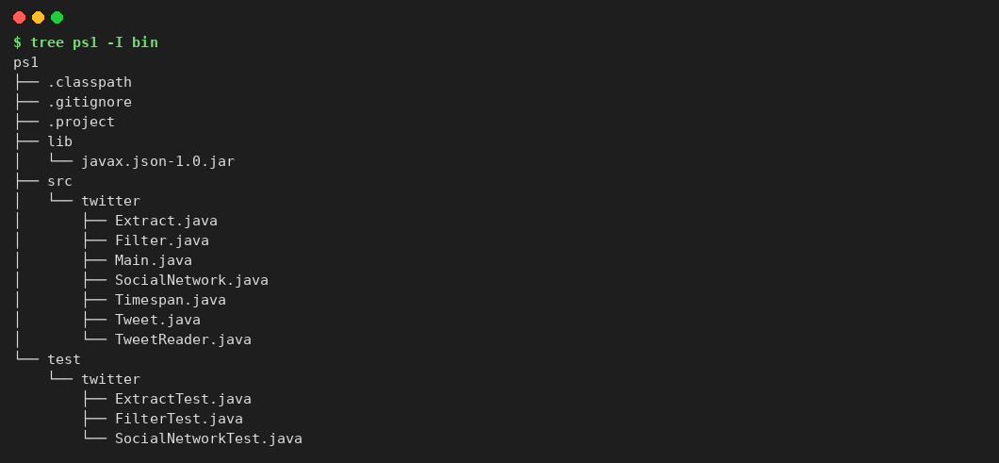
Figure 1: Project structure of ps1 (command-line run)

Step 2: What the specifications say
guessFollowsGraph(List<Tweet>): returns a Map<String, Set<String>> in which map[A] is the set of people that A follows. Ernie follows Bert if and only if there is evidence for it; an @-mention of Bert by Ernie is evidence and must be implemented. The spec allows other kinds of evidence at the implementor's discretion (so the result is not unique: the postcondition is underdetermined), and every username of the result must be an author or an @-mention in the tweets. Users can't follow themselves, usernames are not case sensitive, and a username appears at most once as a key and in any follows set.
influencers(Map<String, Set<String>>): returns all distinct usernames of the graph, in descending order of follower count. The spec does not say how users with the same number of followers are ordered, and it does not fix the letter case of the returned names.

Step 3: Testing strategy
Because the postcondition of guessFollowsGraph() is underdetermined, an implementation that adds more evidence than the minimum is still correct. The tests therefore only check that the required follows ARE present (positive checks), or, when no evidence exists at all, that nobody follows anybody. No test checks the exact size of the graph or the exact set of keys. Usernames are compared in lower case, and tied users are compared as groups, never as an order. The partitions are listed in the class comment of SocialNetworkTest.java and in Table 1.
Table 1: Partitions of the input space
Method | Partition | Values tested
guessFollowsGraph | number of tweets | empty list, 1, many
guessFollowsGraph | mentions per tweet | none, one, many
guessFollowsGraph | tweets per author | one, many (mentions are merged)
guessFollowsGraph | username case / repeats | Ernie vs ERNIE, @BERT vs @Bert: one follow edge
guessFollowsGraph | text with an e-mail address | not a mention, no evidence
guessFollowsGraph | mention of oneself | not a follow (users can't follow themselves)
influencers | graph | empty, one user without followers, one influencer, several users
influencers | follower counts | all different (strict order), tied (in the middle and at the top)
influencers | username case | Bert and bert are one person, counted once
both | input is not modified | tweets list / graph are unchanged after the call

Task 3: Test Cases, Red Bar, Implementation, Green Bar

Step 1: The ten required test cases
The lab lists ten test cases. Table 2 maps each of them to the JUnit test that covers it. Nine more tests were added: a second tie test, and eight tests for case-insensitivity, e-mail addresses, self-mentions, several authors, unmodified input and one combined test of both methods. SocialNetworkTest.java therefore has 20 tests (19 real tests plus testAssertionsEnabled, as in the starter code).
Table 2: Required test cases and the tests that implement them
# | Required test case | JUnit test(s) and what is asserted
1 | Empty list of tweets | testGuessFollowsGraphEmpty: the graph is empty
2 | Tweets without mentions | testGuessFollowsGraphNoMentions: nobody follows anybody (the authors may or may not be keys)
3 | Single mention | testGuessFollowsGraphSingleMention: ernie is in the graph and follows bert
4 | Multiple mentions | testGuessFollowsGraphMultipleMentions: ernie follows bert, oscar and grover
5 | Multiple tweets from one user | testGuessFollowsGraphMultipleTweetsFromOneUser: the mentions of the first and of the last tweet are both kept
6 | Empty graph for influencers() | testInfluencersEmptyGraph: the list is empty
7 | Single user without followers | testInfluencersSingleUserWithoutFollowers: nobody except that user is listed
8 | Single influencer | testInfluencersSingleInfluencer: bert (1 follower) is before ernie (0)
9 | Multiple influencers | testInfluencersMultipleInfluencers: order carol (3), dave (2), bert (1)
10 | Tied influence | testInfluencersTiedInfluence, testInfluencersTiedAtTheTop: tied users are compared as a group, not as an order
+ | Extras | UpperCaseUsernames (both methods), EmailIsNoEvidence, SelfMentionIsNotAFollow, DifferentAuthors, DoesNotModifyInput (both), testGuessThenInfluencers

A note on test case 7. The lab text says that a user without followers "yields no influencers". The spec of influencers(), however, returns all distinct usernames of the graph, so the single user is allowed to appear in the list (with 0 followers). The test accepts both: the list has at most one user and nobody else is listed. This follows the spec and does not over-specify.

Step 2: Red bar (tests first)
Before any implementation, a stub of SocialNetwork.java was created that compiles but returns an empty graph and an empty list. SocialNetworkTest.java was run against the stub: 12 of the 20 tests fail (Figure 2); the other 8 pass by accident because the empty answer is right for them (empty list, no mentions, e-mail, unmodified input, single user). The first lines of the failure trace are in Listing 1. This is the "red" step of the red-to-green cycle.
Listing 1: JUnit output against the stub (first failures)
JUnit version 4.13.2
..E...E.E.E.E.E.E.....E..E.E.E.E
Time: 0.025
There were 12 failures:
1) testGuessFollowsGraphSingleMention(twitter.SocialNetworkTest)
java.lang.AssertionError: ernie must be in the graph
2) testGuessFollowsGraphUpperCaseUsernames(twitter.SocialNetworkTest)
java.lang.AssertionError: case-insensitive: ernie follows bert exactly once expected:<[bert]> but was:<[]>
3) testInfluencersTiedInfluence(twitter.SocialNetworkTest)
java.lang.AssertionError: 4 users expected:<4> but was:<0>
4) testGuessFollowsGraphMultipleTweetsFromOneUser(twitter.SocialNetworkTest)
java.lang.AssertionError: mention in the first tweet is kept
5) testGuessFollowsGraphMultipleMentions(twitter.SocialNetworkTest)
java.lang.AssertionError: ernie follows bert
6) testGuessFollowsGraphSelfMentionIsNotAFollow(twitter.SocialNetworkTest)
java.lang.AssertionError: the mention of bert is still evidence
7) testGuessThenInfluencers(twitter.SocialNetworkTest)
java.lang.IndexOutOfBoundsException: Index 0 out of bounds for length 0
8) testInfluencersUpperCaseUsernames(twitter.SocialNetworkTest)
java.lang.AssertionError: distinct people only: ernie, grover, bert, oscar expected:<4> but was:<0>
9) testGuessFollowsGraphDifferentAuthors(twitter.SocialNetworkTest)
java.lang.AssertionError: ernie follows bert

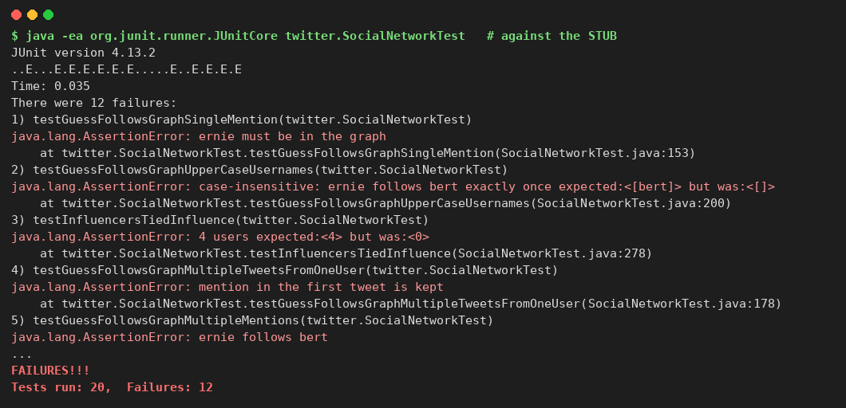
Figure 2: Red: SocialNetworkTest against the stub, 12 of 20 tests fail (command-line run)

Step 3: Implementation
guessFollowsGraph() lower-cases the author, finds the @-mentions of each tweet with a regular expression (an @ that is not directly after a username character, so an e-mail address is no mention; SocialNetwork does not depend on Problem 1), skips a mention of oneself because a user cannot follow themselves, and adds the rest, in lower case, to the follows set of the author. Lower case everywhere makes every user appear at most once, as the spec demands. Only authors who mention somebody get an entry, which is the minimum the spec requires. influencers() builds, for every user of the graph (as follower or as followed user), the set of distinct followers in lower case, so the same person written as Ernie and ERNIE counts once, and sorts the users by the size of that set in descending order. Ties are put in alphabetical order, which is allowed by the spec and makes the output stable. The complete code is in Listing 4.

Step 4: Green bar
With the real SocialNetwork.java all 20 tests pass (Figure 3). Together with the 15 tests of ExtractTest and FilterTest from Lab 05, the whole project has 35 tests and all of them pass (Figure 4, Listing 2).
Listing 2: JUnit output of the whole suite (SocialNetworkTest, ExtractTest, FilterTest)
JUnit version 4.13.2
...................................
Time: 0.065

OK (35 tests)

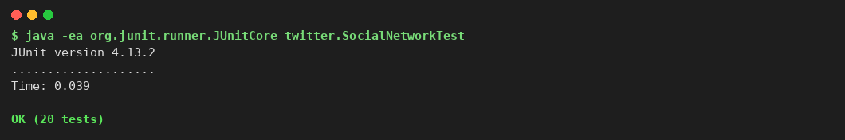
Figure 3: Green: SocialNetworkTest with the implementation, 20 of 20 pass (command-line run)
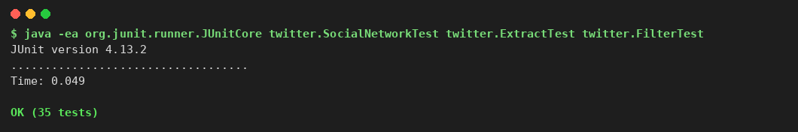
Figure 4: Green: whole project (SocialNetworkTest, ExtractTest, FilterTest), 35 of 35 pass (command-line run)

Step 5: Run Main.java
The starter Main.java downloads a live sample of tweets from an MIT course server. This version uses a built-in sample of seven tweets instead, so that it also runs offline and always gives the same output. It prints the guessed follows graph and the top most-followed people (Listing 3, Figure 5). In the sample, alyssa is mentioned by four different users, so she is the first influencer; bbitdiddle and carol are tied with two followers each.
Listing 3: Output of Main.java
Number of tweets: 7
Timespan: 2016-02-17T10:00:00Z to 2016-02-17T16:00:00Z
Mentioned users: [alyssa, bbitdiddle, carol, dave]
Written by alyssa: [tweet 1, tweet 4]
In timespan 09:00-12:00: [tweet 1, tweet 2]
Containing [talk, lunch]: [tweet 1, tweet 2, tweet 4, tweet 5]

Guessed follows graph (user -> follows):
alyssa -> [carol]
bbitdiddle -> [alyssa]
carol -> [alyssa, bbitdiddle]
dave -> [alyssa, bbitdiddle, carol]
erin -> [alyssa, dave]

Top 10 most-followed people:
1. alyssa (4 followers)
2. bbitdiddle (2 followers)
3. carol (2 followers)
4. dave (1 follower)
5. erin (0 followers)

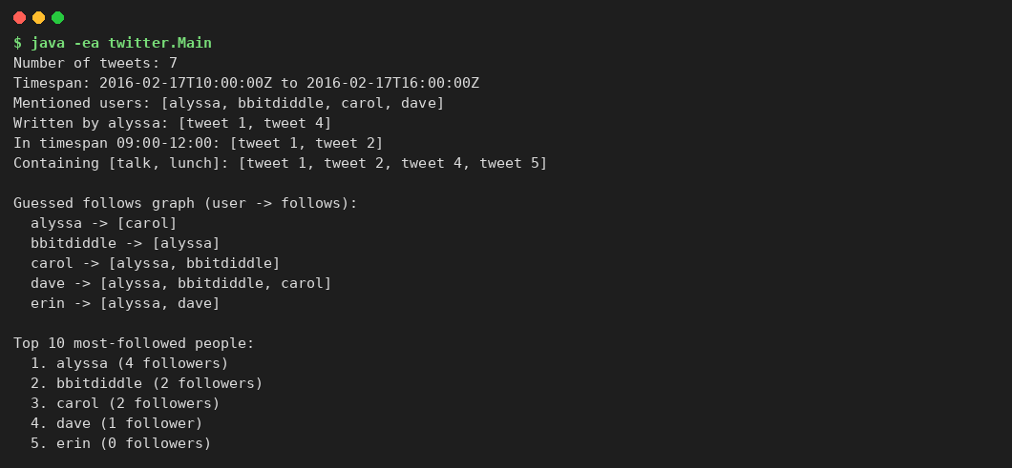
Figure 5: Output of Main.java: follows graph and the top most-followed people (command-line run)

Step 6: Do the tests respect the underdetermined postcondition?
The tests were also run against a second implementation that is legal by the spec but different from mine: it makes every author a key (even without mentions), returns upper-case names from influencers() and orders tied users differently. All 20 tests pass on it, so the tests do not depend on my implementation choices. Then seven wrong implementations ("mutants") were tried, each with one change (Table 3). Six are caught. One is not caught, on purpose: letting every author follow every user mentioned anywhere is extra "evidence" that the spec leaves to the implementor, so a test that forbids it would not be a legal client of the underdetermined spec.
Table 3: Robustness of the tests (all results were run, none estimated)
Implementation | Result of the 20 tests | Meaning
Stub (empty graph, empty list) | 12 fail | Red bar: the tests demand real behaviour
My implementation | All pass | Green bar
Legal variant (different keys, case, tie order) | All pass | Tests are legal clients of the spec
Mutant: influencers() in ascending order | 6 fail | Caught
Mutant: only the first mention of an author is kept | 2 fail | Caught
Mutant: Ernie and ERNIE counted as two followers | 1 fails | Caught
Mutant: users who only follow are forgotten | 4 fail | Caught
Mutant: author name not lower-cased (Ernie, ERNIE are two keys) | 1 fails | Caught: a username must appear once
Mutant: a user follows themselves | 1 fails | Caught
Mutant: every author follows every mentioned user | All pass | Not catchable: extra evidence is allowed by the underdetermined spec

Step 7: Git: clean commits, red to green
The work was committed in small steps that follow the test-first cycle, so that the history shows the red bar before the green bar (Table 4, Figure 6).
Table 4: Commit history of the lab
# | Commit message | Content
1 | Lab 07: add SocialNetwork stub with specs | SocialNetwork.java (stub, compiles, does nothing)
2 | Lab 07: add SocialNetworkTest (red) | SocialNetworkTest.java: 12 of 20 tests fail
3 | Lab 07: implement guessFollowsGraph and influencers (green) | SocialNetwork.java: all 20 tests pass
4 | Lab 07: extend Main to print follows graph and top influencers | Main.java
5 | Lab 07: add report and console evidence | Lab_07_Huzaifa_Furqan_Test_First_II.docx

[ INSERT SCREENSHOT HERE ]
GitHub repository page — folder lab07/ps1 and the commit history (git log --oneline)
Figure 6: GitHub repository page

Source Code
The complete source code of the lab is below. Tweet, Timespan, Extract and Filter are unchanged from the earlier labs and are in the repository.
Listing 4: SocialNetwork.java
/* Copyright (c) 2007-2016 MIT 6.005 course staff, all rights reserved.
* Redistribution of original or derived work requires permission of course staff.
*/
package twitter;

import java.util.ArrayList;
import java.util.Collections;
import java.util.HashMap;
import java.util.HashSet;
import java.util.List;
import java.util.Map;
import java.util.Set;
import java.util.regex.Matcher;
import java.util.regex.Pattern;

/**
* SocialNetwork provides methods that operate on a social network.
*
* A social network is represented by a Map<String, Set<String>> where map[A] is
* the set of people that person A follows on Twitter, and all people are
* represented by their Twitter usernames. Users can't follow themselves. If A
* doesn't follow anybody, then map[A] may be the empty set, or A may not even exist
* as a key in the map; this is true even if A is followed by other people in the network.
* Twitter usernames are not case sensitive, so "ernie" is the same as "ERNie".
* A username should appear at most once as a key in the map or in any given
* map[A] set.
*
* DO NOT change the method signatures and specifications of these methods, but
* you should implement their method bodies, and you may add new public or
* private methods or classes if you like.
*/
public class SocialNetwork {

/** An @-mention: '@' (not directly after a username character) + username. */
private static final Pattern MENTION =
Pattern.compile("(?<![A-Za-z0-9_-])@([A-Za-z0-9_-]+)");

/**
* Guess who might follow whom, from evidence found in tweets.
*
* @param tweets
* a list of tweets providing the evidence, not modified by this
* method.
* @return a social network (as defined above) in which Ernie follows Bert
* if and only if there is evidence for it in the given list of
* tweets.
* One kind of evidence that Ernie follows Bert is if Ernie
* @-mentions Bert in a tweet. This must be implemented. Other kinds
* of evidence may be used at the implementor's discretion.
* All the Twitter usernames in the returned social network must be
* either authors or @-mentions in the list of tweets.
*/
public static Map<String, Set<String>> guessFollowsGraph(List<Tweet> tweets) {
// Implementation: the only evidence used is the @-mention. All names are
// stored in lower case, so each user appears at most once.
Map<String, Set<String>> followsGraph = new HashMap<>();
for (Tweet tweet : tweets) {
String author = tweet.getAuthor().toLowerCase();
Matcher matcher = MENTION.matcher(tweet.getText());
while (matcher.find()) {
String mentioned = matcher.group(1).toLowerCase();
if (!mentioned.equals(author)) { // users can't follow themselves
followsGraph.computeIfAbsent(author, k -> new HashSet<>()).add(mentioned);
}
}
}
return followsGraph;
}

/**
* Find the people in a social network who have the greatest influence, in
* the sense that they have the most followers.
*
* @param followsGraph
* a social network (as defined above)
* @return a list of all distinct Twitter usernames in followsGraph, in
* descending order of follower count.
*/
public static List<String> influencers(Map<String, Set<String>> followsGraph) {
// Implementation: names are returned in lower case; users with the same
// follower count are in alphabetical order (the spec leaves this open).
final Map<String, Set<String>> followers = new HashMap<>(); // user -> distinct followers
for (Map.Entry<String, Set<String>> entry : followsGraph.entrySet()) {
String follower = entry.getKey().toLowerCase();
followers.computeIfAbsent(follower, k -> new HashSet<>());
for (String name : entry.getValue()) {
String followee = name.toLowerCase();
followers.computeIfAbsent(followee, k -> new HashSet<>());
if (!followee.equals(follower)) {
followers.get(followee).add(follower);
}
}
}
List<String> result = new ArrayList<>(followers.keySet());
Collections.sort(result, (a, b) -> {
int byCount = Integer.compare(followers.get(b).size(), followers.get(a).size());
return byCount != 0 ? byCount : a.compareTo(b);
});
return result;
}

}

Listing 5: SocialNetworkTest.java
/* Copyright (c) 2007-2016 MIT 6.005 course staff, all rights reserved.
* Redistribution of original or derived work requires permission of course staff.
*/
package twitter;

import static org.junit.Assert.*;

import java.time.Instant;
import java.util.ArrayList;
import java.util.Arrays;
import java.util.HashMap;
import java.util.HashSet;
import java.util.List;
import java.util.Map;
import java.util.Set;

import org.junit.Test;

/**
* Testing strategy
*
* The postcondition of guessFollowsGraph() is underdetermined: the spec only
* demands that "Ernie follows Bert" is in the graph when Ernie @-mentions Bert,
* and it allows extra evidence. So these tests only check that the required
* edges ARE present (and, where no evidence exists at all, that no one follows
* anyone). They never check that the graph has exactly some size, and they
* compare usernames in lower case because usernames are case-insensitive.
* The spec also says that a username appears at most once as a key and in any
* follows set, which the upper-case tests check. Tests of a stronger spec would
* go into a separate class.
*
* guessFollowsGraph(tweets):
* list of tweets: empty, 1, many
* mentions per tweet: none, one, many
* tweets per author: one, many (mentions of the author's tweets are merged)
* same mention repeated / written in a different case: user appears once
* mention of oneself: not a follow (users can't follow themselves)
* e-mail address in the text: not a mention
*
* influencers(followsGraph):
* graph: empty, one user without followers, one influencer, several users
* follower counts: all different (strict order), tied
* usernames in different case: the same person, counted once
*
* Only the order of users with different follower counts is checked; the order
* among tied users is not specified by the spec and is never tested.
*/
public class SocialNetworkTest {

private static final Instant d1 = Instant.parse("2016-02-17T10:00:00Z");
private static final Instant d2 = Instant.parse("2016-02-17T11:00:00Z");
private static final Instant d3 = Instant.parse("2016-02-17T12:30:00Z");

@Test(expected = AssertionError.class)
public void testAssertionsEnabled() {
assert false; // make sure assertions are enabled with VM argument: -ea
}

// ---------- helpers (they keep the tests independent of the case and of
// the exact set of keys that an implementation chooses) ----------

/** @return the graph with all usernames in lower case */
private static Map<String, Set<String>> lower(Map<String, Set<String>> graph) {
Map<String, Set<String>> result = new HashMap<>();
for (Map.Entry<String, Set<String>> entry : graph.entrySet()) {
Set<String> follows =
result.computeIfAbsent(entry.getKey().toLowerCase(), k -> new HashSet<>());
for (String name : entry.getValue()) {
follows.add(name.toLowerCase());
}
}
return result;
}

/** The spec: a username appears at most once as a key and in any map[A] set. */
private static void assertEachUserOnce(Map<String, Set<String>> graph) {
Set<String> keys = new HashSet<>();
for (Map.Entry<String, Set<String>> entry : graph.entrySet()) {
assertTrue("key " + entry.getKey() + " appears twice (different case)",
keys.add(entry.getKey().toLowerCase()));
Set<String> names = new HashSet<>();
for (String name : entry.getValue()) {
assertTrue("follows set has " + name + " twice (different case)",
names.add(name.toLowerCase()));
}
}
}

/** @return the people that 'user' follows in the graph, empty if none */
private static Set<String> follows(Map<String, Set<String>> graph, String user) {
Set<String> set = lower(graph).get(user);
return set == null ? new HashSet<String>() : set;
}

/** @return the list of usernames in lower case */
private static List<String> lower(List<String> names) {
List<String> result = new ArrayList<>();
for (String name : names) {
result.add(name.toLowerCase());
}
return result;
}

private static Map<String, Set<String>> graphOf(Object... pairs) {
// pairs: "ernie", new String[]{"bert", "oscar"}, "bert", new String[]{...}
Map<String, Set<String>> graph = new HashMap<>();
for (int i = 0; i < pairs.length; i += 2) {
graph.put((String) pairs[i], new HashSet<>(Arrays.asList((String[]) pairs[i + 1])));
}
return graph;
}

// ---------- guessFollowsGraph() ----------

@Test
public void testGuessFollowsGraphEmpty() {
Map<String, Set<String>> followsGraph =
SocialNetwork.guessFollowsGraph(new ArrayList<Tweet>());

assertTrue("expected empty graph", followsGraph.isEmpty());
}

@Test
public void testGuessFollowsGraphNoMentions() {
Tweet t1 = new Tweet(1, "ernie", "is it reasonable to talk about rivest so much?", d1);
Tweet t2 = new Tweet(2, "bert", "rivest talk in 30 minutes", d2);
Map<String, Set<String>> followsGraph =
SocialNetwork.guessFollowsGraph(Arrays.asList(t1, t2));

// an implementation may or may not list the authors as keys, but nobody follows anybody
for (Set<String> follows : followsGraph.values()) {
assertTrue("no mention, so no evidence of any follow", follows.isEmpty());
}
}

@Test
public void testGuessFollowsGraphEmailIsNoEvidence() {
Tweet t = new Tweet(1, "ernie", "write to oscar@mit.edu for details", d1);
Map<String, Set<String>> followsGraph =
SocialNetwork.guessFollowsGraph(Arrays.asList(t));

Set<String> follows = follows(followsGraph, "ernie");
assertFalse("an e-mail address is not a mention", follows.contains("mit"));
assertFalse("an e-mail address is not a mention", follows.contains("oscar"));
}

@Test
public void testGuessFollowsGraphSingleMention() {
Tweet t = new Tweet(1, "ernie", "hello @bert", d1);
Map<String, Set<String>> followsGraph =
SocialNetwork.guessFollowsGraph(Arrays.asList(t));

assertTrue("ernie must be in the graph", lower(followsGraph).containsKey("ernie"));
assertTrue("ernie follows bert", follows(followsGraph, "ernie").contains("bert"));
}

@Test
public void testGuessFollowsGraphMultipleMentions() {
Tweet t = new Tweet(1, "ernie", "thanks @bert and @oscar, see @grover", d1);
Map<String, Set<String>> followsGraph =
SocialNetwork.guessFollowsGraph(Arrays.asList(t));

Set<String> follows = follows(followsGraph, "ernie");
assertTrue("ernie follows bert", follows.contains("bert"));
assertTrue("ernie follows oscar", follows.contains("oscar"));
assertTrue("ernie follows grover", follows.contains("grover"));
}

@Test
public void testGuessFollowsGraphMultipleTweetsFromOneUser() {
Tweet t1 = new Tweet(1, "ernie", "hello @bert", d1);
Tweet t2 = new Tweet(2, "ernie", "no mention here", d2);
Tweet t3 = new Tweet(3, "ernie", "and also @oscar", d3);
Map<String, Set<String>> followsGraph =
SocialNetwork.guessFollowsGraph(Arrays.asList(t1, t2, t3));

Set<String> follows = follows(followsGraph, "ernie");
assertTrue("mention in the first tweet is kept", follows.contains("bert"));
assertTrue("mention in the last tweet is kept", follows.contains("oscar"));
}

@Test
public void testGuessFollowsGraphDifferentAuthors() {
Tweet t1 = new Tweet(1, "ernie", "hello @bert", d1);
Tweet t2 = new Tweet(2, "bert", "hi @oscar", d2);
Map<String, Set<String>> followsGraph =
SocialNetwork.guessFollowsGraph(Arrays.asList(t1, t2));

assertTrue("ernie follows bert", follows(followsGraph, "ernie").contains("bert"));
assertTrue("bert follows oscar", follows(followsGraph, "bert").contains("oscar"));
}

@Test
public void testGuessFollowsGraphUpperCaseUsernames() {
Tweet t1 = new Tweet(1, "Ernie", "hello @BERT", d1);
Tweet t2 = new Tweet(2, "ERNIE", "again @Bert", d2);
Map<String, Set<String>> followsGraph =
SocialNetwork.guessFollowsGraph(Arrays.asList(t1, t2));

assertEquals("case-insensitive: ernie follows bert exactly once",
new HashSet<>(Arrays.asList("bert")), follows(followsGraph, "ernie"));
assertEachUserOnce(followsGraph);
}

@Test
public void testGuessFollowsGraphSelfMentionIsNotAFollow() {
Tweet t = new Tweet(1, "ernie", "note to self @Ernie, and thanks @bert", d1);
Map<String, Set<String>> followsGraph = SocialNetwork.guessFollowsGraph(Arrays.asList(t));

assertFalse("the spec says users can't follow themselves",
follows(followsGraph, "ernie").contains("ernie"));
assertTrue("the mention of bert is still evidence", follows(followsGraph, "ernie").contains("bert"));
}

@Test
public void testGuessFollowsGraphDoesNotModifyInput() {
Tweet t1 = new Tweet(1, "ernie", "hello @bert", d1);
Tweet t2 = new Tweet(2, "bert", "hi @oscar", d2);
List<Tweet> input = new ArrayList<>(Arrays.asList(t1, t2));
List<Tweet> copy = new ArrayList<>(input);

SocialNetwork.guessFollowsGraph(input);

assertEquals("the spec says the input list is not modified", copy, input);
}

// ---------- influencers() ----------

@Test
public void testInfluencersEmptyGraph() {
List<String> influencers = SocialNetwork.influencers(new HashMap<String, Set<String>>());

assertTrue("expected empty list", influencers.isEmpty());
}

@Test
public void testInfluencersSingleUserWithoutFollowers() {
Map<String, Set<String>> graph = graphOf("ernie", new String[] {});
List<String> influencers = lower(SocialNetwork.influencers(graph));

// the spec lists every user of the graph, so ernie may appear, but nobody else
assertTrue("at most one user", influencers.size() <= 1);
assertFalse("nobody except ernie can be listed", influencers.contains("bert"));
}

@Test
public void testInfluencersSingleInfluencer() {
Map<String, Set<String>> graph = graphOf("ernie", new String[] {"bert"});
List<String> influencers = lower(SocialNetwork.influencers(graph));

assertEquals("bert (1 follower) is before ernie (0)", "bert", influencers.get(0));
assertTrue("ernie is a user of the graph too", influencers.contains("ernie"));
}

@Test
public void testInfluencersMultipleInfluencers() {
// followers: carol 3, dave 2, bert 1, others 0
Map<String, Set<String>> graph = graphOf(
"ernie", new String[] {"bert", "carol", "dave"},
"oscar", new String[] {"carol", "dave"},
"grover", new String[] {"carol"});
List<String> influencers = lower(SocialNetwork.influencers(graph));

assertEquals("all users of the graph, each once", 6, influencers.size());
assertEquals("carol has 3 followers", "carol", influencers.get(0));
assertEquals("dave has 2 followers", "dave", influencers.get(1));
assertEquals("bert has 1 follower", "bert", influencers.get(2));
}

@Test
public void testInfluencersTiedInfluence() {
// bert and dave have 1 follower each, ernie and oscar have none
Map<String, Set<String>> graph = graphOf(
"ernie", new String[] {"bert"},
"oscar", new String[] {"dave"});
List<String> influencers = lower(SocialNetwork.influencers(graph));

assertEquals("4 users", 4, influencers.size());
// the order inside a tie is not specified: only compare the groups
assertEquals("the two users with a follower come first",
new HashSet<>(Arrays.asList("bert", "dave")),
new HashSet<>(influencers.subList(0, 2)));
assertEquals("the two users without followers come last",
new HashSet<>(Arrays.asList("ernie", "oscar")),
new HashSet<>(influencers.subList(2, 4)));
}

@Test
public void testInfluencersTiedAtTheTop() {
Map<String, Set<String>> graph = graphOf(
"ernie", new String[] {"bert", "dave"},
"oscar", new String[] {"bert", "dave", "carol"});
List<String> influencers = lower(SocialNetwork.influencers(graph));

assertEquals("bert and dave (2 followers each) lead",
new HashSet<>(Arrays.asList("bert", "dave")),
new HashSet<>(influencers.subList(0, 2)));
assertEquals("carol (1 follower) is third", "carol", influencers.get(2));
}

@Test
public void testInfluencersUpperCaseUsernames() {
// "Bert" and "bert" are the same person; "Ernie" and "ERNIE" are the same follower
Map<String, Set<String>> graph = graphOf(
"Ernie", new String[] {"Bert"},
"ERNIE", new String[] {"bert", "Oscar"},
"grover", new String[] {"OSCAR"});
List<String> influencers = lower(SocialNetwork.influencers(graph));

assertEquals("distinct people only: ernie, grover, bert, oscar", 4, influencers.size());
assertEquals("oscar has 2 followers (ernie, grover)", "oscar", influencers.get(0));
assertEquals("bert has 1 follower (ernie, counted once)", "bert", influencers.get(1));
}

@Test
public void testInfluencersDoesNotModifyInput() {
Map<String, Set<String>> graph = graphOf("ernie", new String[] {"bert"});
Map<String, Set<String>> copy = graphOf("ernie", new String[] {"bert"});

SocialNetwork.influencers(graph);

assertEquals("the spec says the graph is not modified", copy, graph);
}

@Test
public void testGuessThenInfluencers() {
Tweet t1 = new Tweet(1, "ernie", "hello @bert", d1);
Tweet t2 = new Tweet(2, "oscar", "hi @Bert and @ernie", d2);
Tweet t3 = new Tweet(3, "grover", "@BERT!", d3);
List<String> influencers = lower(SocialNetwork.influencers(
SocialNetwork.guessFollowsGraph(Arrays.asList(t1, t2, t3))));

assertEquals("bert is mentioned by three different authors", "bert", influencers.get(0));
assertEquals("ernie is mentioned by one author", "ernie", influencers.get(1));
}
}

Listing 6: Main.java
/* Copyright (c) 2007-2016 MIT 6.005 course staff, all rights reserved.
* Redistribution of original or derived work requires permission of course staff.
*/
package twitter;

import java.time.Instant;
import java.util.Arrays;
import java.util.List;
import java.util.Map;
import java.util.Set;

/**
* Main is a small driver to see Extract, Filter and SocialNetwork working on a
* sample list of tweets. (The original starter code downloads live tweets; this
* version uses a built-in sample so that it also runs offline. Main is not
* used in grading.)
*/
public class Main {

public static void main(String[] args) {
List<Tweet> tweets = Arrays.asList(
new Tweet(1, "alyssa", "is it reasonable to talk about rivest so much?",
Instant.parse("2016-02-17T10:00:00Z")),
new Tweet(2, "bbitdiddle", "@Alyssa rivest talk in 30 minutes #hype",
Instant.parse("2016-02-17T11:00:00Z")),
new Tweet(3, "carol", "thanks @bbitdiddle and @ALYSSA, mail me at carol@mit.edu",
Instant.parse("2016-02-17T12:30:00Z")),
new Tweet(4, "Alyssa", "Talk about Rivest again tomorrow with @carol",
Instant.parse("2016-02-17T13:15:00Z")),
new Tweet(5, "dave", "great talk @alyssa, see you @carol and @bbitdiddle",
Instant.parse("2016-02-17T14:00:00Z")),
new Tweet(6, "erin", "following @alyssa and @dave closely",
Instant.parse("2016-02-17T15:00:00Z")),
new Tweet(7, "frank", "no mention in this tweet",
Instant.parse("2016-02-17T16:00:00Z")));

System.out.println("Number of tweets: " + tweets.size());

Timespan span = Extract.getTimespan(tweets);
System.out.println("Timespan: " + span.getStart() + " to " + span.getEnd());
System.out.println("Mentioned users: "
+ new java.util.TreeSet<>(Extract.getMentionedUsers(tweets)));

System.out.println("Written by alyssa: " + ids(Filter.writtenBy(tweets, "alyssa")));
Timespan morning = new Timespan(Instant.parse("2016-02-17T09:00:00Z"),
Instant.parse("2016-02-17T12:00:00Z"));
System.out.println("In timespan 09:00-12:00: " + ids(Filter.inTimespan(tweets, morning)));
System.out.println("Containing [talk, lunch]: "
+ ids(Filter.containing(tweets, Arrays.asList("talk", "lunch"))));

// ---- Lab 07: social network ----
Map<String, Set<String>> followsGraph = SocialNetwork.guessFollowsGraph(tweets);
System.out.println();
System.out.println("Guessed follows graph (user -> follows):");
for (String user : new java.util.TreeSet<>(followsGraph.keySet())) {
System.out.println(" " + user + " -> "
+ new java.util.TreeSet<>(followsGraph.get(user)));
}

List<String> influencers = SocialNetwork.influencers(followsGraph);
System.out.println();
System.out.println("Top 10 most-followed people:");
for (int i = 0; i < Math.min(10, influencers.size()); i++) {
String user = influencers.get(i);
int n = followerCount(followsGraph, user);
System.out.println(" " + (i + 1) + ". " + user + " (" + n
+ (n == 1 ? " follower)" : " followers)"));
}
}

/** @return number of distinct people in the graph who follow the given user */
private static int followerCount(Map<String, Set<String>> graph, String user) {
int count = 0;
for (Map.Entry<String, Set<String>> entry : graph.entrySet()) {
if (entry.getValue().contains(user)) {
count++;
}
}
return count;
}

/** @return the ids of the given tweets, for compact printing */
private static String ids(List<Tweet> tweets) {
StringBuilder sb = new StringBuilder("[");
for (int i = 0; i < tweets.size(); i++) {
sb.append(i == 0 ? "" : ", ").append("tweet ").append(tweets.get(i).getId());
}
return sb.append("]").toString();
}
}

Deliverables
This single Word document (with the solution, the code and the screenshots) is submitted on LMS together with the GitHub link on the first page. In case of any problem with LMS, the lab is emailed to aftab.farooq@seecs.edu.pk.

