Start a project by ``nest new <project-name>``

then ``npm I @nestjs/mongoose mongoose``

Update the app.module.ts as:

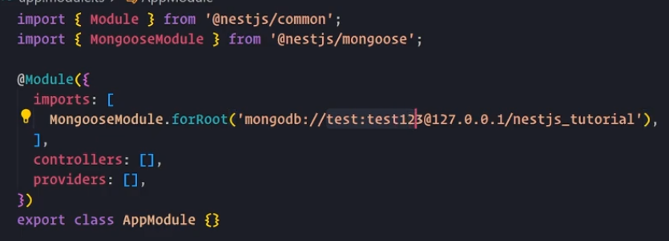the crietria is ‘mongodb://<username>:<password>@<hostname>/<database name>’

create a folder called schemas and add in it a file e.g. User.schema.ts in that add the code:

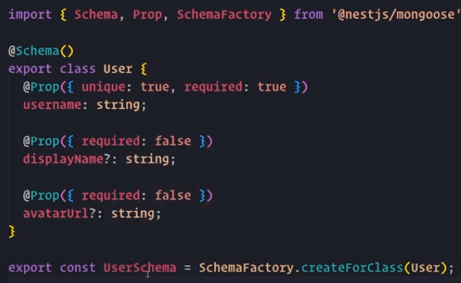

create a module and add:

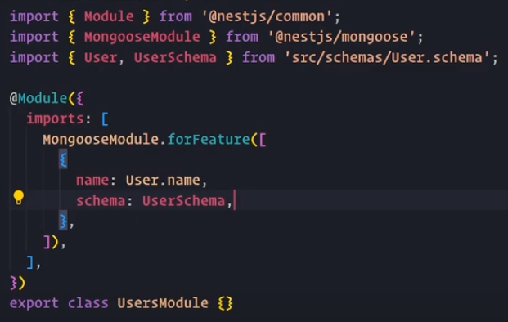

add that newly created module in app.module.ts

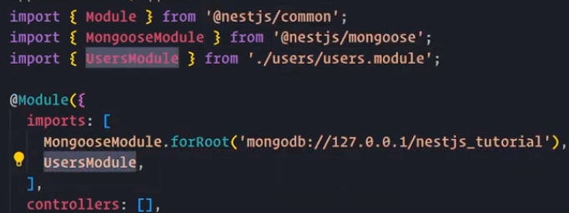

create a service in that module and inject the model/entity in constructor

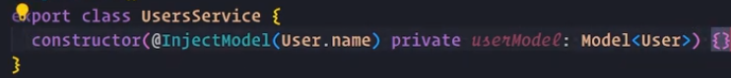

now we can use this userModel anywhere as this.userModel