RIPHAH INTERNATIONAL UNIVERSITY


Faculty of Computing

Semester Project Report - Fall 2022

<Rent a Car System>

Project Team
Full Name of Student | SAP-ID | Program | Contact Number | Email Address
M.Huzaifa Khan | 46878 | SE | 03115888641 | hk9349881@gmail.com
M.Hamza Ali | 46897 | SE | 03425399918 | buttalihamza@gmail,com
Alyan Rizvi | 34822 | SE | 03493662296 | Alyyanrizvi1@gmail.com

Project Supervisor: Muhammad Shabbir Hassan
(Lecturer)

Introduction / abstract
We are creating a project on rent a car system. In this project we will give some options for the selection of cars the user will login to the program a menu will display to him then user will be able to select the car. We also implement the program for the method of payments. The main focus of project is to make booking easy for the user and the owner.
- Problem identification
As we know that car booking system was bit difficult as manually we create this project so that the user easily fulfills all the requirements and papers to o book the car.
System features
Requirements

User Requirements
- User should be able to choose a car by his own
- User Should be able to see types of Cars
- User Should be able to see car model
- User should be able to see rent of each model of car
- Should be able to book the car
- User should be able to choose payment method
- User should have a choice to book a car with driver without a driver

System Requirements
- The System should have Login interface
- The system should get User information
- The system should give Options for cars
- The system should give suggestion for car by getting some information
- The System should give the options for Classic or Luxury cars
- The system should have the Payment method

Functional Requirements
- The program should display menu for the Cars
- The program should display a message if the user enters wrong information
- The program should run until it is interrupted or terminated

Non Functional Requirements
- The program should be easy to understand and use
- The program should be reliable and not crash or produce un expected results
- The program should be saleable and able to handle a large number of vehicle
- The program should be well documented and maintain able

Plaining phase
Modules | Task Description | Start-Date | Resource |  | End-Date
Login | In this module user will enter his name and password to get further details | 25-12-2022 | user |  | 26-12-2022
Available cars | In this module program will show car types, models and which car will available or not | 27-12-2022 | Aliyan |  | 29-12-2022
Car comfortability | In this module the program will show whether customer wants classic car or luxury car | 30-12-2022 | Huzaifa |  | 01-01-2023
User info form | In this module customer will enter details e.g. name, id card, license and other details. | 02-01-2023 | Hamza |  | 04-01-2023
Payments | In this module program will get bank details for payment and then show the cost of that car | 06-01-2023 | User/Bilal | 07-01-2023

Modules

Module 1
- Login
Features
- User name
- Password

Module 2
- Available cars
Features
- car info

Module 3
- Car comfortability
feature
- Classic cars
- Luxury cars

Module 4
- User info form

Features
- Getting user information
- Which include
- Name
- ID card no
- License
- Booking starting date and ending date

Module 5
- Payments
Feature
- Display amounts
- Getting bank details
- Getting payments
Design phase
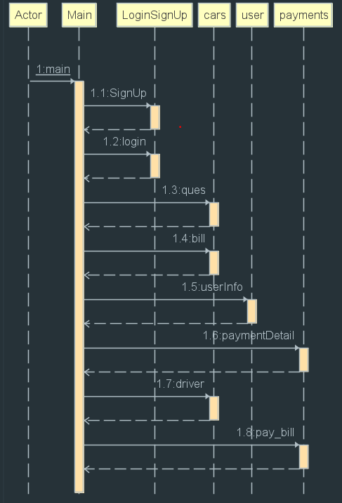

- UML Diagram
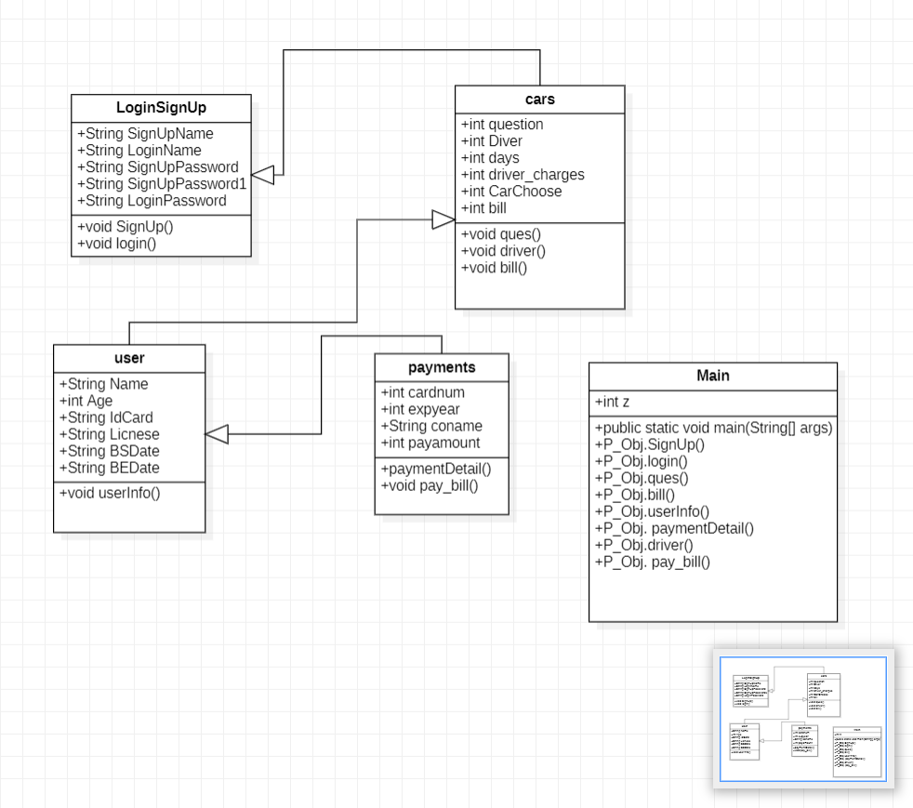
Coding phase
package Rent_A_Car_System;
import java.util.Scanner;
public class Main {
public static void main(String[] args) {
Scanner sc=new Scanner(System.in);
payments P_Obj=new payments();
int z=-1;
P_Obj.SignUp();
do{
P_Obj.login();
if(P_Obj.LoginPassword.length()==P_Obj.SignUpPassword.length())
{
System.out.println(" Your Login is Sucessfull >>>!");
System.out.println("press 0 to move for next function : ");
z=sc.nextInt();
}
else
{
System.out.println(" UserName and Passsword Does Not Match ");
System.out.print("press 9 to login again : ");
z=sc.nextInt();
}
}while(z!=0);
System.out.println(" ");
P_Obj.ques();
P_Obj.bill();
P_Obj.userInfo();
P_Obj. paymentDetail();
P_Obj.driver();
P_Obj. pay_bill();
}
}

Testing phase

Test Case1 | Module | Input | Variable | Operation | Output/Error
Test Case1 | Signup | Name: string  Password: (int) | String SignUpName;  int SignUpPassword; | Name Stored in this variable  Password Stored in variable | Output:  Signup Successfully.  Error:  If we enter string in password we got error

Description:
In this case we test the function of signup. We enter name with alphabet and also numeric digits its work but in password functionality if we enter string type password then it gives us error.

Solution:
Initially we choose password datatype as integer after testing we change its data type as string. Then it works proplerly.

Test Case2 | Module | Input | Variable | Operation | Output/Error
Test Case2 | Login | Name: string  Password: (int) | String LoginName;  String LoginPassword; | Name Stored in this variable  Password Stored in variable | Output:  Login Successfully.  Error:  If we enter wrong password or username then it gives message to relogin again

Description:
In this case we test the function of Login. We enter wrong username and password then program gives output in message to Login again.

Solution:
You have to enter correct username and password so that it matches with
signup username and password.

Test Case 3 | Module | Input | Variable | Operation | Output/Error
Test Case 3 | Cars File | question: int  Driver: (int)  days: (int)  Days_charges: (int)  carchoose: (int)  bill: (int) | int question;  int Diver;  int days;  int driver_charges=3000;  int CarChoose;  int bill; | All are used to store values in variables | Output:  Program will ask for 2 values to enter 1 and 2  Error:  If we enter wrong option then program will give some options to choose car

Description:
In this case we test the function of Car. We have got two option 1 and 2 if user enter 3 program will give some options to choose car however option 1 is to recommend company suggestion for cars and this function have some questionnaire and option 2 is to choose options by customer’s own self.

Solution:
This function is working correctly so no need to recommend any solution.

MORE Description:
If user enter option 1 program will ask for some questions after taking information about those questions program will recommend some perfect cars to travel those areas and give all other cars too if user want to take any other car. After choosing any one of required car program will ask to enter days for which you want to take the car. After entering days’ program will gives detail information about the car that you choose.

If user enter option 2 program will directly give option to enter car. After entering the option program will give detail information about that car.

Test Case 4 | Module | Input | Variable | Operation | Output/Error
Test Case 4 | User File | age: int  idcard: (string)  Licsense: (STRING)  BSdate: (string)  BEdate: string | String Name;  int Age;  String IdCard;  String Licnese;  String BSDate;  String BEDate; | All are used to store values in variables | Output:  Program will ask to enter user detail information  Error:  This function gives no error as every variable is string

Description:
In this case we test the function of user. After entering all the information about cars file the program will ask the customer to enter detail information about his self and start and end date of booking the cars.

Solution:
This function is working correctly so no need to recommend any solution.

Test Case 5 | Module | Input | Variable | Operation | Output/Error
Test Case 5 | payment | cardnum: int  coname: (string)  expyear: (int)  payamount: (int) | int cardnum;  int expyear;  String coname;  int payamount; | All are used to store values in variables | Output:  Program will ask to enter user account information  Error:

Description:
In this case we test the function of payment. Program will ask to enter information about account card details. Card expiry date and other information then program will ask to drive car by yourself or you want to take driver with you. Then extra bill will be added. After entering all the information, you have to enter bill then the bill will be paid.

Solution:
This function is working correctly so no need to recommend any solution.

Conclusion

The conclusion of this project is that our project is created to help peoples with the booking for cars with an easy way. Basically this project can be published online and then can be useful for future use with the fusion of GUI interface. The working of this project is that first user will get a login interface the user will enter name and password menu will display for choosing cars types and models. Then program will ask for the classical and luxurious cars. After that program will ask for the driver whether customer wants vehicle with driver or without driver. After that the program will ask for the payment procedure. These are the workings and functions of our project.

