Lab 3: Campus Cafe Order System

Step 1 Output:
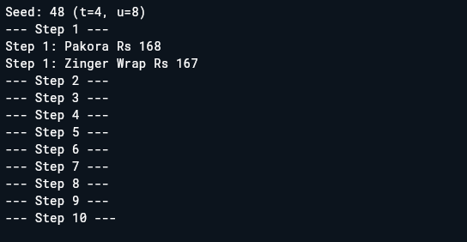
Step 2 Output:
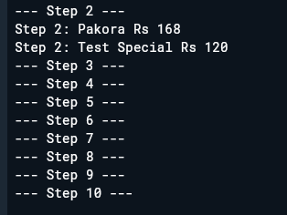
Step 3 Output:
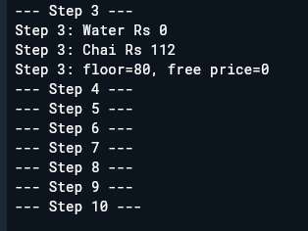
Step 4 Output:
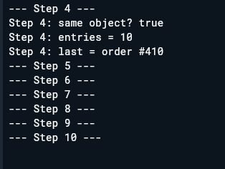
Step 5 Output:
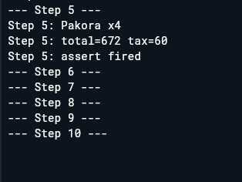
Step 6 Output:
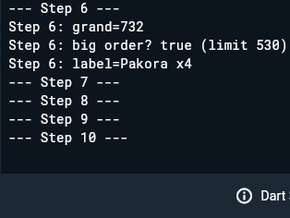

Step 7 Output:
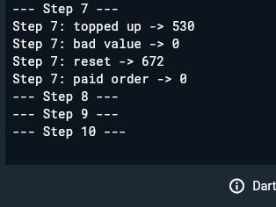
Step 8 Output:

Step 9 Output:

Step 10 Output:

