# **DAY3-API INTEGRATION AND DATA MIGRATION**

* **Initialize a new Sanity project using the CLI**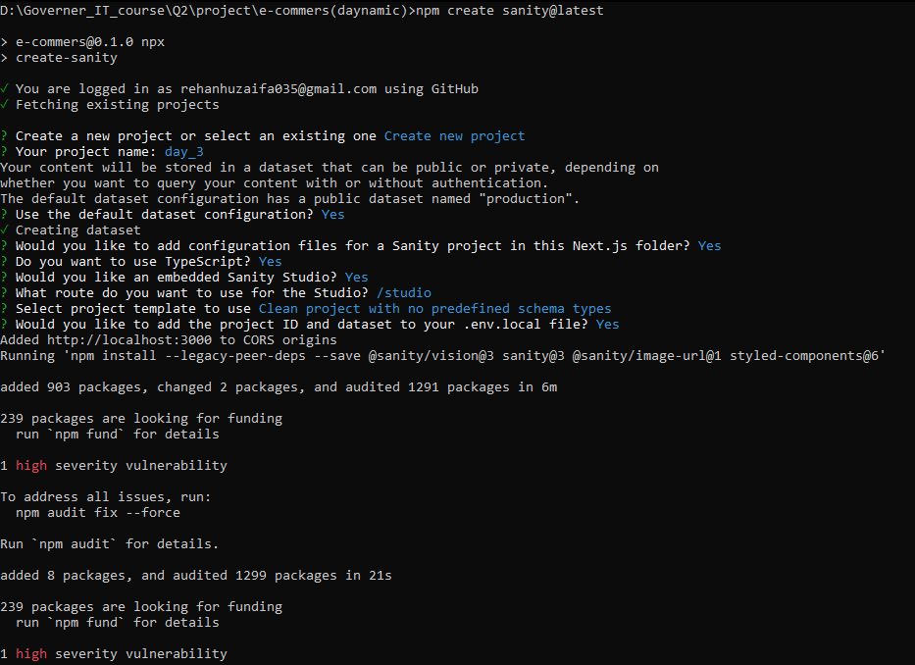
* **Configure and manage API tokens with appropriate permissions (e.g., Developer level) to securely connect external applications to the Sanity Studio**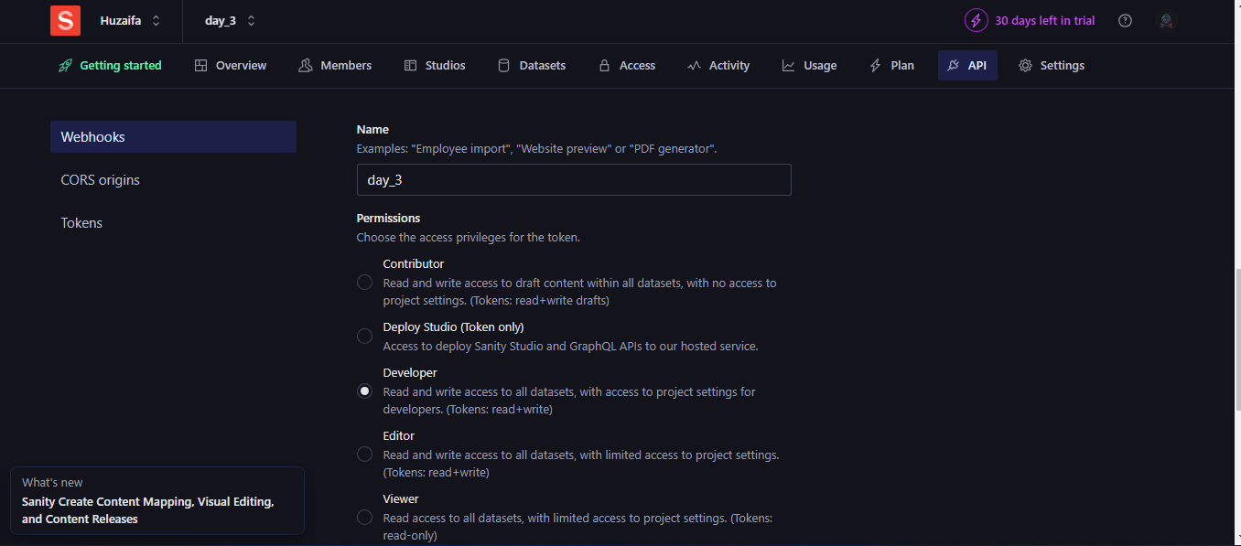
* **API token generated, securely stored, and ready for integration.**

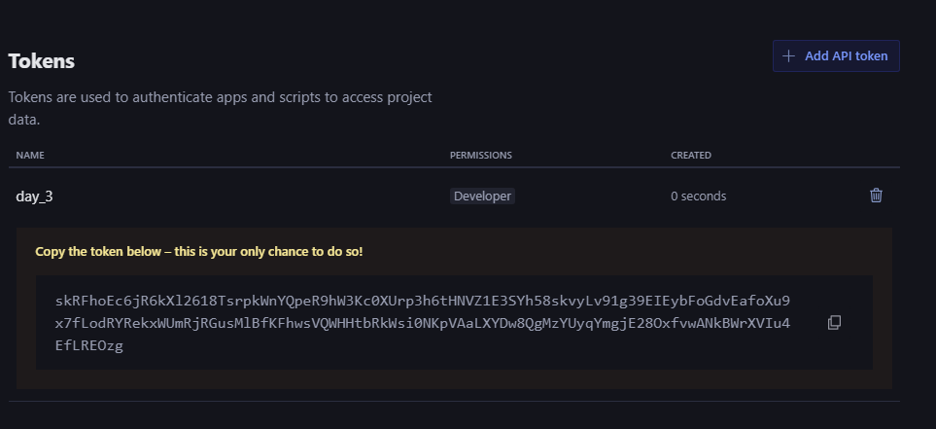

* **Sanity schema for "Product" created with fields and validation rules.**

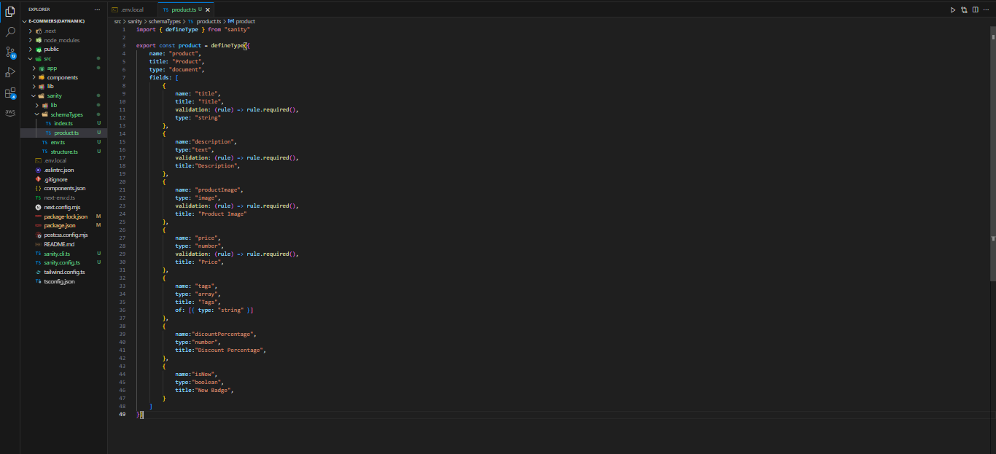

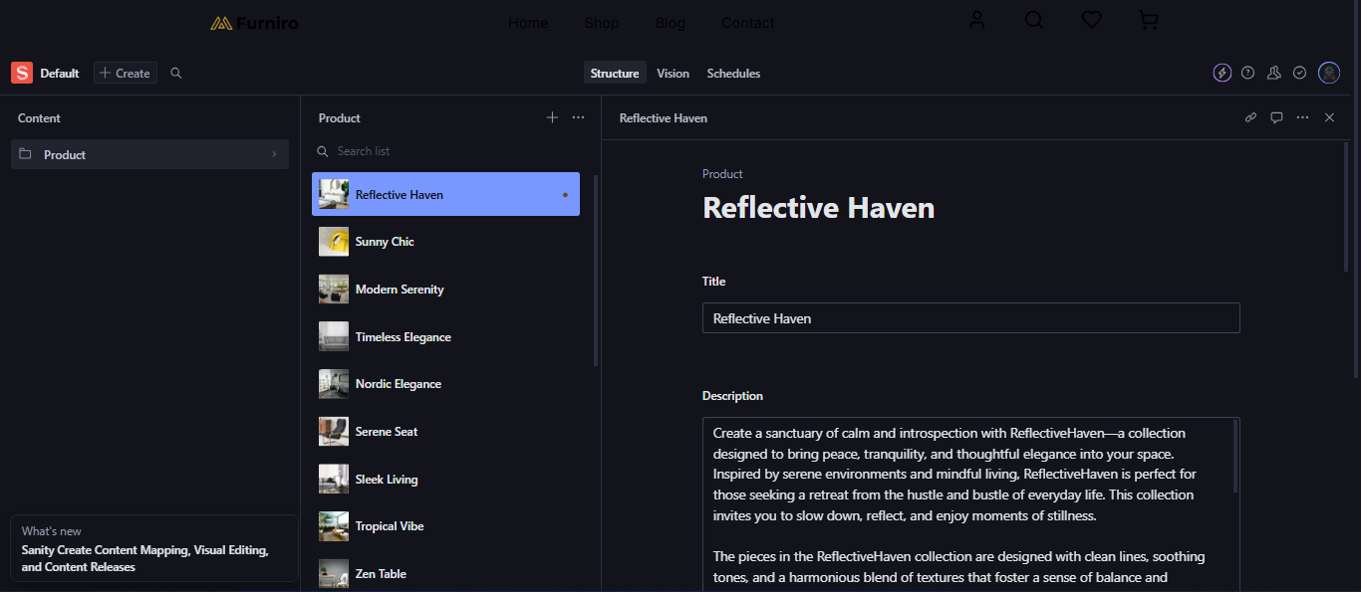

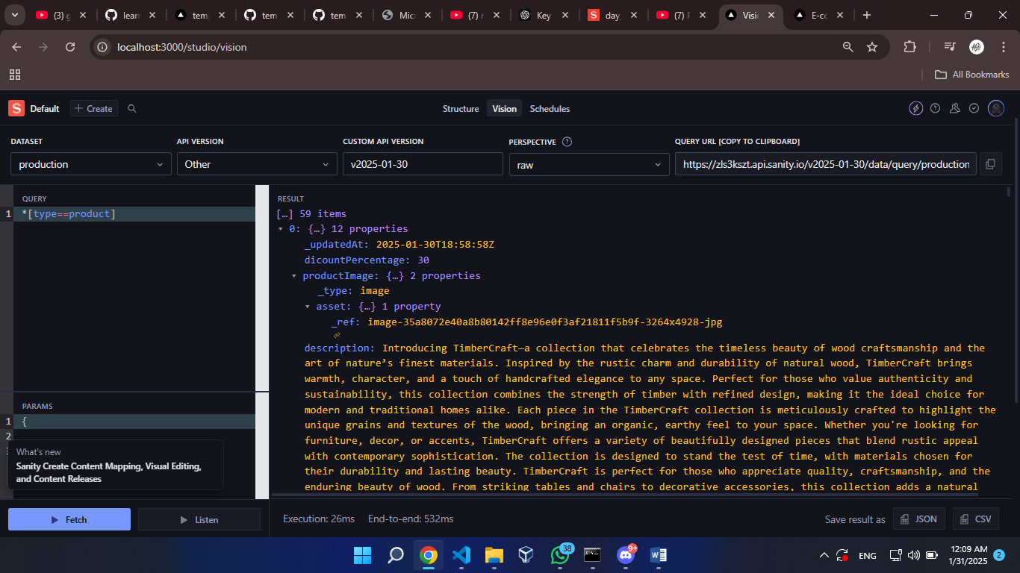

* **Create a scripts folder and an importData.js file to handle data imports.**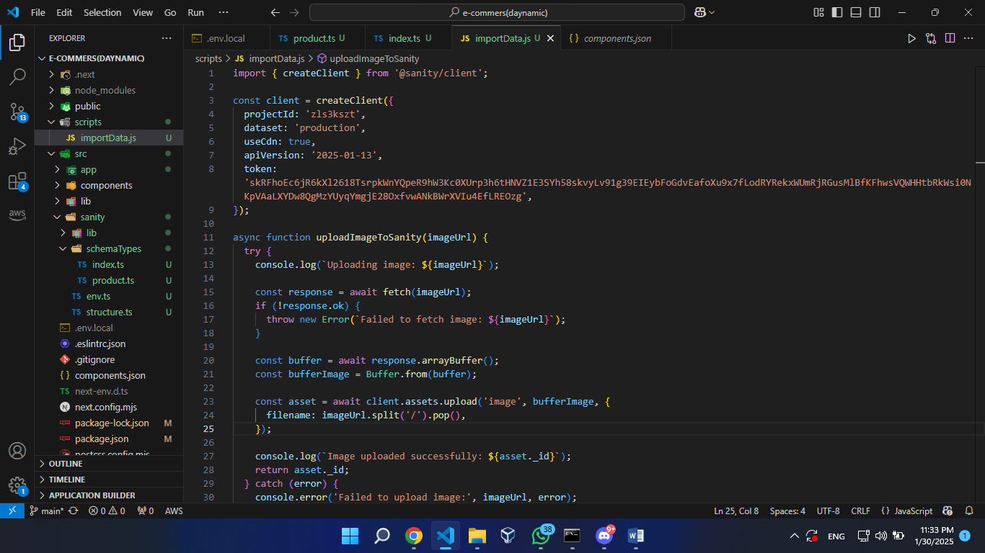
* **Making changes in package.json**

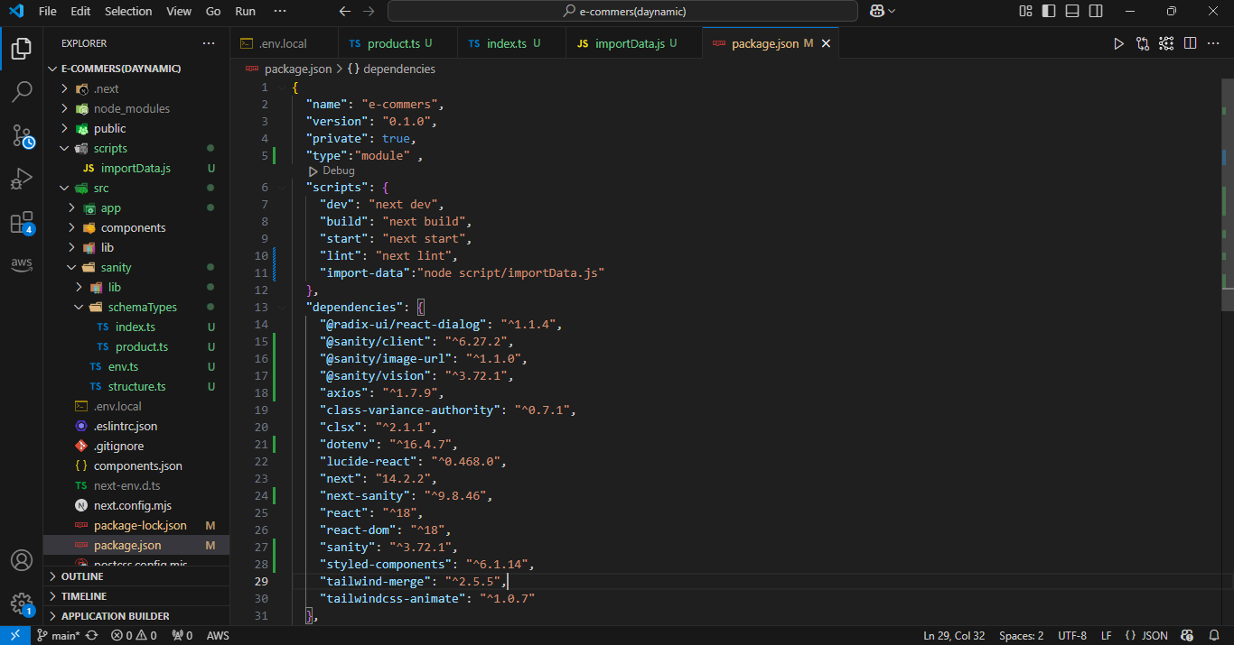

* **Making code suitable for Product**

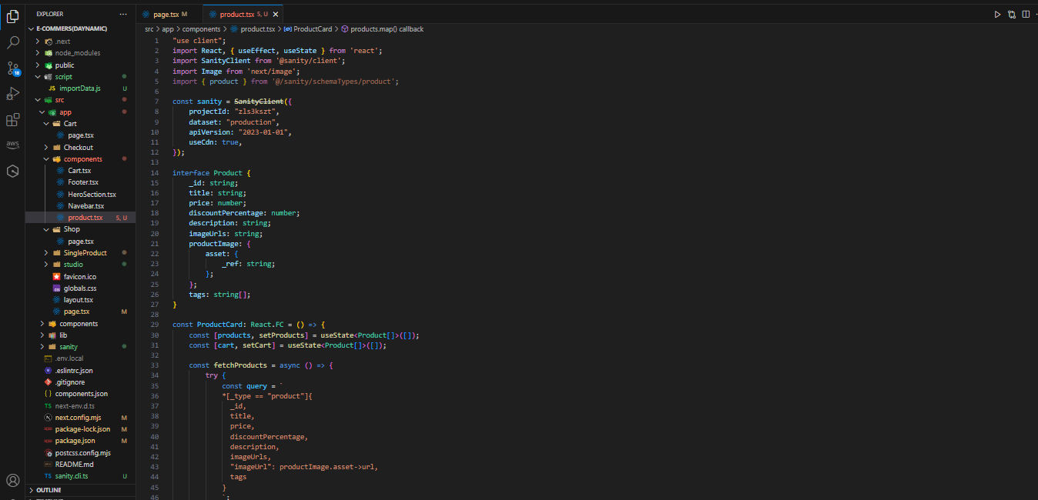

* **The result**

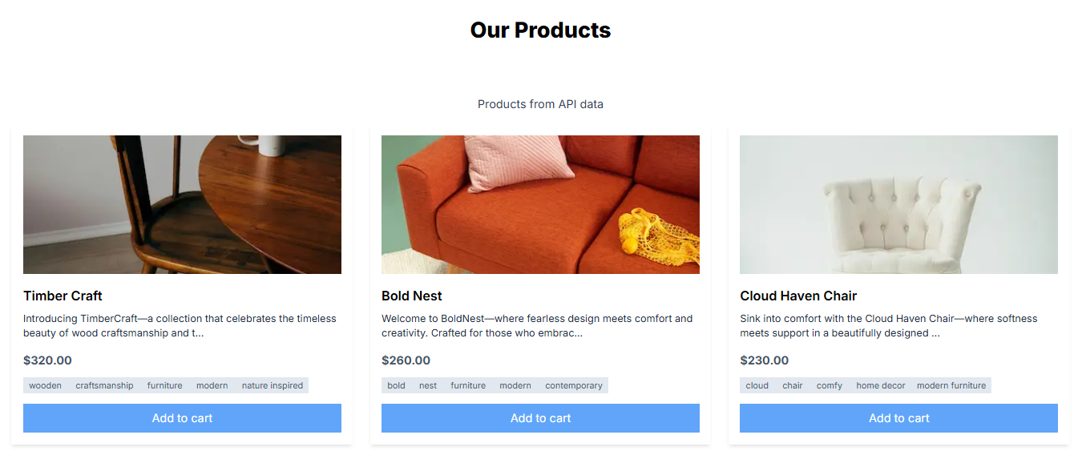

* **Cart Summary**

