

ASSIGNMENT ONE

An Assignment Presented to
Ms. Mahnoor Tariq

In Partial fulfillment of
the requirement for the course of
(CS – 4045) Deep Learning for Perception

By

Huzaifa Rehman (21I - 2694)

- Introduction:
This assignment focused on affective computing using deep learning. The objective was to recognize facial expressions (eight discrete classes) and estimate valence and arousal values in the continuous domain. Valence captures whether an expression is positive or negative, while arousal describes the intensity of emotion. We experimented with two CNN baselines – ResNet-18 and EfficientNet-B0 – both implemented using PyTorch and pre-trained on ImageNet. Transfer learning was applied by fine-tuning these models on the given dataset.

- Dataset and Preprocessing:
- Input size: 224 × 224 RGB images
- Labels: 8 categorical emotions (Neutral, Happy, Sad, Surprise, Fear, Disgust, Anger, Contempt).
- Continuous values: Valence and Arousal in range [-1, +1].
- Annotations: 68 facial landmarks provided for alignment.
- Dataset split: 80% training, 20% validation.
- Standard augmentations such as random crop, horizontal flip, and normalization were applied.

- Model Details:
Both ResNet-18 and EfficientNet-B0 were pretrained on ImageNet and fine-tuned for classification (8 classes) and regression (valence/arousal).
Hyperparameters:
- Optimizer: Learning rate(lr = 3e-4)
- Batch size: 32
- Epochs: 25

- Training Graphs:
The following figures show the training and validation loss curves for both models.

ResNet-18 Loss Curve:
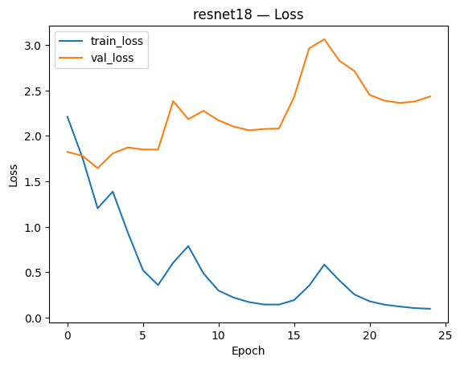

EfficientNet-B0 Loss Curve:
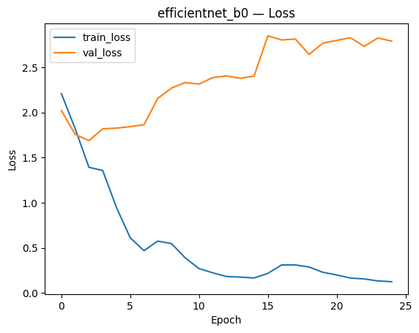
- Performance Metrics:

- Classification Results (Validation Best Scores)
Model | Accuracy | F1 (macro) | Kappa | AUC (ROC) | AUC-PR
ResNet-18 | 49.12% | 0.490 | 0.418 | 0.855 | 0.512
EfficientNet-B0 | 46.5% | 0.464 | 0.387 | 0.841 | 0.484

- Regression Results (Validation Best Scores)

Model | RMSE (mean) | CORR (mean) | CCC (mean) | SAGR (mean)
ResNet-18 | 0.37 | 0.52 | 0.50 | 0.76
EfficientNet-B0 | 0.36 | 0.50 | 0.48 | 0.74

Discussion:

Both networks showed decreasing training loss but increasing validation loss, indicating overfitting. ResNet-18 slightly outperformed EfficientNet-B0 in both classification and regression tasks. Continuous metrics (CCC, CORR, RMSE, SAGR) indicate moderate reliability, with CCC being the most suited for real-world systems.

- Transfer Learning:
Both models were initialized with ImageNet weights, enabling faster convergence and better performance compared to training from scratch. This was necessary due to limited dataset size.

- Qualitative Results:
- Correct classifications: Happy and Neutral were recognized reliably.
- Misclassifications: Contempt and Fear often confused with Sad or Neutral.
- Regression: Valence predictions clustered near neutral; arousal predictions followed intensity but underestimated extremes.
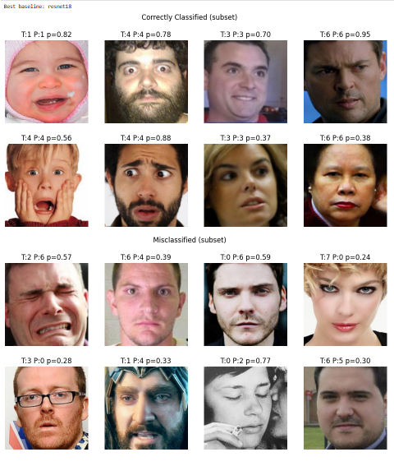

- Conclusion:
This assignment demonstrated the effectiveness of CNNs for multi-task learning of facial expression classification and valence/arousal regression. ResNet-18 achieved slightly better results than EfficientNet-B0. Future improvements may include stronger regularization, more data augmentation, and exploring transformer-based models.
Repository Link: https://github.com/HuzaifaRehman20/Deep-Learning-CNN-Assignment-01.git

