

ASSIGNMENT TWO

An Assignment Presented to
Ms. Mahnoor Tariq

In Partial fulfillment of
the requirement for the course of
(CS – 4045) Deep Learning for Perception

By

Huzaifa Rehman (21I - 2694)

- Introduction:
The aim of this assignment was to design and train deep learning models capable of determining whether two legal clauses express the same meaning. Legal contracts often contain repetitive or equivalent clauses written with different wording. Automating the detection of such semantic similarities can significantly reduce manual effort during contract review and improve the efficiency of document comparison systems. To achieve this goal, two Natural Language Processing (NLP) architectures were implemented and evaluated:
- Siamese BiLSTM Model
- Siamese Convolutional Neural Network with Additive Self-Attention (AttCNN).

Both models were trained on a large dataset of legal clauses extracted from various agreements and labeled for semantic similarity. The evaluation included both quantitative metrics and qualitative case studies of matched and mismatched clauses.

- Dataset and Preprocessing:
The dataset consists of thousands of legal clauses drawn from multiple contract categories such as Definitions, Force Majeure, Confidentiality, and Waiver Clauses. Each data instance represents a pair of clauses labeled as similar (1) or dissimilar (0). To ensure model interpretability, all text was lowercased and tokenized using a rule-based tokenizer that captures alphanumeric words and common symbols. A custom vocabulary of 27,834 tokens was built from the training set, and each clause was truncated or padded to a maximum length of 128 tokens. The final dataset contained 120,404 training pairs, 14,886 validation pairs, and 14,894 test pairs, ensuring that the splits were mutually exclusive to prevent data leakage.

- Network Details and Training Setup:
Two Siamese architectures were explored in this task.
- BiLSTM Siamese Network: Each clause was encoded using a Bidirectional LSTM (Long Short-Term Memory) network with hidden size 256 and embedding dimension 200. The output embeddings from both directions were concatenated, producing a 512-dimensional representation for each clause. A cosine similarity score between the pair embeddings was computed and passed through dense layers to classify whether the clauses are semantically similar. The BiLSTM architecture was chosen for its ability to capture long-range contextual dependencies and word order sensitivity, both critical in understanding legal phrasing.
- AttCNN Siamese Network: This model used a series of one-dimensional convolution filters with kernel sizes of (3, 4, 5), each followed by ReLU activation and a global additive self-attention layer to emphasize the most informative tokens. The resulting context vector was concatenated for the two clauses along with their cosine similarity before passing through fully connected layers. The AttCNN was selected as an efficient alternative capable of parallel text feature extraction and capturing local phrase patterns effectively.

Both models used AdamW optimizer (learning rate 3e-4, weight decay 1e-4), batch size 128, and were trained for 12 epochs with mixed precision (AMP) on a Google Colab T4 GPU. TF32 was enabled for optimized computation.

- Training Graphs:
The following figures demonstrate the training and validation performance of both architectures. The loss curves show smooth convergence without overfitting, while the validation metrics illustrate consistent improvement across epochs.

BiLSTM Siamese Network Loss Curves and Metrics:
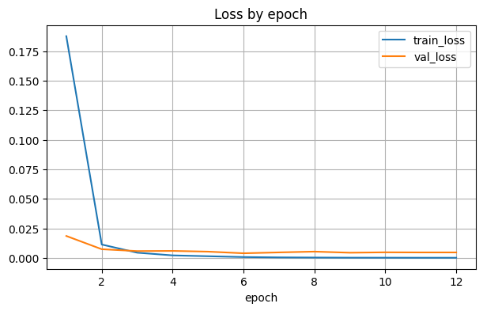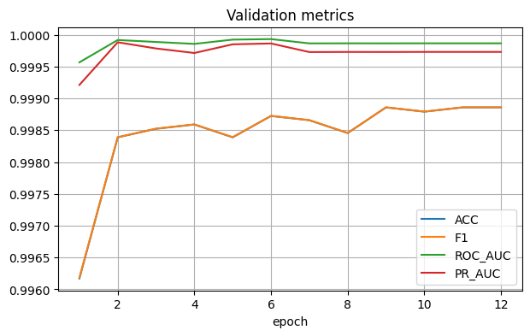

AttCNN Siamese Network Loss Curves and Metrics:
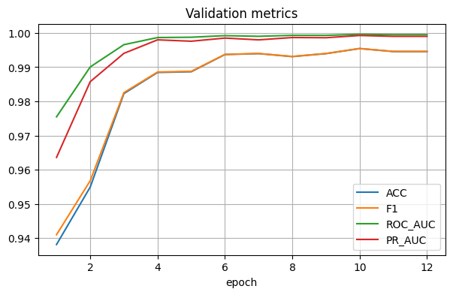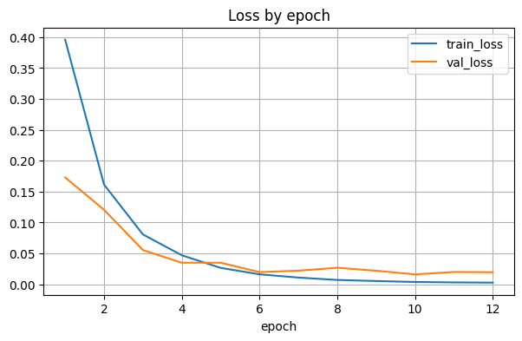
- Performance Measures and Comparison:
Performance was evaluated using several standard classification metrics including Accuracy, Precision, Recall, F1-Score, ROC-AUC, and PR-AUC. These measures assess both the overall correctness of predictions and the model’s ability to discriminate between similar and dissimilar clauses. The following table summarizes the quantitative results achieved by both models on the held-out test set.
Metric | BiLSTM | AttCNN
Accuracy | 0.9989 | 0.9955
Precision | 0.9980 | 0.9916
Recall | 1.0000 | 0.9994
F1-Score | 0.9989 | 0.9955
ROC-AUC | 0.99998 | 0.99972
PR-AUC | 0.99998 | 0.99928

Confusion Matrix Visualization:
The confusion matrices below show the classification performance of both architectures. Both models achieved strong diagonals, confirming consistent true positive and true negative predictions with minimal misclassifications.
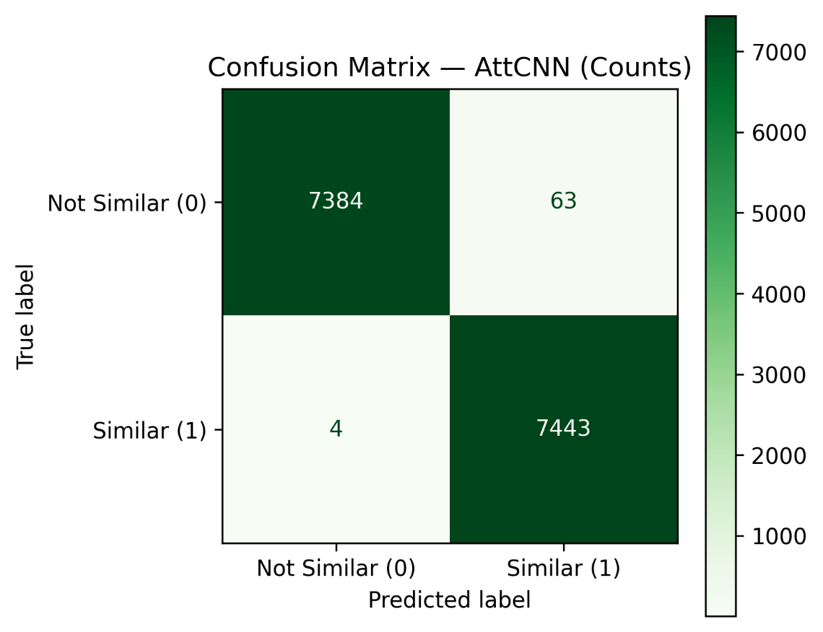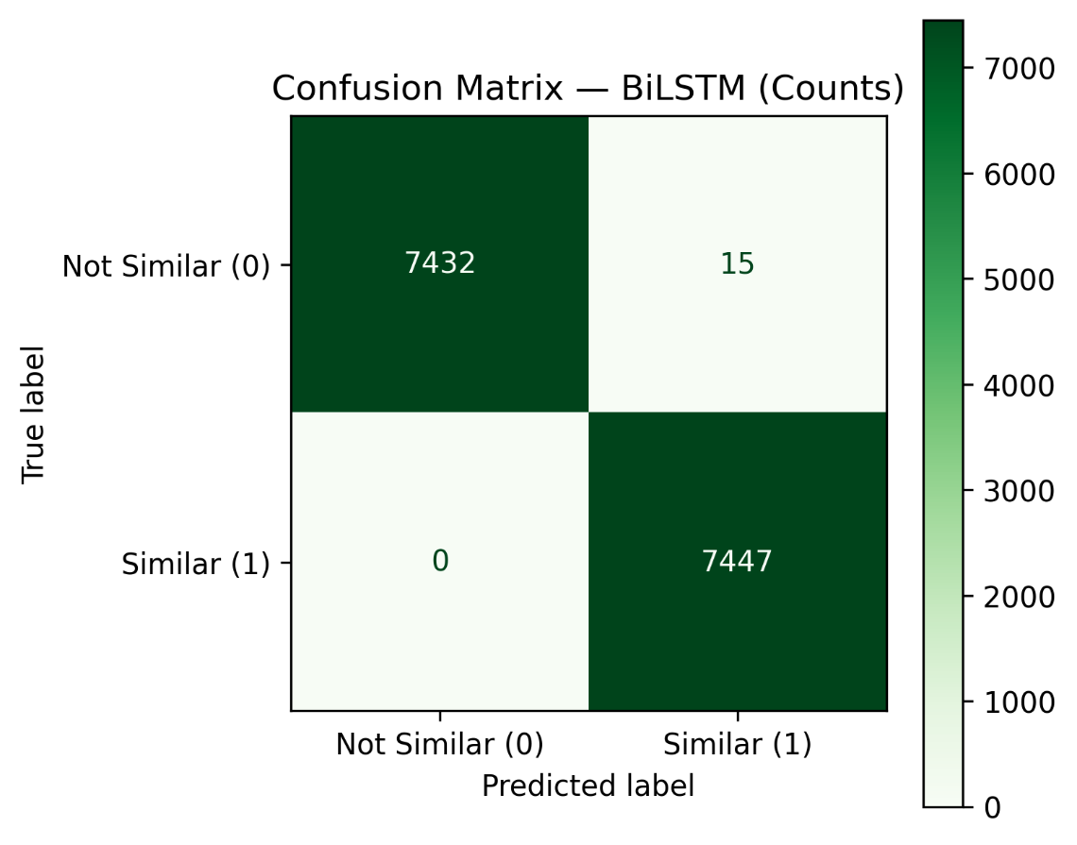

- Discussion on Evaluation Metrics:
In real-world applications of legal clause similarity, metrics must reflect both accuracy and reliability. Accuracy alone can be misleading when the dataset is imbalanced or when false positives carry higher risk. Therefore, Precision and F1-score are the most informative metrics for deployment. Precision ensures that when a model predicts two clauses as similar, it is almost always correct; an essential requirement in legal document analysis to avoid incorrect cross-referencing. Recall measures completeness but is less critical if a few missed matches are acceptable. ROC-AUC and PR-AUC provide threshold-independent views of model discrimination ability, confirming that both architectures maintain high separability between the two classes. In real deployment scenarios, F1-score and Precision should be prioritized for optimal trade-off between risk and recall.

- Qualitative Results:
A qualitative evaluation was performed to interpret how each model behaves on different clause types. Examples are summarized below: Correctly Matched Clauses (True Positives): Clauses such as “Definitions and Interpretation” or “Time” were consistently recognized as similar despite minor structural variations. False Positives (FP): Clauses like “Waiver of Past Defaults” and “Waiver of Jury Trial” were incorrectly classified as similar. These clauses share similar titles but differ in meaning, showing that surface-level lexical overlap can sometimes mislead the model. False Negatives (FN): Examples like “Force Majeure” and “Recitals” contained paraphrased content that conveys the same intent but used substantially different vocabulary, which occasionally caused the model to miss the similarity.

- Conclusion:
This assignment successfully demonstrated two NLP baselines for clause similarity detection. Both Siamese BiLSTM and AttCNN models produced exceptional quantitative results, with the BiLSTM slightly outperforming due to its ability to model long-term dependencies. The AttCNN, on the other hand, achieved faster convergence and lower computational cost, making it more practical for large-scale systems. In future work, the integration of contextual embeddings such as GloVe, Word2Vec, or LegalBERT could enhance understanding of domain-specific terminology. Additionally, contrastive or triplet losses may be used to further strengthen the embedding space. Deploying such models in real-world contract review systems would require additional robustness testing across unseen legal corpora.

Repository Link: https://github.com/HuzaifaRehman20/Deep-Learning-NLP-Assignment-02.git

