Sampling techniques ko do categories mein divide kia jata hai:

1. **Probability Sampling**
2. **Non-Probability Sampling**

### **1. Probability Sampling**

Is technique mein sample select karne ka equal chance har individual ko milta hai. Ye techniques tab use ki jati hain jab unbiased aur representative data chahiye ho.

#### **1.1 Simple Random Sampling**

* **Explanation:** Har individual ka equal chance hota hai select hone ka.
* **Example:** Ek school mein 100 students hain. Randomly 10 students ko select karte hain without kisi bias ke. Is k liye "random number generator" use kia ja sakta hai. OR a lottery system OR qura andazi.
* **Use Case:** Jab population ka proper list available ho aur unbiased sampling chahiye ho.

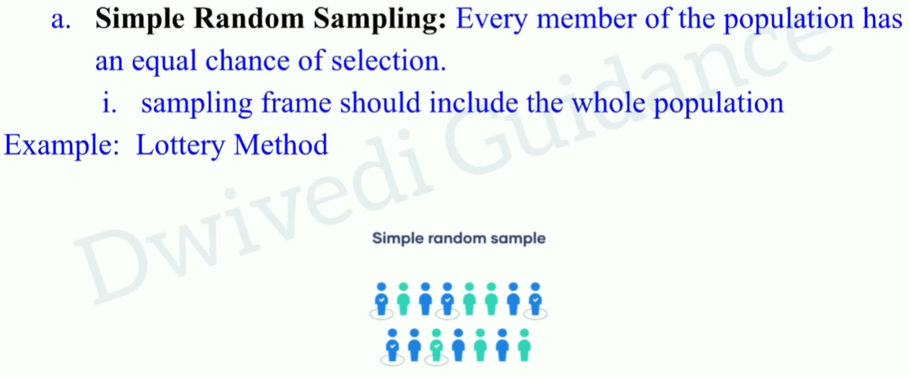

#### **1.2 Stratified Sampling**

* **Explanation:** Population ko strata (groups) mein divide karte hain (e.g., age, gender), aur har strata se proportional sample select karte hain.
* **Example:** Ek company mein 60% males aur 40% females hain. Agar 10 log chahiye, to 6 males aur 4 females ko randomly select karein.
* **Use Case:** Jab population heterogeneous ho aur har subgroup ka representation ensure karna ho.

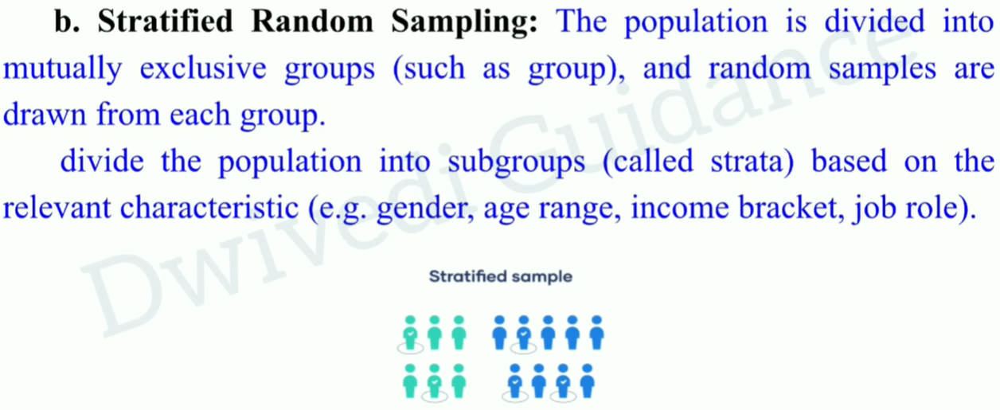

Mutually Exclusive: elements belong to only one strata(group). Same element of a group is not available in another group.

Stratified sampling mein **zaroori nahi hai** ke hamesha proportional sampling hi karein. Stratified sampling do types ki ho sakti hai:

### **1. Proportional Stratified Sampling**

* **Explanation:** Har strata (group) se uske population ke proportion ke mutabiq sample select kia jata hai.
* **Example:** Agar ek company mein:
  + 60% males hain (600 log)
  + 40% females hain (400 log)  
     Aur total sample size 100 chahiye, to:
  + 60 males (60% of 100)
  + 40 females (40% of 100) liye jayenge.
* **Use Case:** Jab overall population ka exact representation ensure karna ho.

### **2. Disproportional Stratified Sampling**

* **Explanation:** Har strata se **equal ya customized number** of samples liye ja sakte hain, chahe unka population mein proportion jo bhi ho.
* **Example:** Agar ek company mein:
  + 600 males hain
  + 400 females hain  
     Aur researcher ne decide kia hai ke **har group se 50 samples** liye jayenge, to:
  + 50 males
  + 50 females liye jayenge.  
     Chahe proportion male-dominated hai, lekin researcher ko dono genders ka equal representation chahiye.
* **Use Case:** Jab kuch subgroups zyada chhoti population ke sath ho aur unka equal representation ensure karna ho ya jab kisi specific group par zyada focus karna ho.

### **Kab Proportional aur Disproportional Use Hota Hai?**

| **Scenario** | **Sampling Type** | **Reason** |
| --- | --- | --- |
| Overall population ka accurate representation chahiye. | Proportional Stratified Sampling | Kyun ke ye population ka unbiased reflection deta hai. |
| Subgroups mein equal representation chahiye. | Disproportional Stratified Sampling | Kyun ke kuch subgroups chhote ho sakte hain, aur unka inclusion zaroori ho. |
| Specific subgroup par zyada focus karna ho. | Disproportional Stratified Sampling | Kyun ke study ka purpose ek particular group ka analysis ho sakta hai. |

### **Conclusion**

* Stratified sampling mein **proportional hona zaroori nahi hai**.
* Research ka goal decide karta hai ke **proportional** lena hai ya **disproportional**.  
   Agar unbiased representation chahiye, to proportional sampling better hai. Agar subgroups ko equal weight dena chahiye, to disproportional sampling use hoti hai.

#### **1.3 Systematic Sampling**

* **Explanation:** Population ko ek order mein arrange karte hain aur fixed interval se select karte hain (e.g., har 5th person).
* **Example:** Ek factory mein 500 workers hain. Har 10th worker ko select karte hain inspection ke liye.
* **Use Case:** Jab population large ho aur random selection ki simplicity chahiye ho.

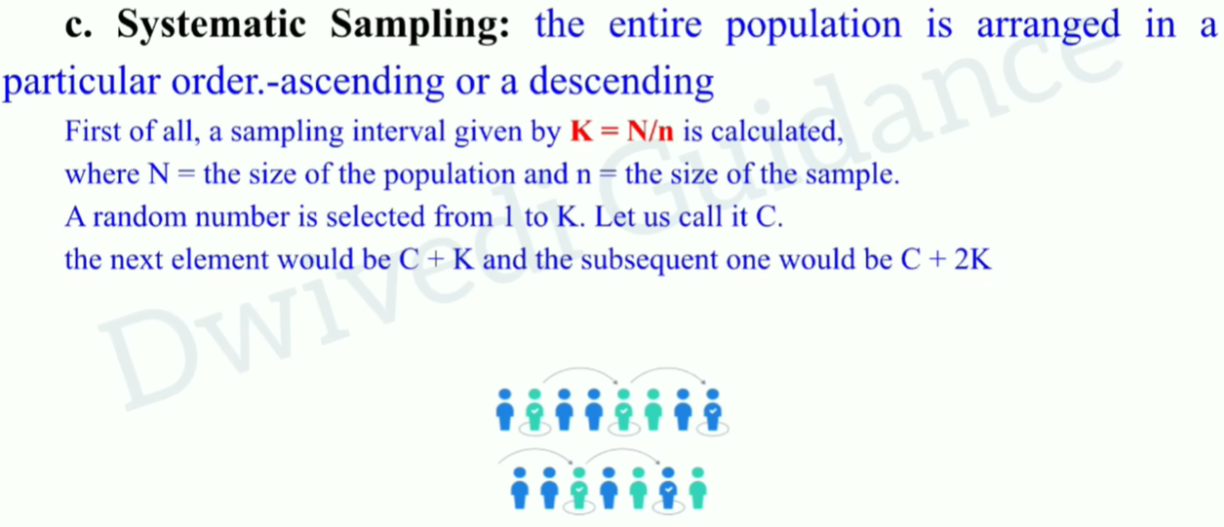

#### **1.4 Cluster Sampling**

* **Explanation:** Population ko clusters (groups) mein divide karte hain, aur phir randomly kuch clusters select karte hain.
* **Example:** Ek country mein schools hain. Randomly 5 schools select karte hain aur phir unke sare students ka data lete hain.
* **Use Case:** Jab population geographically dispersed ho aur pura data collect karna mushkil ho.

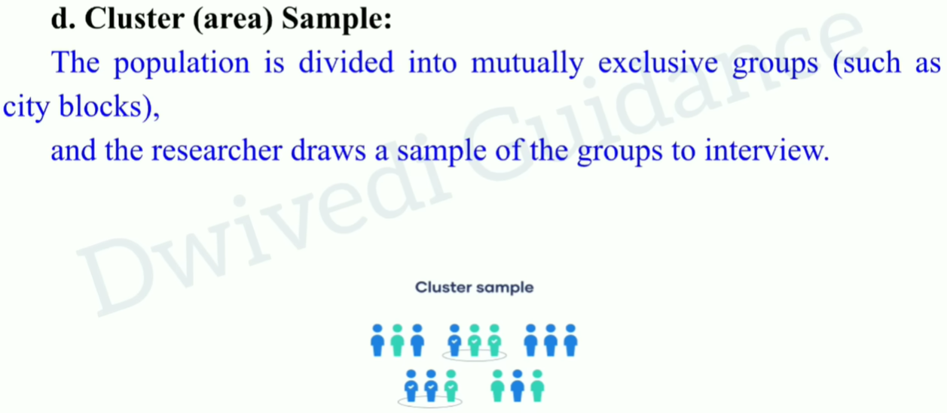

Difference b/w Stratified and clustered sampling?

**Stratified:** members of subgroups have similar characteristics .

**Cluster:** characteristics of members of subgroups are not the same.

### **2. Non-Probability Sampling**

Is technique mein har individual ka equal chance nahi hota. Ye biased ho sakta hai.

#### **2.1 Convenience Sampling**

* **Explanation:** Jo log easily available ho unhe sample ke liye select karte hain.
* **Example:** Ek researcher apne friends ya nearby logon se survey kar le.
* **Use Case:** Jab quick aur cost-effective sampling chahiye ho.

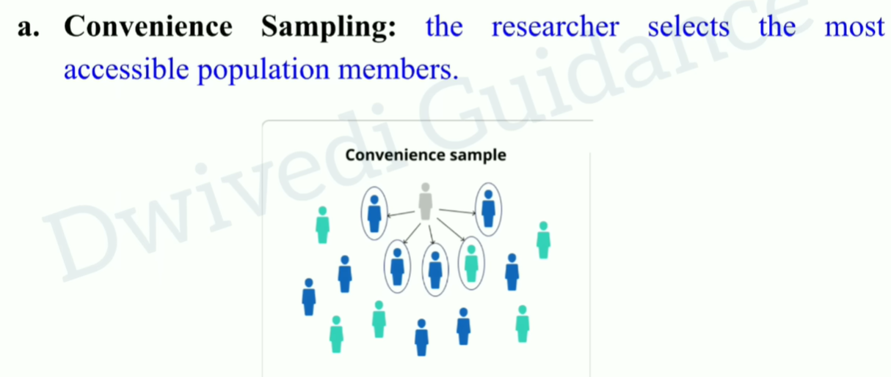

#### **2.1 Voluntary Response Sampling**

* **Definition:**Is technique mein participants **khud apni marzi se** survey ya study mein participate karte hain (volunteer karte hain).
* **Key Points:**
  + Researcher participants ko select nahi karta; wo khud apne aap respond karte hain.
  + Usually wo log respond karte hain jo ya to topic mein zyada interested hain ya strong opinions rakhte hain.
  + Bias ka zyada risk hota hai, kyun ke sirf strongly opinionated log participate karte hain.
* **Example:**Ek online survey jahan kisi website pe question post kiya gaya ho aur log apni marzi se respond karein.
* **Use Case:**Jab logon ka feedback lena ho, lekin sampling ko control karna mushkil ho.

#### **2.2 Judgmental (Purposive) Sampling**

* **Explanation:** Researcher apne judgment se sample select karta hai jo unhe lagta hai relevant hain.
* **Example:** Ek health researcher sirf diabetic patients ka data collect kare.
* **Use Case:** Jab specific expertise chahiye aur population ka targeted subset relevant ho.

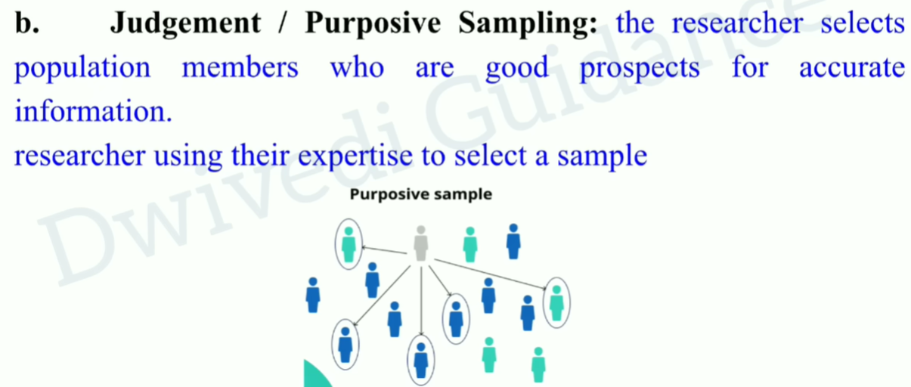

#### **2.3 Snowball Sampling**

* **Explanation:** Ek participant dusre participant ko refer karta hai.
* **Example:** Ek survey mein drug users ka data collect karte hain. Ek drug user doosre users ka reference deta hai.
* **Use Case:** Jab population rare ho ya identifiable na ho.

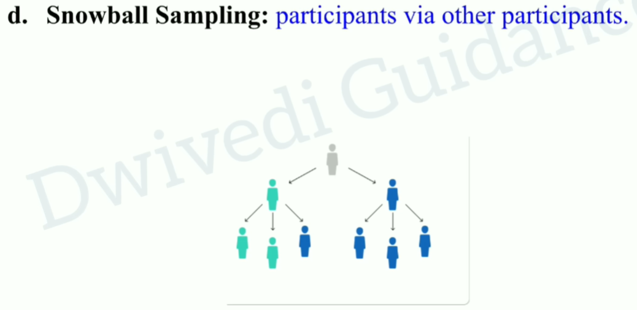

#### **2.4 Quota Sampling**

* **Explanation:** Researcher apni choice se subgroups (quotas) mein divide karta hai aur har group ka fixed number select karta hai.
* **Example:** Ek survey mein 50 males aur 50 females ko select karna chahte hain.
* **Use Case:** Jab specific subgroup representation chahiye ho.

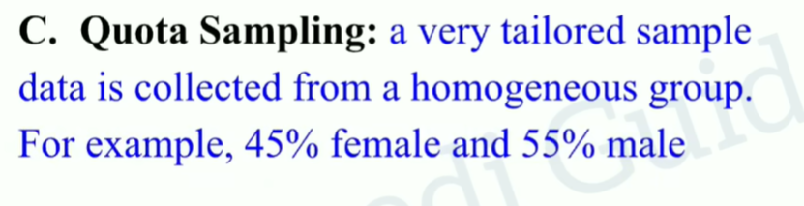

### **Comparison Table**

| **Technique** | **Use Case** | **Example** |
| --- | --- | --- |
| Simple Random Sampling | Unbiased, representative data | Randomly select 10 students from 100. |
| Stratified Sampling | Subgroup representation required | Select 6 males and 4 females from a group. |
| Systematic Sampling | Large population, ordered list | Select every 10th worker from 500 workers. |
| Cluster Sampling | Geographically dispersed population | Select 5 schools and survey their students. |
| Convenience Sampling | Quick and cost-effective sampling | Survey nearby people in a park. |
| Judgmental Sampling | Expert knowledge needed | Study only diabetic patients in a city. |
| Snowball Sampling | Rare or hidden population | Find participants through referrals. |
| Quota Sampling | Equal representation of specific groups | Select 50 males and 50 females. |

**Note:**

* Probability techniques unbiased aur scientific research ke liye zyada suitable hain.
* Non-Probability techniques exploratory research ya jab population ka access mushkil ho, tab use hoti hain.

Sampling error:

Difference between the results of a sample and a population