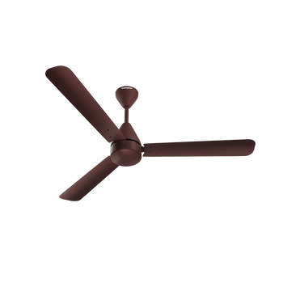

FanOFan – Redefining Cool Comfort
Experience the perfect blend of innovation, performance, and style with FanOFan Ceiling Fans — engineered to deliver powerful airflow and unmatched durability. Designed for modern homes and workplaces, FanOFan fans ensure whisper-quiet operation, energy efficiency, and year-round comfort.
Each FanOFan ceiling fan is crafted using high-quality materials and precision-balanced blades to provide steady, vibration-free performance. Whether you prefer sleek minimalism or classic elegance, our designs complement every interior space while maintaining exceptional functionality.
With advanced motor technology, FanOFan fans consume less power without compromising on cooling performance — keeping your environment refreshing even on the hottest days. The aerodynamic blade design enhances air circulation, ensuring every corner of the room stays cool and breezy.
FanOFan also focuses on long-lasting reliability. Our fans are built to resist dust, corrosion, and wear, offering a perfect balance of beauty and strength. Every model undergoes strict quality testing to meet our promise of durability and performance excellence.
Choose FanOFan where craftsmanship meets comfort. Discover how elegance, innovation, and efficiency come together to make your living spaces cooler, quieter, and more beautiful.
FanOFan Feel the Breeze, Live the Comfort.

