Name : Huzaifa (2303.KHI.DEG.016)
Partner Name : Muhammad Safi (2303.KHI.DEG.023)

1) Install plotly and making dataframe

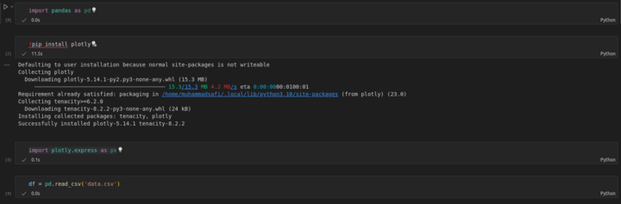
2) Making scatter_matrix

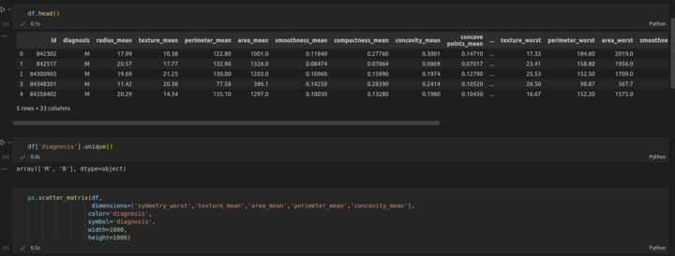
3) Output
