Assignment 4.1

Name : Huzaifa Ali (2303.khi.deg.016)
Partner Name: Muhammad Safi (2303.khi.deg.023)

1) Start the system using docker-compose so that it runs in background,

2)Visit https/localhost to see WordPress installation panel

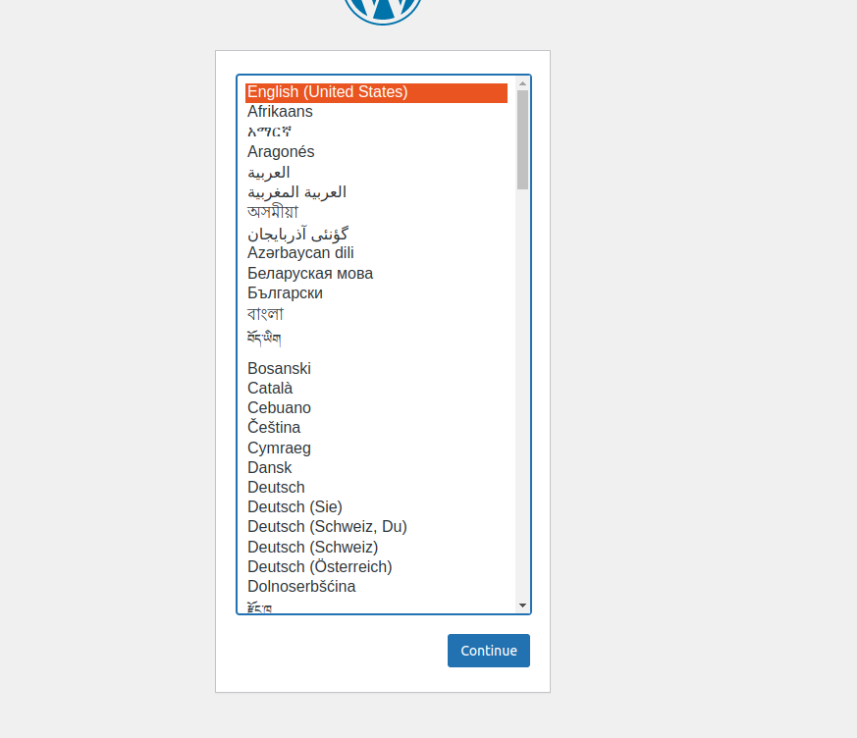

3) view log report

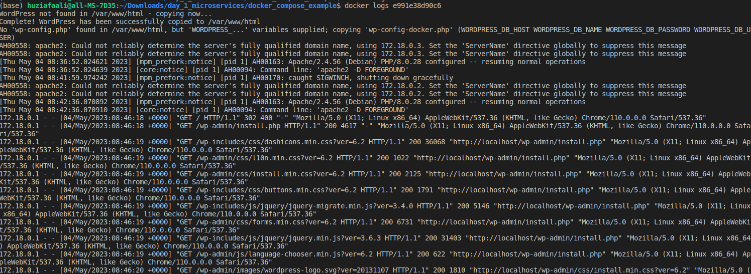

4) Add a PHPMyAdmin service .

5) login in word press.
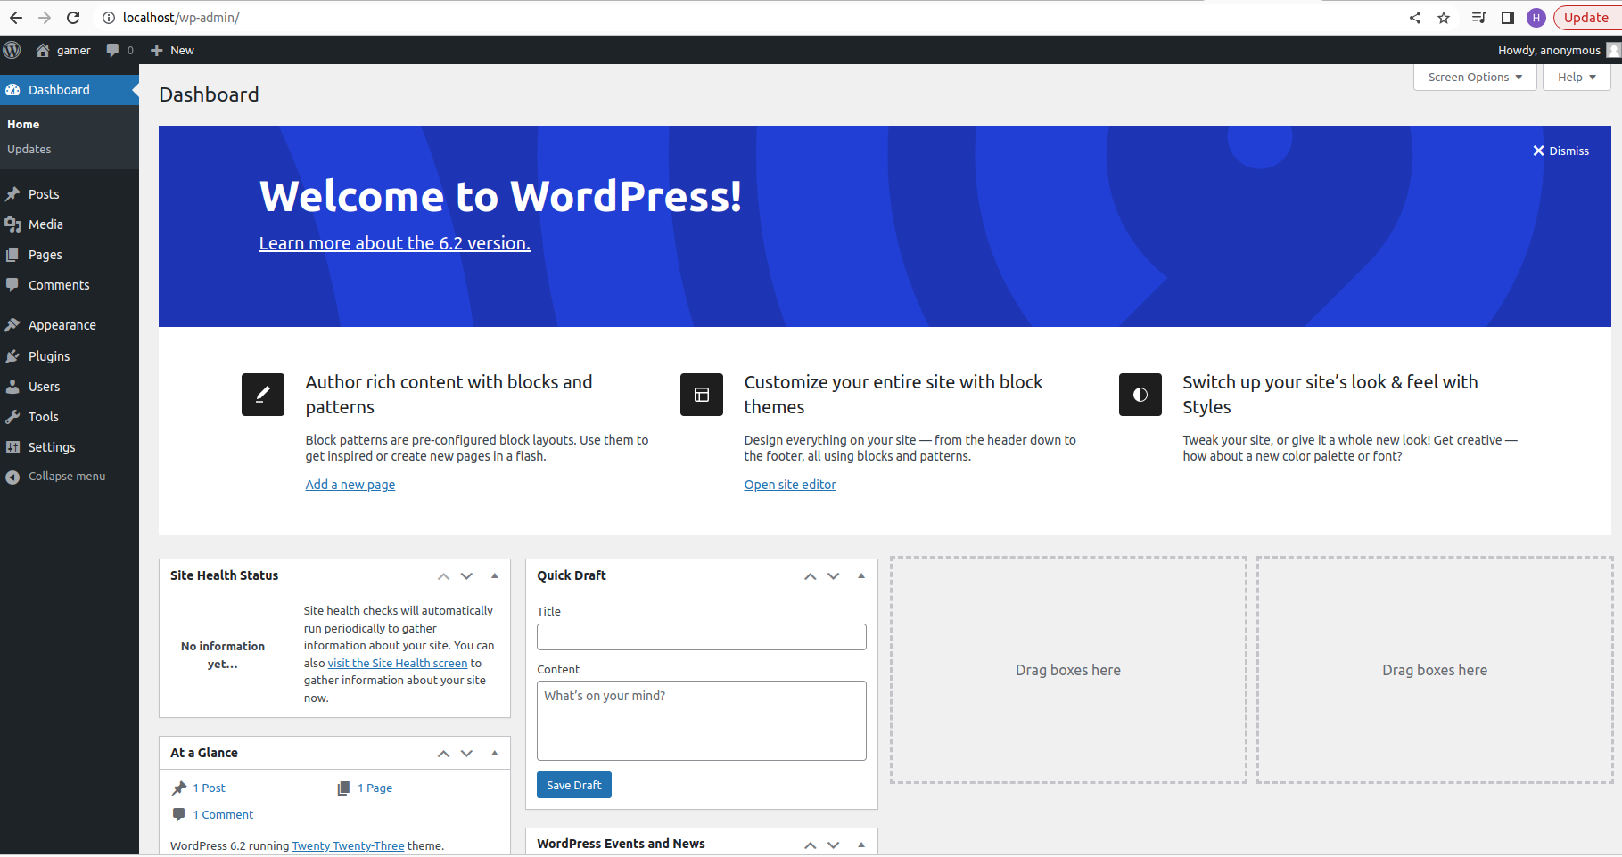

6) Login into phpmyadmin by using

user : wordpress
password : wordpress

