Name: Huzaifa Ali (2303.KHI.DEG.016)

Assignment partner: Muhammad Safi (2303.KHI.DEG.023)

1. The spaces in print within ```python are deliberately given so that nbQA can reformat.

**Before**

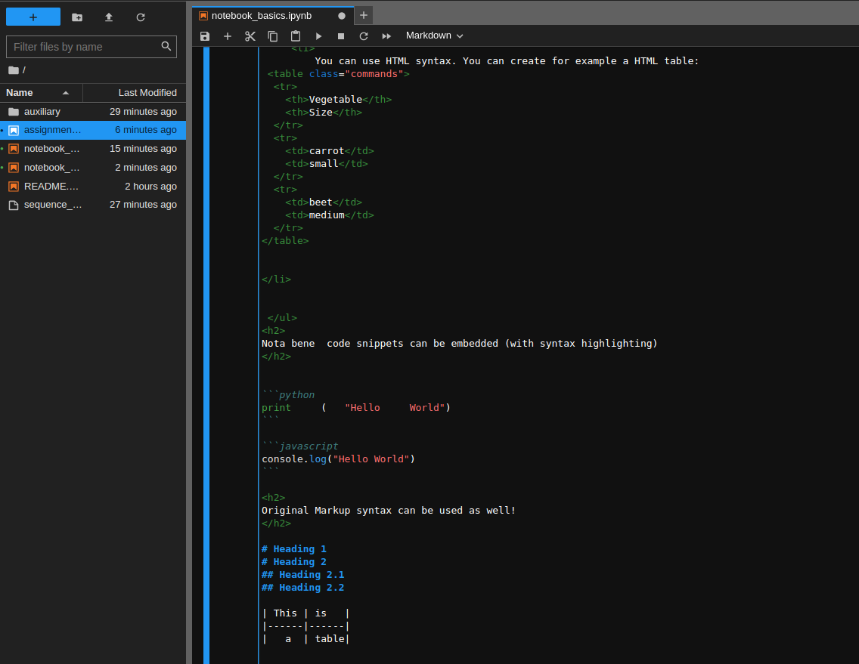

**Before**

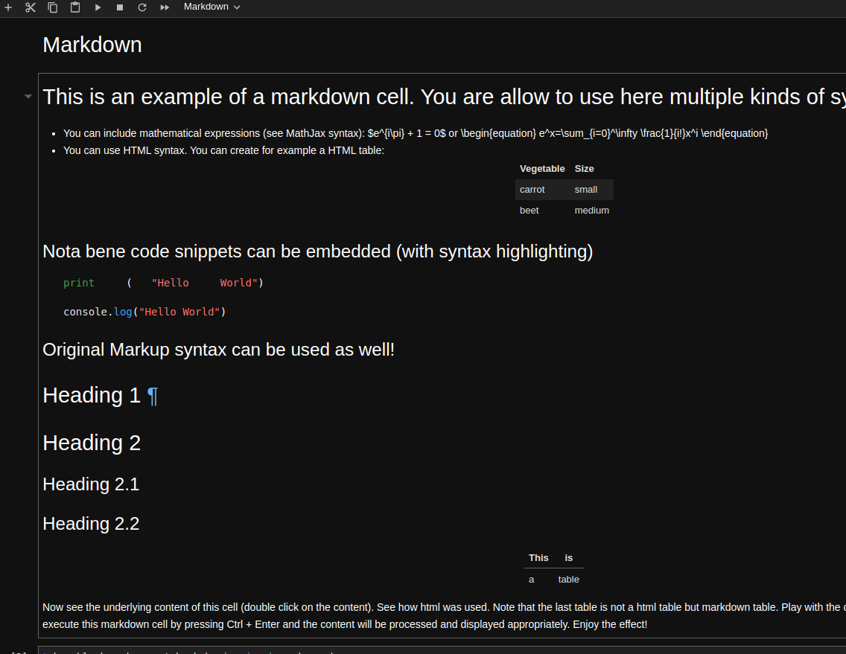

2. Running nbQA bash command inside the notebook.

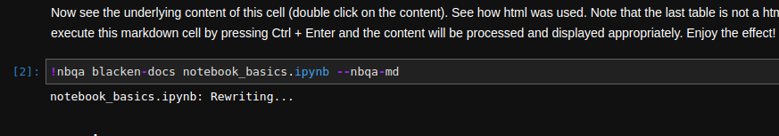

3. The spaces given after the print statement were fixed and reformatted.

**After**

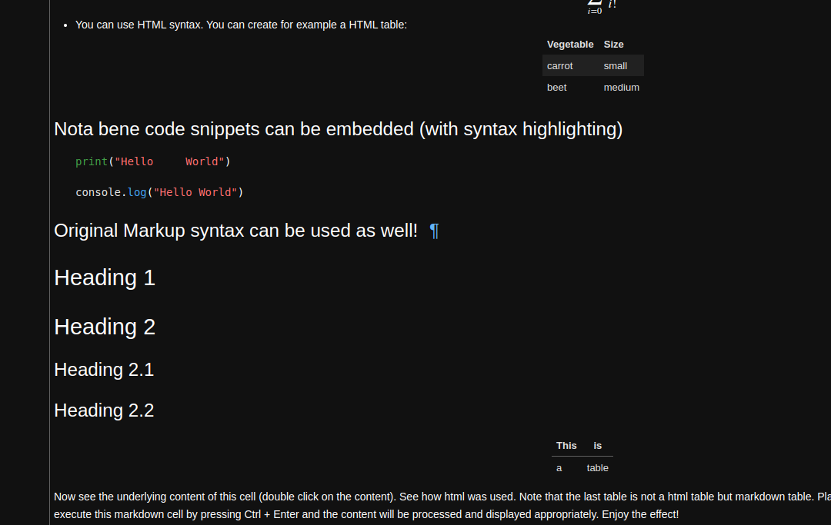

**After**

