NAME: Huzaifa Ali (2303.KHI.DEG.016)

ASSIGNMENT PARTNER:Muhammad Safi (2303.KHI.DEG.023)

Docker assignment

1)Configuring docker image

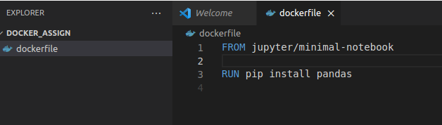

2)Building image

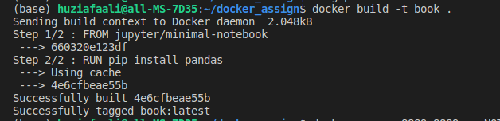

3)Mapping port defining environment

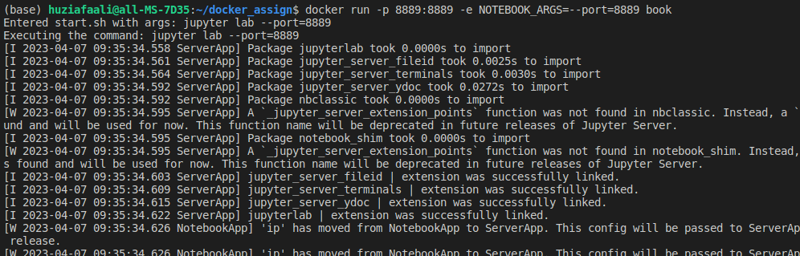

4)Output

