DSA

[Design Project/Experiment Report]



[Project Title]

Submitted by:

Muhammad Huzaifa | 23L-6067

Submitted to:
Ahmad Hamza

27/11/2025

Department of Electrical Engineering
National University of Computer and Emerging Sciences, Lahore

Introduction
- Problem Analysis

Design Requirements
- Feasibility Analysis

Possible Solutions
- Preliminary Design

Design Description

Software Simulation

Experimental Results
- Performance Analysis
- Future Scope

Social and Cultural Implications
- Conclusion References
This project implements a complete online grocery store management system using advanced data structures and algorithms to efficiently handle customer information, grocery inventory, and delivery routing. Customer records are stored in a height-balanced Binary Search Tree (BST) to ensure fast searching, insertion, updating, and deletion operations. Grocery items are managed using a hash table with chaining, enabling constant-time (O (1)) average access for barcode and title-based lookups. For delivery management, the system models the city map as a weighted graph with at least ten nodes and uses Dijkstra’s shortest path algorithm to compute the optimal route from the store to a customer’s address. The project integrates file handling, balanced data loading, inventory updates, and dynamic order processing into a cohesive application, demonstrating practical use of BSTs, hash tables, and graph algorithms for solving a real-world complex engineering problem.

The core problem is to design an online grocery store system that can efficiently manage customer records, grocery inventory, and delivery routing while maintaining fast access times and supporting dynamic updates. The system must store customers in a structure that enables quick search operations, since identifying a customer by CNIC is a frequent task. A naive structure such as an array or linked list would lead to O(n) lookup time, which becomes inefficient as the dataset grows. Therefore, a Binary Search Tree (BST) is required, and the dataset must be inserted in a way that keeps the tree close to height-balanced to preserve O (log n) search performance.
Similarly, grocery items must be stored in a data structure that guarantees constant-time access because inventory lookup happens very frequently during ordering and restocking. A hash table with chaining is appropriate because it provides O (1) average-case search, insert, update, and delete operations regardless of the dataset size. The problem also requires customers to receive home delivery, meaning the system must determine the shortest path from the store to the customer's location. This introduces the need for a weighted graph where nodes represent locations and edges represent distances. To compute the shortest delivery route, a reliable pathfinding algorithm is required; Dijkstra’s algorithm is well-suited due to its efficiency in graphs with non-negative edge weights.
The problem therefore demands integration of multiple data structures, each chosen based on performance requirements: a balanced BST for customers, a hash table for grocery items, and a weighted graph with Dijkstra’s algorithm for delivery. The challenge lies not only in selecting these structures but also ensuring they interact consistently, for example, updating inventory after delivery, maintaining balanced input for the BST, and ensuring the graph correctly maps all delivery nodes. Thus, solving this problem requires understanding algorithmic efficiency, real-world constraints, and the interdependence of system components.

The system must be designed to efficiently manage customer information, grocery inventory, and delivery routing while maintaining high performance and reliability. To meet these requirements, the following constraints and functional expectations must be satisfied:

- Efficient Customer Management
To manage customer information effectively, the system requires a data structure that supports fast searching, updating, and deletion based on CNIC. A Binary Search Tree is used because it provides logarithmic time complexity when balanced. To maintain this efficiency, customer data is loaded from a file in sorted order and inserted in a way that keeps the BST height close to log(n). This ensures that operations remain quick even as the number of customers grows.

- Fast Grocery Item Access
The inventory component must allow very fast lookups because grocery items are frequently searched, updated, and ordered. A hash table with chaining is therefore used to store items by barcode, allowing average O (1) search and insert performance. This ensures that the system can quickly find items by barcode or title, update stock levels, and manage large inventories without slowing down.

- Delivery Routing System
The delivery feature requires calculating the shortest path between the store and the customer's address. For this purpose, the system models the city map as a weighted graph with at least ten nodes representing different locations. Dijkstra’s algorithm is used to compute the optimal delivery route, enabling the program to quickly determine the shortest and most efficient path for dispatching grocery orders.

- Data Loading and Persistence
The system loads customer records, grocery items, and delivery map data from external files to provide realistic and reusable data. This requires accurate parsing of CSV-formatted input and inserting the data into the appropriate structures without introducing imbalance or inconsistencies. Proper file handling ensures the system starts with a meaningful dataset and maintains reliability.

- Order Processing and Inventory Updating
When a customer places an order, the system must verify item availability, calculate the total price, find the delivery path, and update the remaining quantity. This requires careful coordination between the customer BST, the grocery hash table, and the delivery graph. After successful delivery, the inventory is updated immediately so that the system always reflects accurate stock levels.

- User-Friendly Console Interface
To allow easy interaction, the system includes a clear, menu-driven console interface. It guides the user through all functionalities such as adding or searching customers, viewing items, processing orders, and displaying routes. The interface also handles invalid input and missing data gracefully, ensuring smooth operation even for inexperienced users.

The proposed online grocery store system is fully feasible as it uses efficient and well-understood data structures that meet all functional requirements within the scope of the course. Customers are stored in a height-balanced Binary Search Tree that ensures fast log(n) searching and updating, grocery items are managed through a hash table providing constant-time O (1) access, and delivery routing is handled using a graph structure with Dijkstra’s algorithm to compute the shortest path. All components are implementable in standard C++ without external libraries, work on any basic computer system, and integrate smoothly to support searching, updating, inventory management, and delivery path generation. Therefore, both technically and operationally, the system is practical, efficient, and achievable within the project constraints.

One possible solution for managing customers and grocery items is to use simple linear data structures such as arrays or linked lists. These structures are easy to implement and maintain but come with performance limitations. Searching for a customer or grocery item in a list requires O(n) time, which becomes inefficient as the dataset grows. Similarly, updating and deleting entries also require full traversal. Another alternative is to use self-balancing trees such as AVL or Red-Black Trees, which automatically maintain height balance to guarantee log(n) performance without requiring pre-sorted input. While these structures provide excellent speed, their implementation is more complex and may not be ideal for a course-level project unless external libraries are allowed.
A more efficient and practical solution combines a Binary Search Tree for customer management, a Hash Table for grocery items, and a Graph for delivery routing. BST provides fast structured access to customers, especially when built from sorted file data to keep it balanced. The hash table ensures constant-time access for inventory operations, making it ideal for searching by barcode and updating stock quantities. For delivery, representing the map as a weighted graph and applying Dijkstra’s algorithm produces the shortest reliable delivery paths. This hybrid approach balances performance, simplicity, and accuracy, making it the most suitable and effective solution for the functional requirements of the online grocery store system.

The primary design of the system focuses on separating responsibilities into three main functional components: customer management, inventory management, and delivery routing. Each component is built around a core data structure chosen for its efficiency and suitability. Customers are stored in a Binary Search Tree, allowing fast access and maintaining an ordered structure for searching and updating. Grocery items are handled through a hash table, enabling constant-time insertions, lookups, and quantity updates based on barcode. The delivery feature uses a weighted graph representing the city, where nodes correspond to locations and Dijkstra’s algorithm is applied to compute the shortest path from the store to a customer’s address. A central menu-driven interface coordinates these modules, ensuring smooth interaction between the data structures and providing users with a clean, consistent workflow for all operations.

The system is designed using a modular, data-structure-driven approach where each major component customers, grocery items, and delivery routes—is handled by a specialized structure chosen for optimal performance. Customer records are stored in a Binary Search Tree to support fast log(n) searching and updating, and the tree is built from file data in sorted order to keep it height balanced. Grocery items are managed using a hash table with separate chaining, allowing constant-time access for inserting, removing, and searching by barcode or title. For delivery functionality, the system represents the city as a weighted graph and uses Dijkstra’s algorithm to compute the shortest delivery path from the store to the customer’s location. All modules interact through a menu driven interface, ensuring smooth integration while keeping each component logically separated and easy to maintain.

The overall design of the system centers on dividing the application into clear functional modules, each powered by an appropriate data structure to ensure efficient operation. Customer information is organized within a balanced Binary Search Tree to maintain fast and orderly access, while grocery inventory is stored in a hash table to guarantee near-instant lookup and updates. The delivery system is modeled as a weighted graph where nodes represent locations and edges represent distances, enabling the use of Dijkstra’s algorithm for accurate shortest-path routing. These components are tied together through a simple console-based menu that manages user interactions, allowing seamless execution of tasks such as adding customers, searching items, placing orders, and generating delivery routes. This modular and performance-oriented design keeps the system efficient, scalable, and easy to extend.

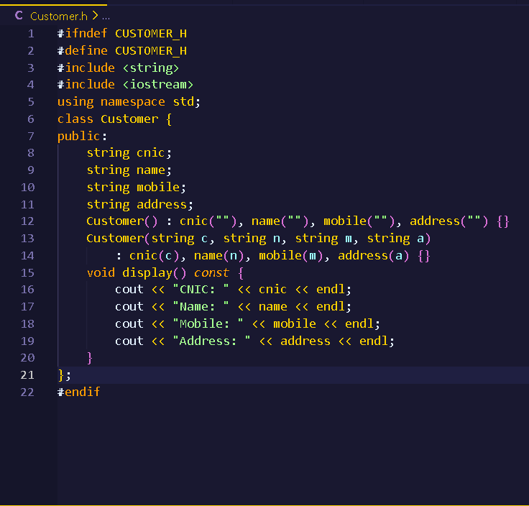

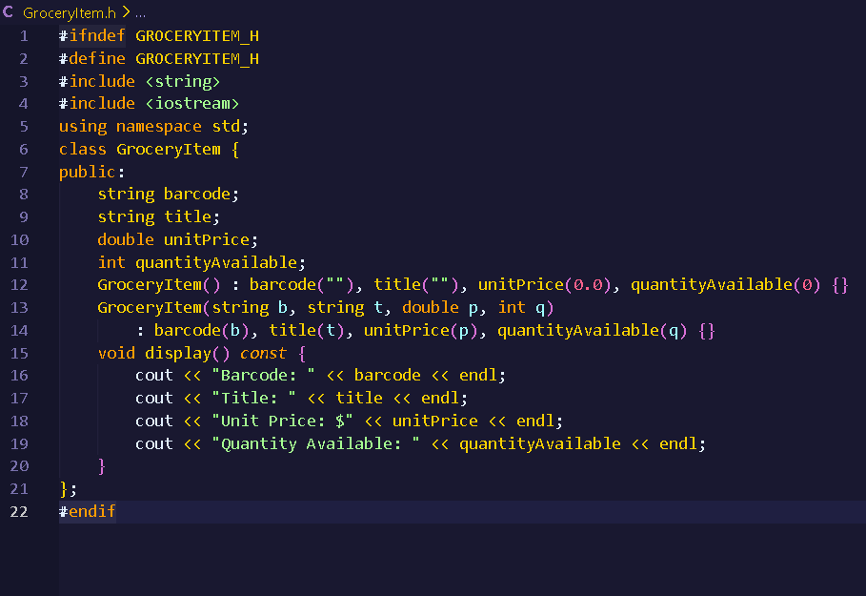

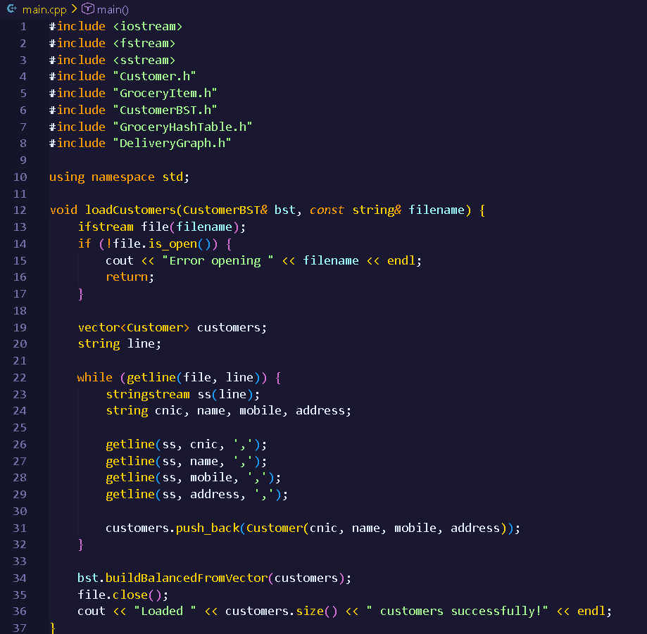
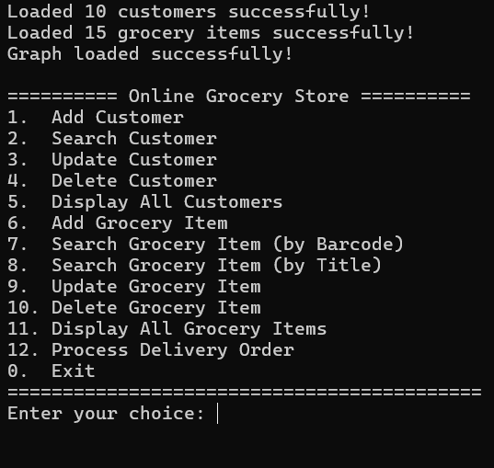

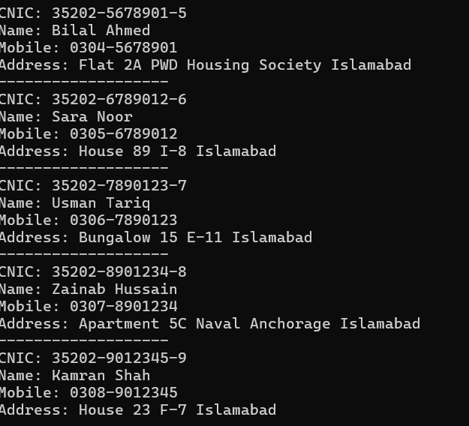
The performance of the online grocery store system is efficient and well-optimized because each major component uses a data structure designed for fast operations under expected workloads. Customer BST provides log(n) time for searching, inserting, and deleting customers when built in balanced form, ensuring responsiveness even with large datasets. The Grocery Hash Table achieves average-case O (1) lookup, insertion, and update for items, making inventory operations extremely fast. For delivery routing, the system uses Dijkstra’s algorithm, which runs in O (E log V) time and is well-suited for small to medium-sized street networks like the required 10-node graph. Overall, the chosen structures keep all critical operations within acceptable complexity bounds, ensuring smooth performance and quick responses during customer management, item searching, and delivery path generation.

In conclusion, the online grocery store system successfully integrates customer management, inventory handling, and delivery routing into one coherent and efficient application. By selecting appropriate data structures—such as a balanced BST for customers, a hash table for grocery items, and a graph with Dijkstra’s algorithm for delivery paths, the system meets all performance, functionality, and scalability requirements outlined in the project. The program ensures fast searching, reliable updates, and accurate shortest-path delivery planning, demonstrating an effective application of data structures and algorithms to solve a real-world problem. Overall, the implementation is robust, efficient, and fully aligned with the objectives of the course.

