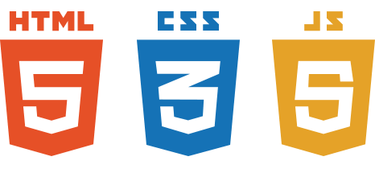

III Pillars WEB Development

Every basic thing you need to know about HTML5,CSS,JAVASCRIPT

Huzaifa Iqbal

ApTECH  GLS 2

**Family *Tree***

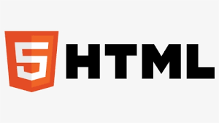

**HTML** stands for Hyper Text Markup Language. **HTML** is the standard markup language for creating Web pages. **HTML** describes the structure of a Web page. **HTML** consists of a series of elements. **HTML** elements tell the browser how to display the content.

`

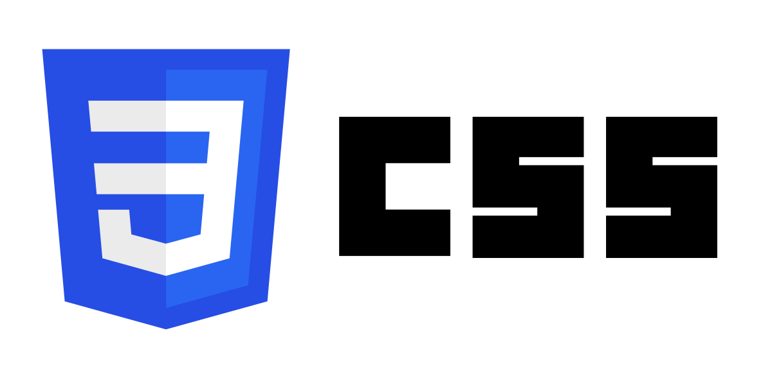

**CSS** (Cascading Style Sheets) is used to style and layout web pages — for example, to alter the font, color, size, and spacing of your content, split it into multiple columns, or add animations and other decorative features.

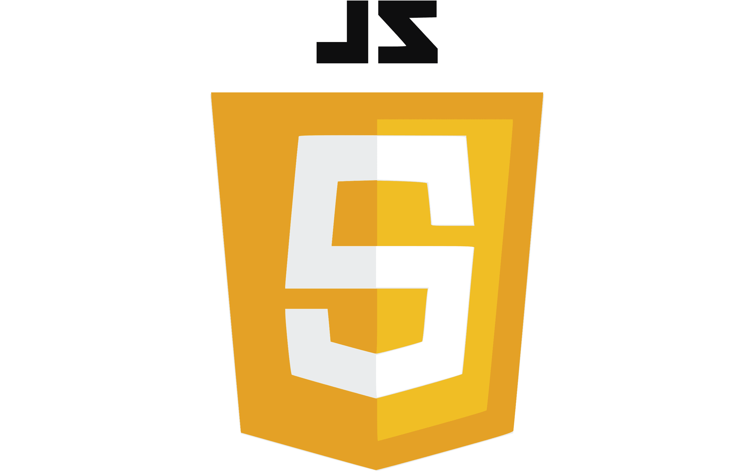

**JavaScript** is used by programmers across the world to create dynamic and interactive web content like applications and browsers. **JavaScript** is so popular that it's the most used programming language in the world, used as a client-side programming language by 97.0% of all websites