**DAY 14**

**LOGICAL PROGRAMMING QUESTION WITH ASYNC IMPLEMENTED IN IT**

**1)**

Minimum Depth of the Binary Tree Input

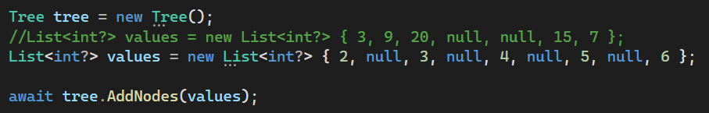

Minimum Depth of the Binary Tree Output

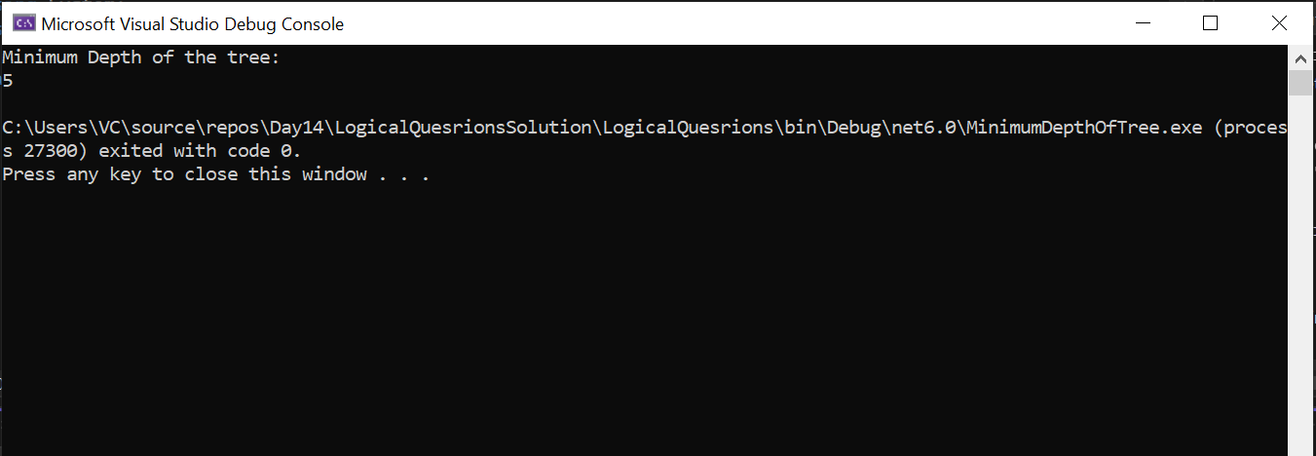

**2)**

Excel Style Column Name from the given number

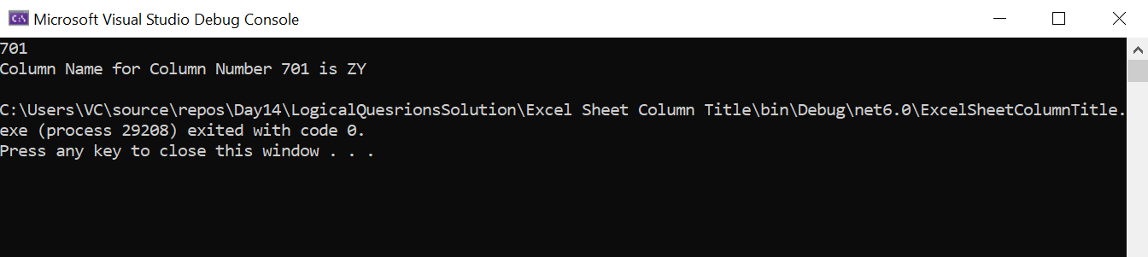

**3)**

Detect Cycle Input

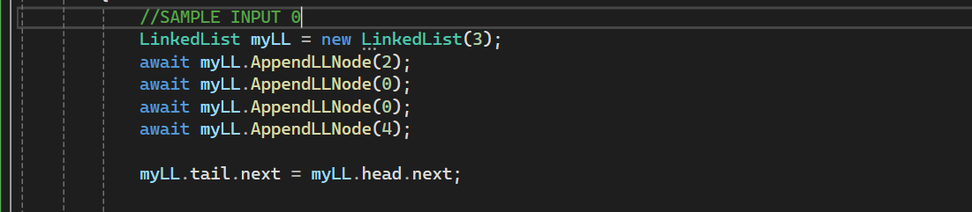

Detect Cycle Output

