**DAY 16**

1. Print all the titles names

Query :

select title 'Titles' from titles

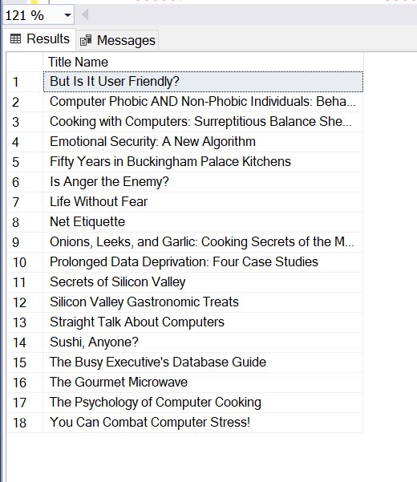

1. Print all the titles that have been published by 1389

Query :

select title 'Titles' , pub_id 'Published by' from titles where pub_id = 1389

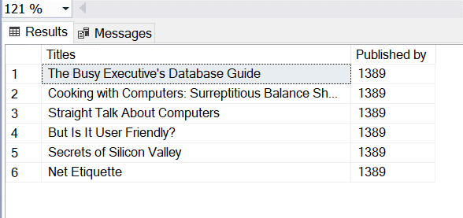

1. Print the books that have price in rangeof 10 to 15

Query :

select title_id 'ID', title 'Book', type 'Book Type',price 'Price' from titles where price between 10 and 15

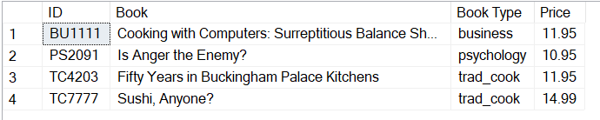

1. Print those books that have no price

Query:

select title_id 'ID', title 'Book', type 'Book Type',price 'Price' from titles where price is NULL

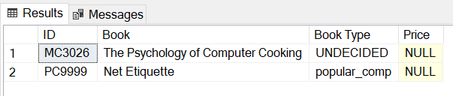

1. Print the book names that strat with 'The'

Query :

select title_id 'Book Id',title 'Book Names starting with THE' from titles where title like 'The%'

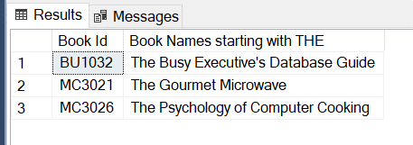

1. Print the book names that do not have 'v' in their name

Query :

select title_id 'Book Id',title 'Book Names starting with THE' from titles where title not like '%v%'

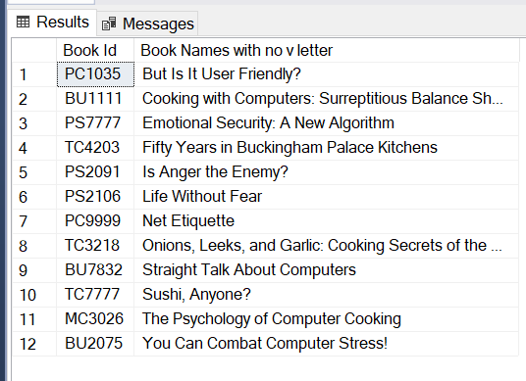

1. print the books sorted by the royalty

Query :

select title_id 'ID', title 'Book' , royalty 'Royalty' from titles order by royalty

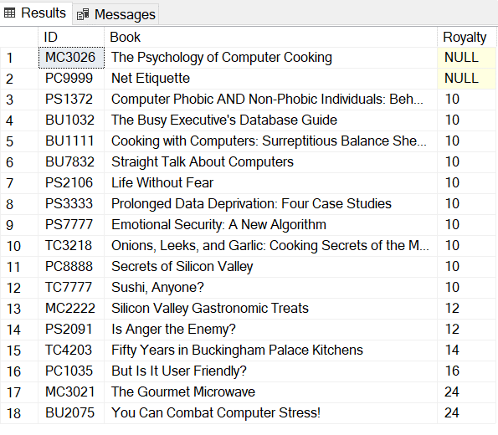

1. print the books sorted by publisher in descending then by types in asending then by price in descending

Query :

select title_id 'ID', title 'Book', pub_id 'Publisher', type 'Book Type',price 'Book Price’

from title order by pub_id desc,type, price desc

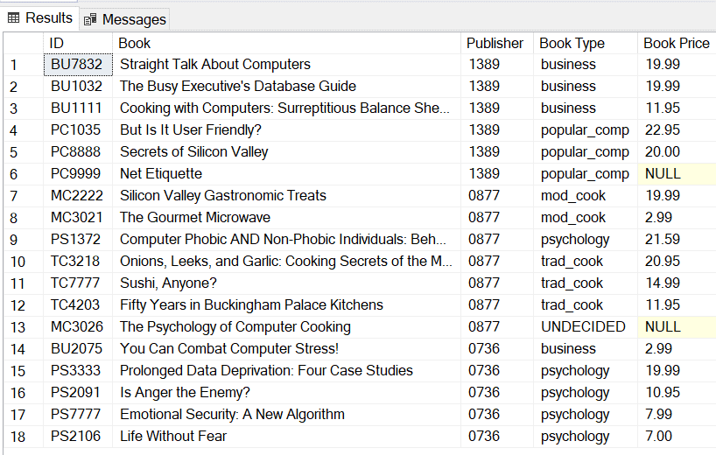

1. Print the average price of books in every type

Query :

select avg(price) 'Average Price' ,type 'Book Type' from titles

group by type

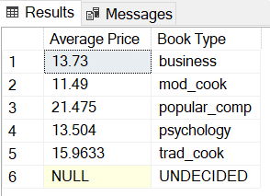

1. print all the types in uniques

Query :

select distinct type 'Distinct Book Types' from titles

\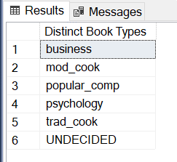

1. Print the first 2 costliest books

Query :

select top(2) title_id 'ID', title 'Book', price 'Book Price'

from titles order by price desc

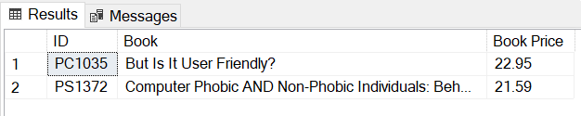

1. Print books that are of type business and have price less than 20 which also have advance greater than 7000

Query :

select title_id 'ID', title 'Book'from titles where type='business' and (price<20 and advance>7000)

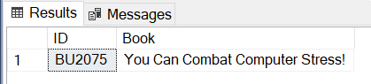

1. Select those publisher id and number of books which have price between 15 to 25 and have 'It' in its name. Print only those which have count greater than 2. Also sort the result in ascending order of count

Query :

select pub_id, COUNT(title) 'Number of Books' from titles

where price BETWEEN 15 AND 25 AND title LIKE '%It%'

group by pub_id

having count(title) > 2

order by count(title)



1. Print the Authors who are from 'CA'

Query :

select au_id 'Author ID',au_fname 'First Name', au_lname 'Last Name' , state 'State'

from authors where state='CA'

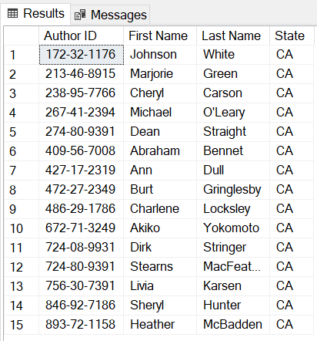

1. Print the count of authors from every state

Query :

select count(au_id) 'count of Author' , state 'State of author'

from authors group by state

