**DAY 19 (Store Procedure and Union Task)**

use Pubs

**1) Create a stored procedure that will take the author firstname and print all the books polished by him with the publisher's name**

create proc GetBooksByAuthor

@AuthorFirstName varchar(30)

as

begin

select

t.title AS 'Book Name',

p.pub_name AS 'Publisher Name'

from

titles t

join

titleauthor ta on ta.title_id = t.title_id

join

authors a on a.au_id=ta.au_id

join

publishers p on t.pub_id = p.pub_id

where

a.au_fname = @AuthorFirstName;

end;

exec GetBooksByAuthor @AuthorFirstName = 'Johnson';

select * from authors

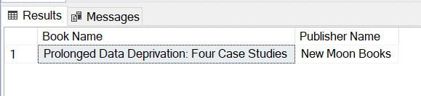

**2) Create a sp that will take the employee's firtname and print all the titles sold by him/her, price, quantity and the cost.**

select * from employee

create proc GetEmployeesSalesDetails

@EmpFirstName varchar(30)

as

begin

select

t.title 'Title', t.price 'Price', s.qty 'Quantity', (s.qty*t.price) 'Cost' from employee e

join

titles t on t.pub_id=e.pub_id

join

sales s on s.title_id=t.title_id

where e.fname=@EmpFirstName

end;

exec GetEmployeesSalesDetails @EmpFirstName='Paolo'

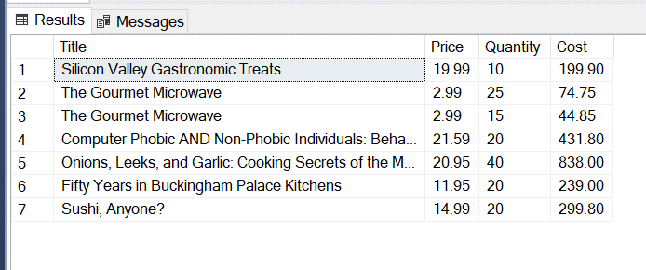

**3) Create a query that will print all names from authors and employees**

select concat(au_fname,au_lname) 'Names' from authors

union

select concat(fname,lname) from employee

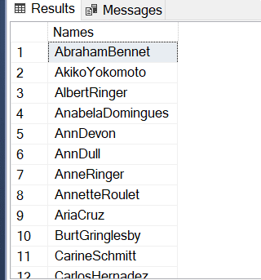

**4) Create a query that will float the data from sales,titles, publisher and authors table to print title name, Publisher's name, author's full name with quantity ordered and price for the order for all orders,**

**print first 5 orders after sorting them based on the price of order**

select top 5 t.title 'Title Name', p.pub_name 'Publisher Name',

concat(a.au_fname,a.au_lname) 'Author Name', s.qty 'Qunatity Ordered',

(t.price*s.qty) 'Price for the order',s.ord_num 'Order Number'

from titles t

join publishers p on t.pub_id=p.pub_id

join titleauthor ta on ta.title_id = t.title_id

join authors a on ta.au_id=a.au_id

join sales s on s.title_id=t.title_id

order by t.price

