**DAY 20 (DATABASE FIRST)**

**FINE CODE COVERAGE**

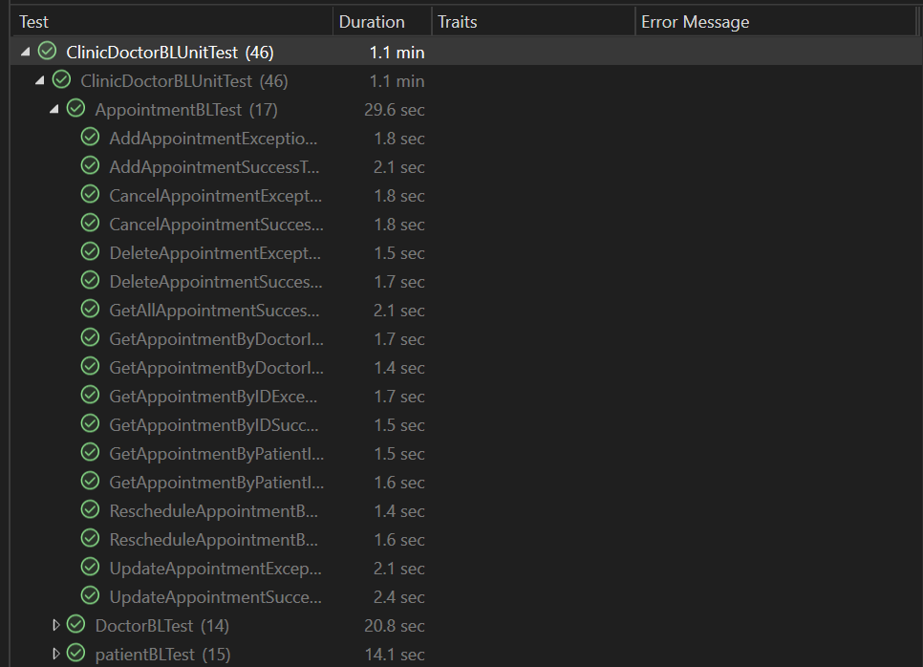

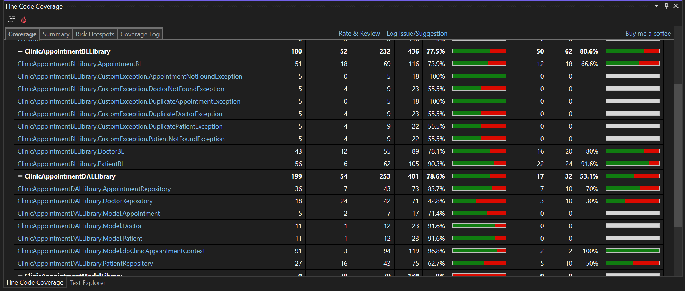

**Doctor, Patient and Appointment Table**

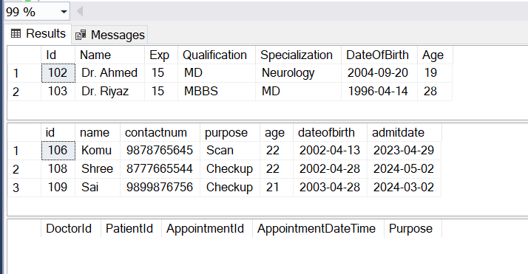

**Project Folder Structure**

