**DAY 24**

**QUESTION 1:**

Query the Name of any student in STUDENTS who scored higher than Marks. Order your output by the last three characters of each name. If two or more students both have names ending in the same last three characters (i.e.: Bobby, Robby, etc.), secondary sort them by ascending ID.

**QUERY :**

select name from students where marks>75

order by substring(name,len(name)-2,3),

Id asc

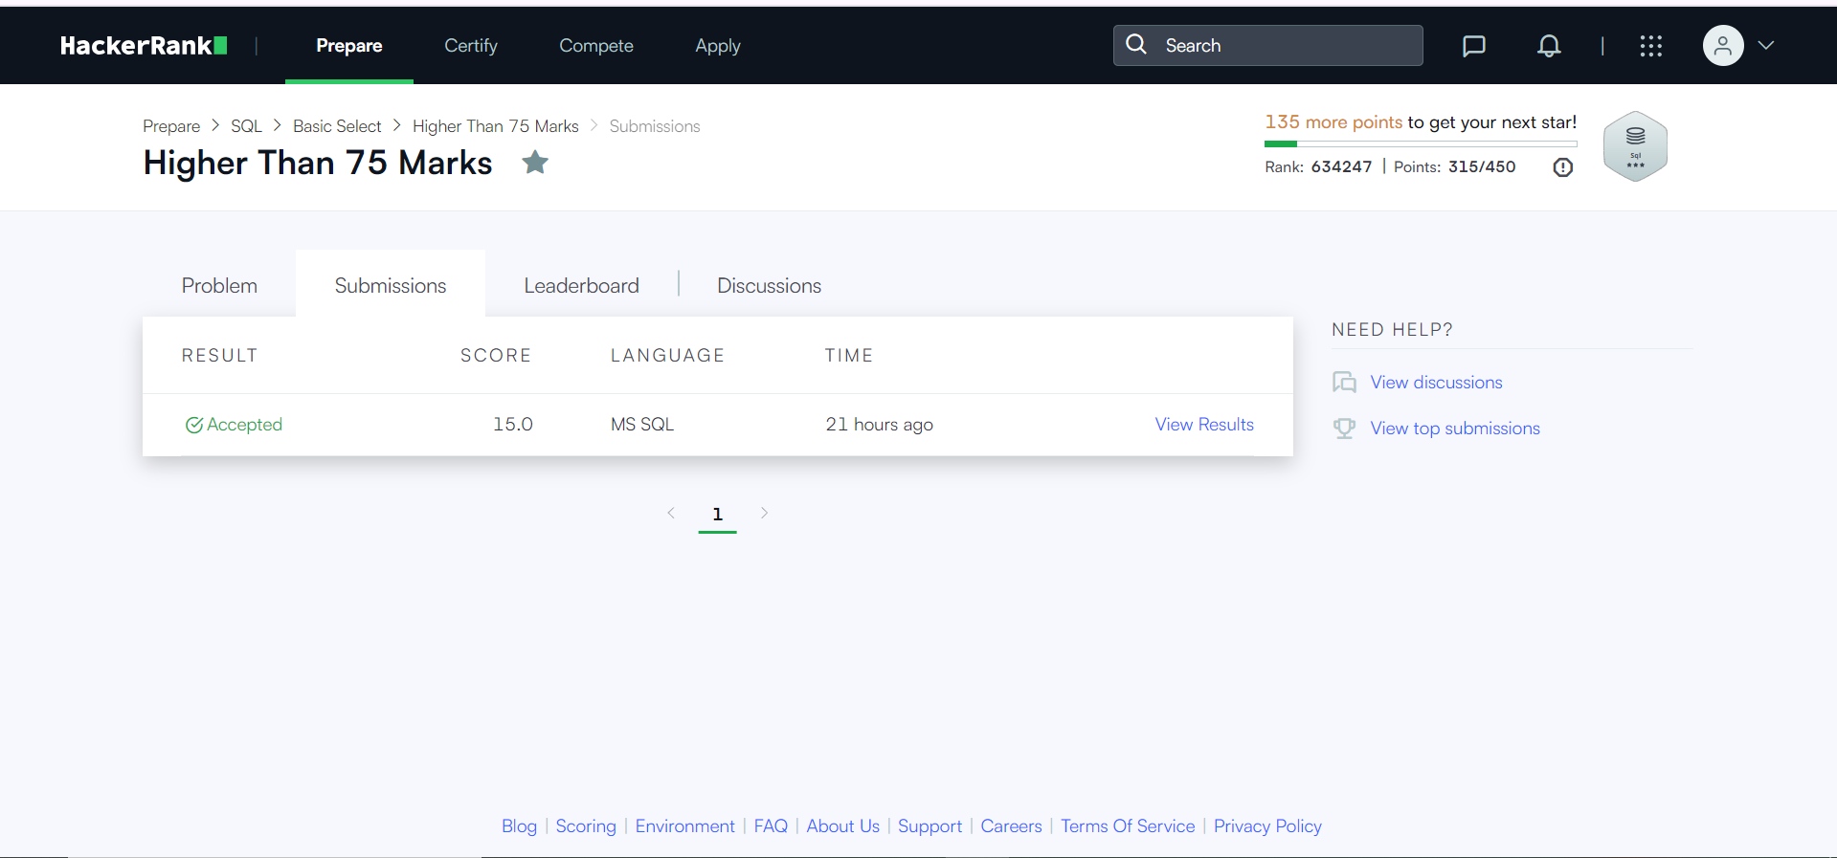

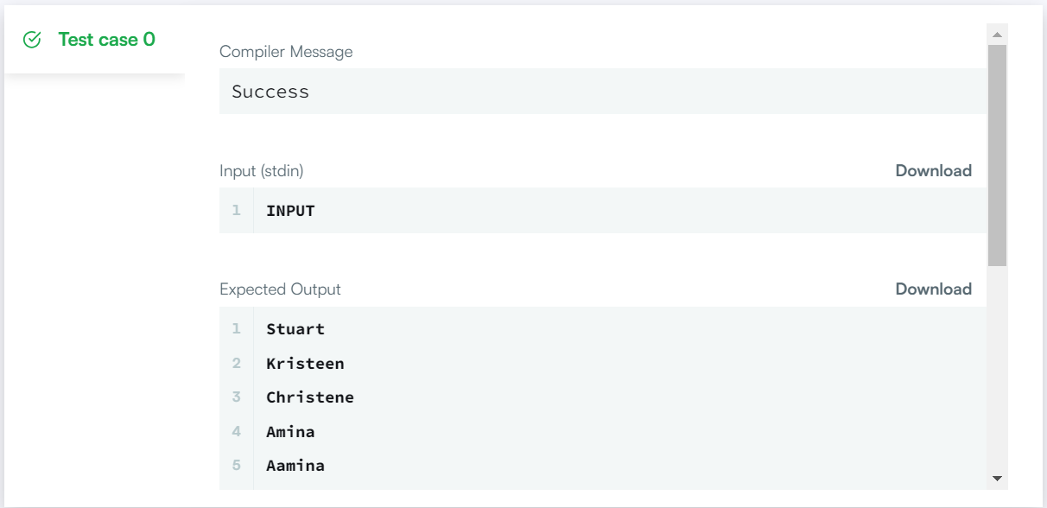

**QUESTION 2:**

You did such a great job helping Julia with her last coding contest challenge that she wants you to work on this one, too!

The total score of a hacker is the sum of their maximum scores for all of the challenges. Write a query to print the hacker_id, name, and total score of the hackers ordered by the descending score. If more than one hacker achieved the same total score, then sort the result by ascending hacker_id. Exclude all hackers with a total score of 0 from your result.

**QUERY:**

select s.hacker_id, h.name,

sum(s.score) 'Total Score'

from

(select hacker_id, challenge_id,max(score) as score from submissions

group by hacker_id,challenge_id) as s

left outer join hackers h

on s.hacker_id = h.hacker_id

group by s.hacker_id,h.name

having sum(s.score)>0

order by sum(s.score) desc, s.hacker_id asc;

