**DAY 24**

**GET** – ALL DOCTORS

SWAGGER

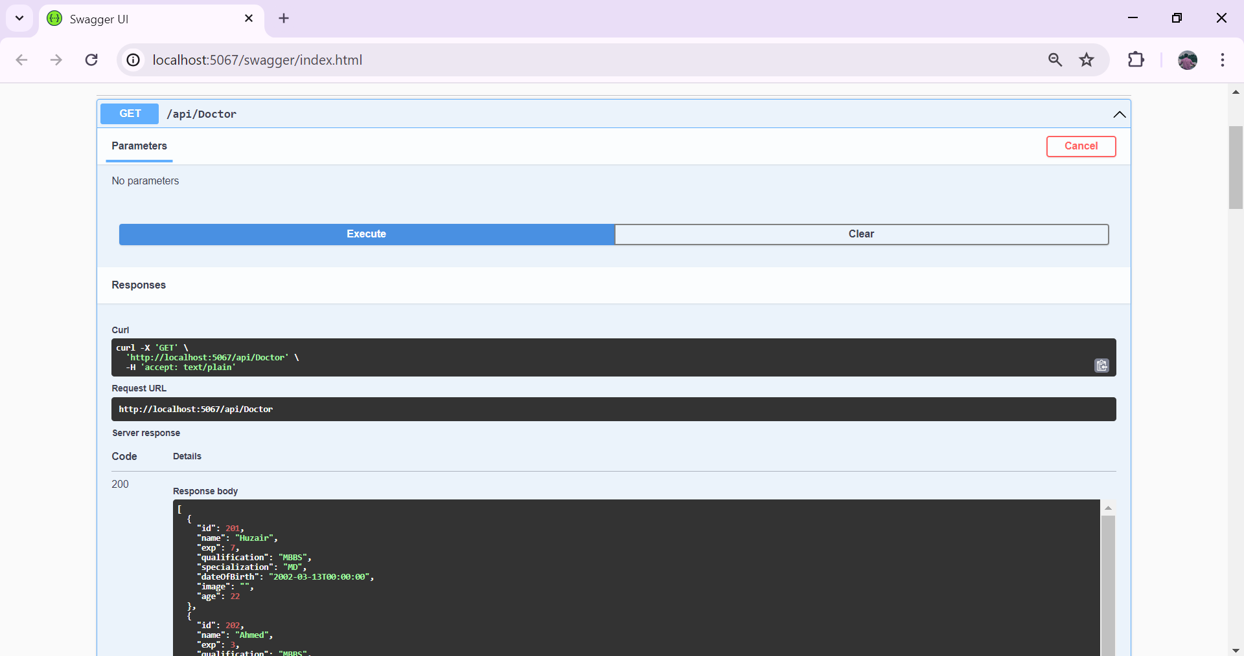

POSTMAN

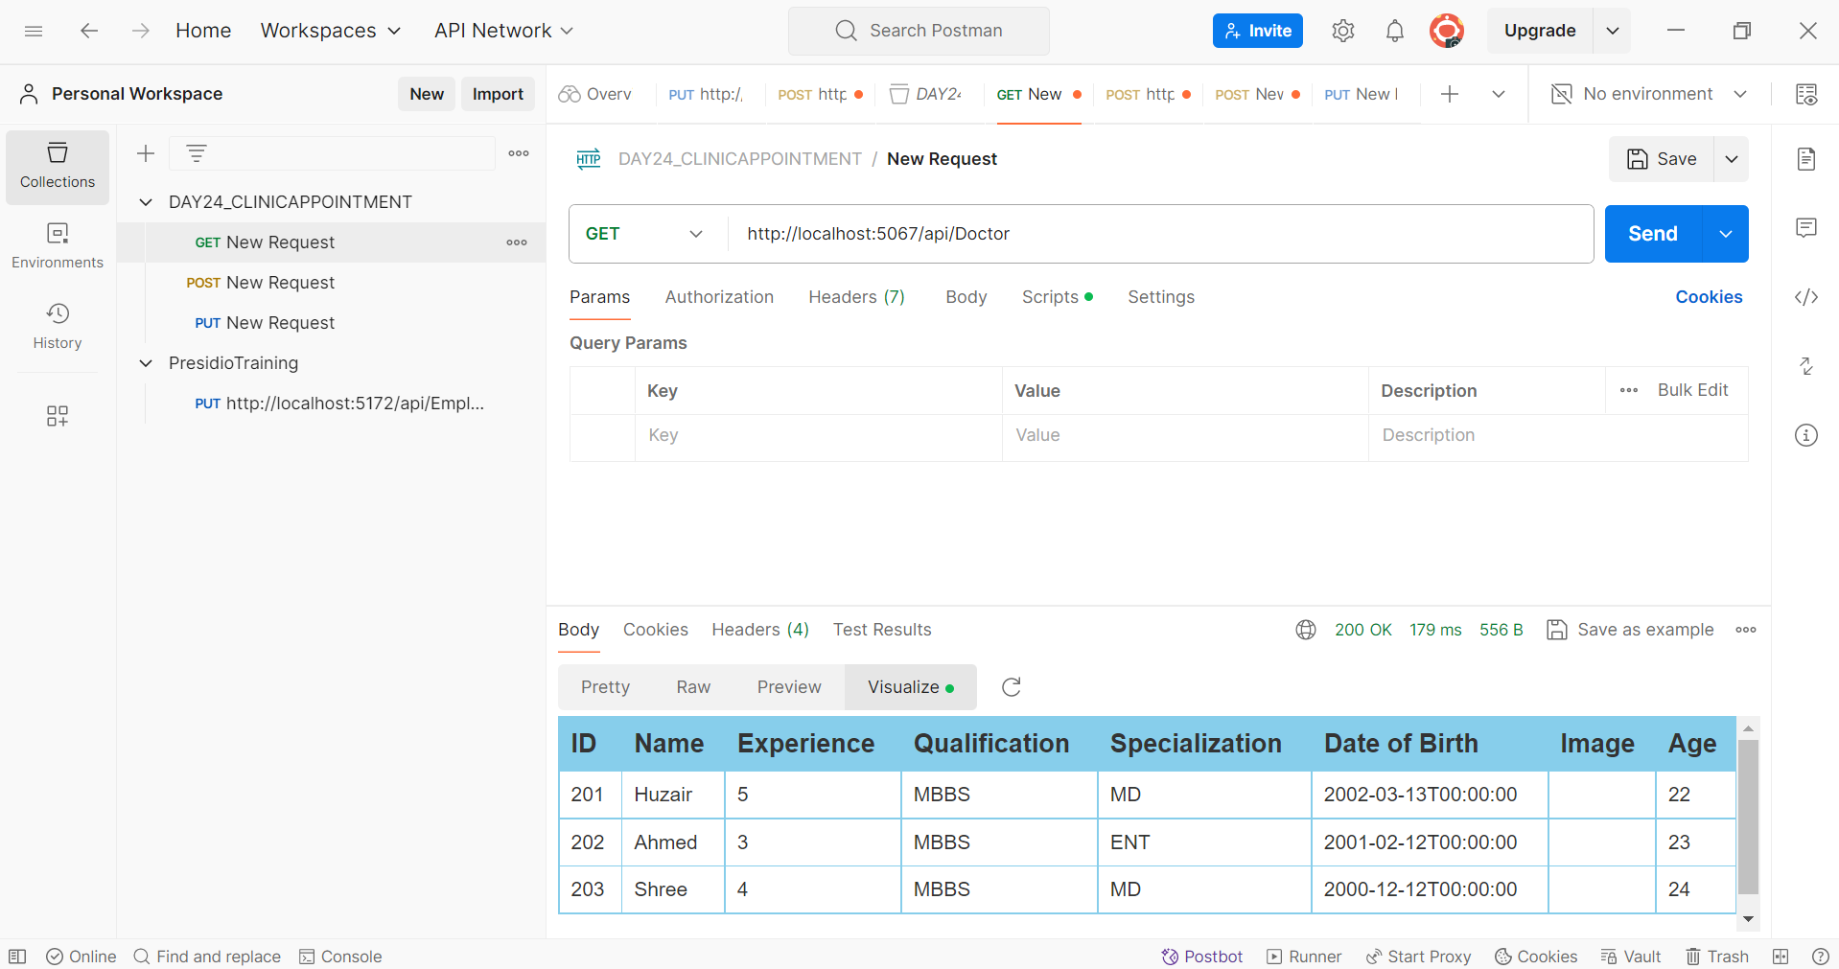

PUT – UPDATE DOCTOR EXPERIENCE

SWAGGER

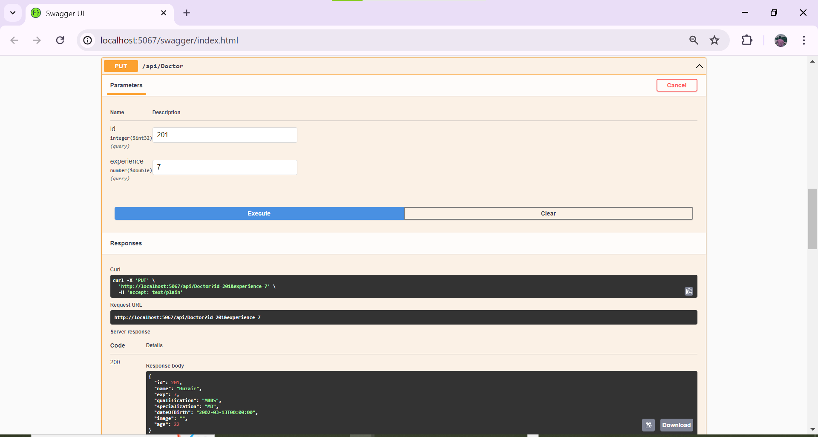

POSTMAN

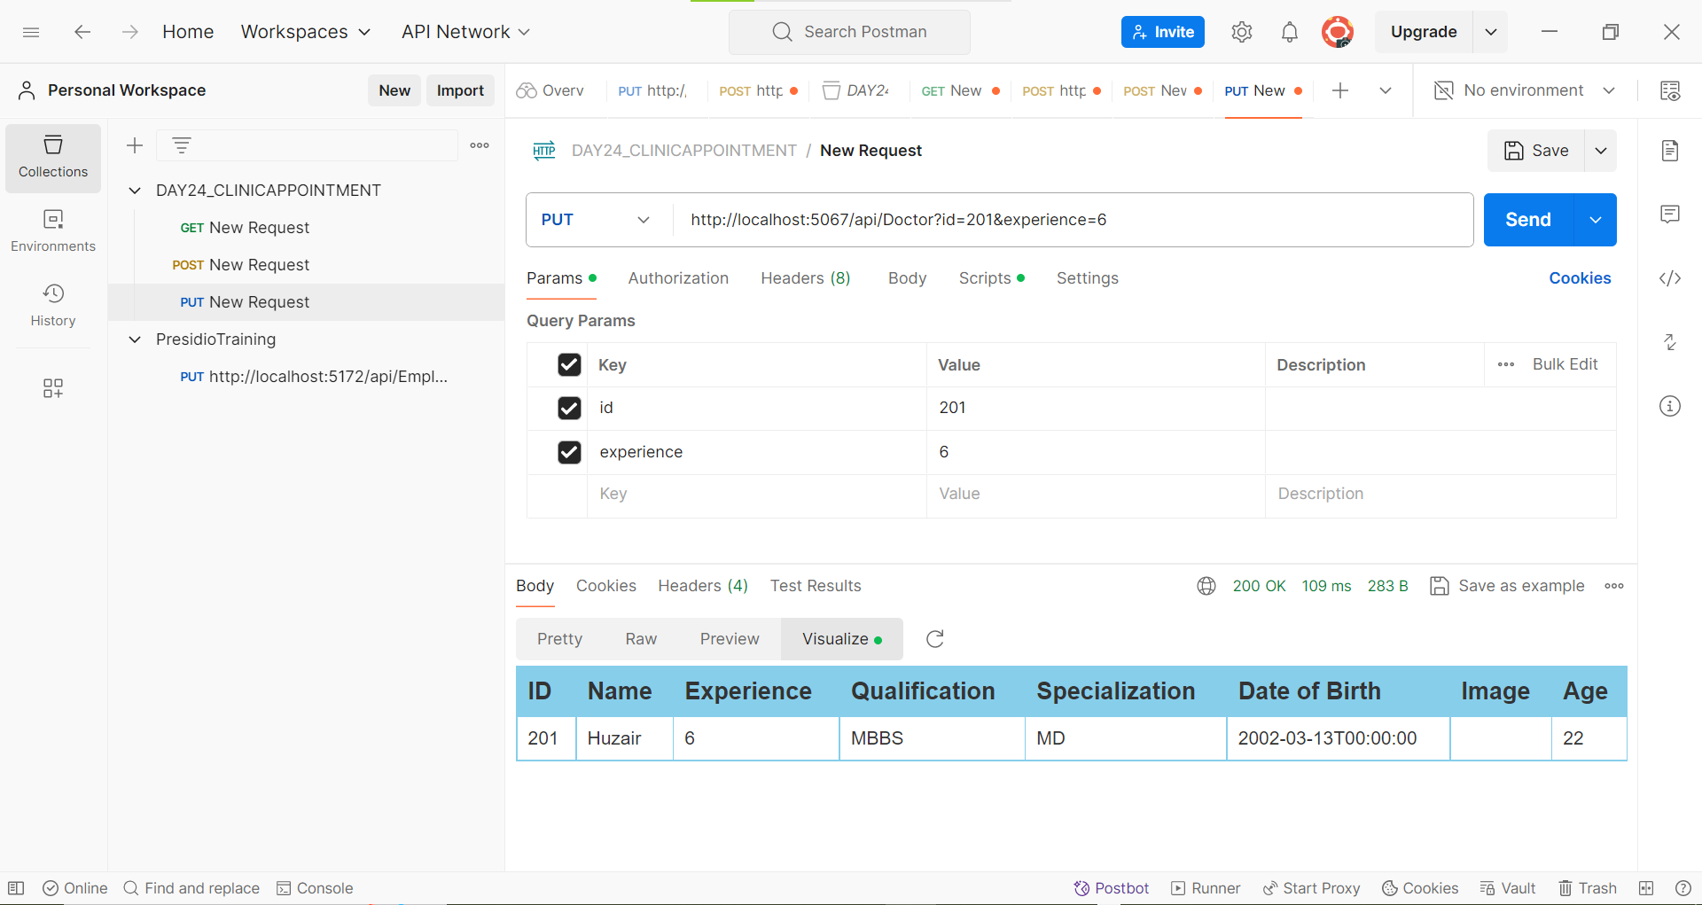

POST – GET DOCTOR BY SPECIALITY

SWAGGER

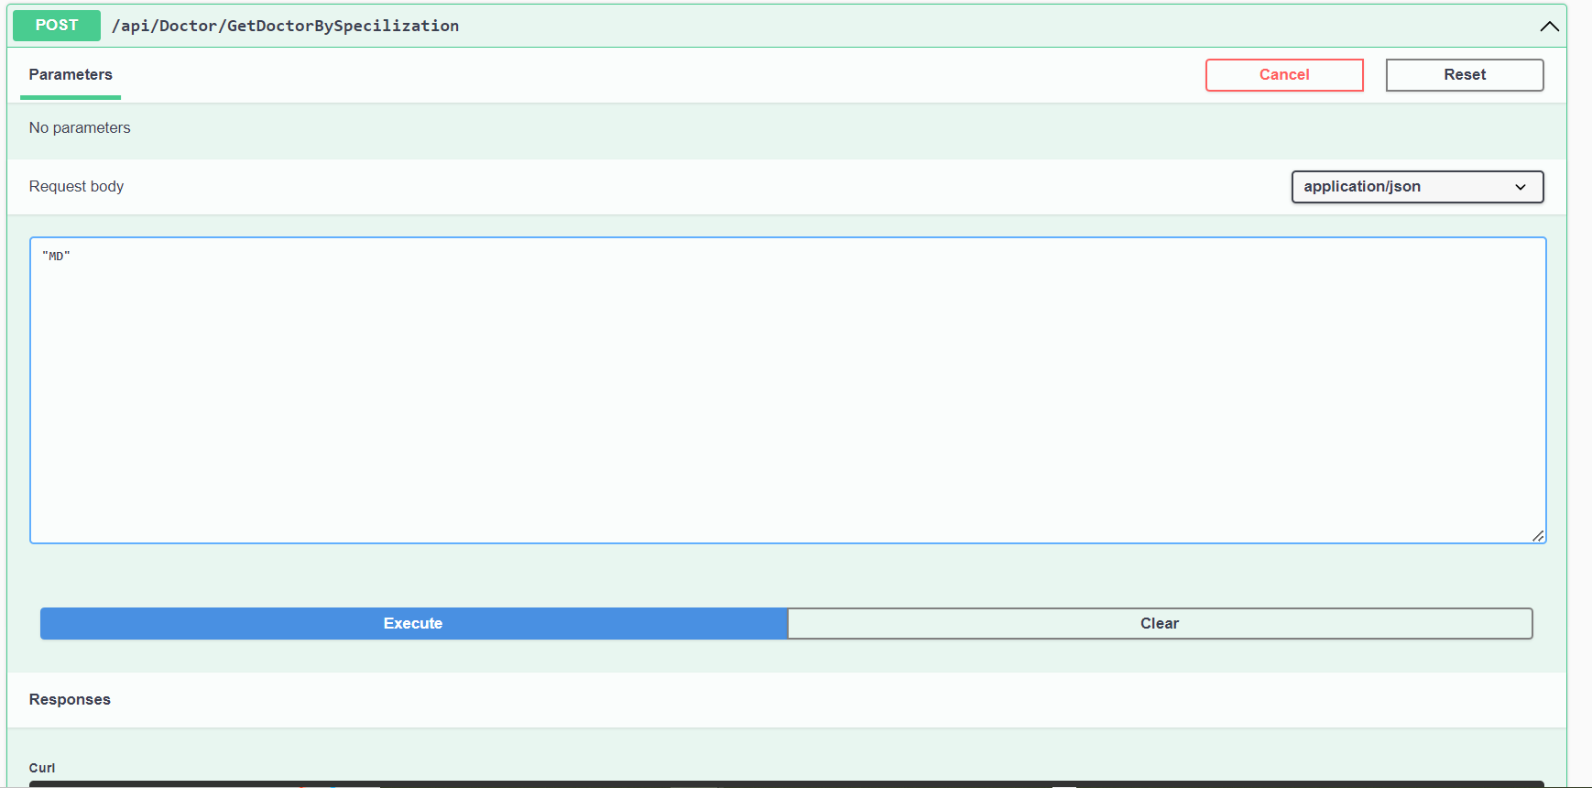

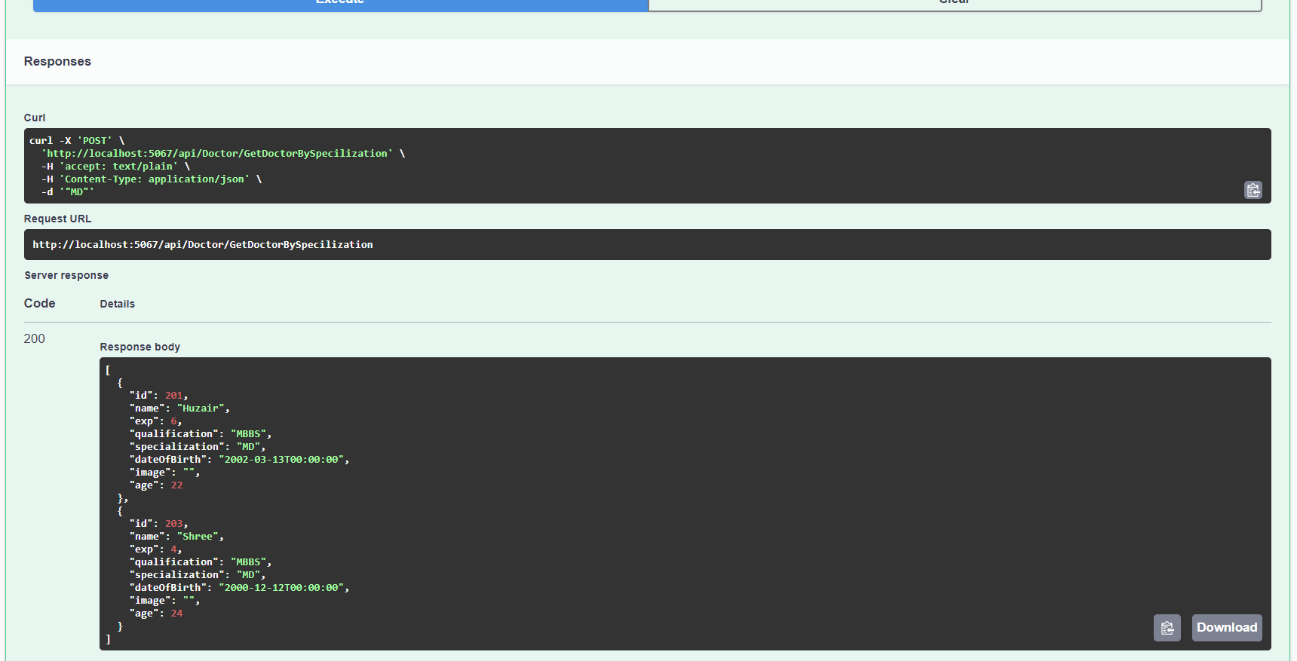

POSTMAN

